 | CO2 Motors
J.D. Nicoud, Mouette 5  CH-1092 Belmont, Switzerland  Tel ++41 21 728-6156, Fax ++41 21 728-6157  Email info@didel.com www.didel.com | S. Gasparin Podskali 96  CZ-25101 Ricany, Czech Republic  Tel ++42 032 360-3088 Fax ++42 032 360-5798  Email sgasparin@iol.cz www.gasparin.cz
File http::/www.didel.com/slow/servo/Gdservo.doc

GDservo – the 1.3g servo

The GD servo is a marvel of miniaturization. With its 1.4g weight and a torque of up to 20 gcm at 3.5V, it is the perfect solution for 15 to 30 gram model planes and many micro-robotic and industrial applications where weight, size and speed matter.

Characteristics  Voltage:  Current::  Weight (naked):  Connector weight:  Full deviation sweep time:  Force (0.9mm lever)  Sweep angle and precision: | 2.8 to 5.5V  20 to 100mA, average <30 mA  1.33 g  0.13 g  < 0.1s at full load, 3.5V  > 20g at 3.5V  ca +/- 40° +/- 3°

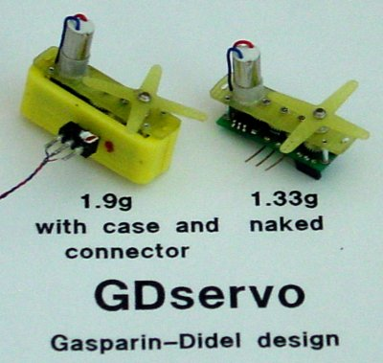
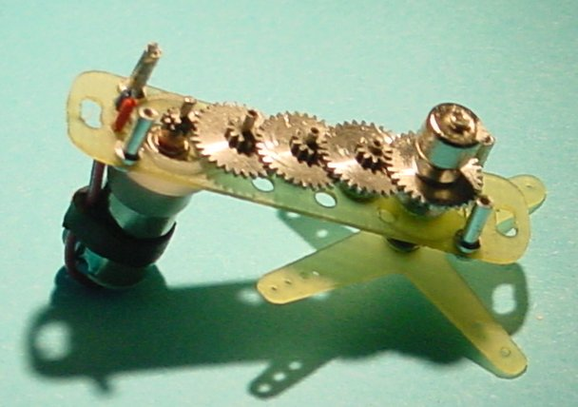 | The GDservo is the result of the collaboration between Stefan Gasparin, the well known designer of a family of miniature CO2 motors, and J.D. Nicoud, an experienced designer specializing in miniature parts and control systems for ultra-light slow flyers. | 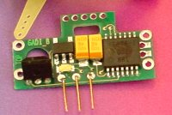

Principle of operation

The drive force of the actuator is a Mk04S-24 motor, controlled by a microcontroller through a transistor bridge. A gear train (module M0.15) provides a ratio of 105 toward the shaft, on which a magnet is fixed. A Hall sensor read by the microcontroller gets the position, compared to the wanted position defined by the servo PPM input.
Since the motor torque at 3.5V is 0.2 mNm, the theoretical torque on the shaft is below 20 mNm = 200 gcm. We measured more than 25 gcm, more at 5V, this is a lot for a plane in the 20-50 grams range.
The advantage of the gear train, compared to the lead screw, is a very high speed (less than 0.1s for a full sweep).

Connection diagram

Three pins provide the power and the PPM signal from the radio receiver (usual positive 1-2 ms pulses every 15-25 ms). The pins are 0.3mm in diameter and match the 0.1 g connector supplied.  It is possible to solder the connecting wires directly on the pins, but use a minimum heat so as not to unsolder them. A direct connection on the PC board saves 0.02 grams; any excess of solder will be heavier. | 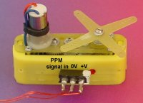

Line resistance must be below 1 Ohm, which corrspond to 50cm of AWG 33 solid wires (dia 0.18mm), of a weight of 0.2 grams for the 3 wires. The signal wire may be thinner.

The algorithms has been opimized for fast reaction and high torque. Due to the lack of friction, the low inertia and the gear backlash, this means oscillations at no load are difficult to suppress. They may appear temporarily above 4V, if the gear train has specially low friction. They disappear as soon the servo do what he as been designed for: doing some real work, even at low torque. Alse, as with most servo, oscillations are triggered if the PPM signal is not very stable.

The Led blink when the program runs correctly. The frequency of the blinking depends on the curreent. If you block the servo, you will notice a frequency increase, and the motor heats up, specially with a 5V supply. If the gear train is blocked by some dust, the same will occur.

Use a screwdriver of the good thickness to align the cross. Do not force too much.

In case of mechanical problems, send the devective part to Stefan Gasparin. Electronic problems are handled by Didel. Do not cut the part with the programming connector. We may do it on productions units, when it will be sure the program will not change (it saves 0.01g only).

The GDservo until the end or 2003 at the special price of 98 USD or 90 Euros (130 CHF). The case will be available since December, for an additional cost of 10 USD.
Jdn 031022 /us18 0903

How to fix the GDservo

If the fuselage has a large enough flat area, cut a slot of 9x6mm, plus a notch for the programmin connector. Glue with two small drops of thick CA at the very end of the servo.  A cutter or CA diluter will allow to remove the servo without arm. | 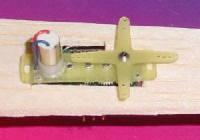
Prepare a bed with two 5mmx6mm pieces cut in 3mm balsa. A 24mmx6mm base cut in 0.8mm balsa, plus 1mmx1mmx6mm reinforcement will give a flat area to stick on you structure.  The weight is 0.04g. | 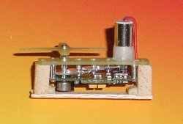
Cut a 15mmx6mm piece in a 3mm soft balsa. Make a slot with a cutter at 3mm from the side and enlarge the slot with a pin. You may harden the balsa at the good place with some thin CA, moving the needle fast to keep the slot at the good width. A round file may be used to increase the contact area with the tube.  Use small drop of thick CA on the protruding printed board to maintain the servo. The weight is 0.02g. | 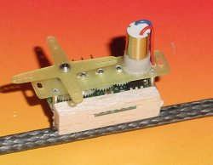
Same as before, with a piece of 0.8mm to get a flat surface for using double-sided gluing tape or velcro to maintain the servo and be able to remove it. Weight is 0.05g. | 