CH-1092 Belmont, Switzerland  Tel +41 21 728-6156, Fax 728-6157  Email info@didel.com, www.didel.com | 
File www.didel.com/slow/propellers/PropSurvey.doc

Propulsion survey for very slow flyers

This document presents in telegraphic form the practical results of the propeller study conducted by Didel. See www.didel.com/slow/propellers/PropStudy.doc for our 15 pages analysis of propellers, motors and gearboxes.

1. Is your motor damaged or has your gearbox a too low efficiency?

Measure the no-load and stall current at 3.5V of your motor outside the gearbox. The noload current of a pager motor should be in the 20-50mA range. The stall current depends on the coil resistance. If the resistance is below 10 Ohm, the current quickly decreases when powered and the motor gets hot.

When the motor is inside the gearbox, no propeller connected, the no-load current increases by 10-20%. More is the indication of a poor box; check the distance between gears.

2. Does your propeller correctly match the motor-gearbox?

Measure the current with the propeller spinning. The current should be between 70 and 80% of the stall current, to get the maximum thrust from the propeller.
If more, shorten your propeller; you will not increase the thrust significantly, but you will considerably reduce the heat, and increase your battery lifetime.
If less, it is good for efficiency. If you need more thrust, put a larger prop, or get a three bladed one. Or reduce the gear ratio keeping the same prop, which will spin faster and give more thrust.

3. How to select a motor/gearbox/propeller for a given thrust?

The tables below give for for four typical motors powered at 3.5Volts and connected to a Didel gearbox, optimal values for the prop diameter and for the thrust.

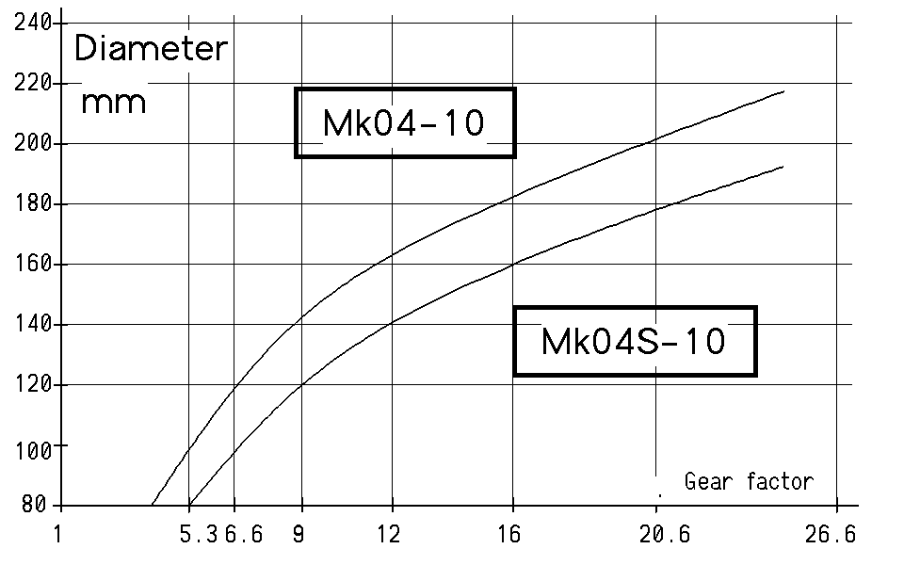 |  | 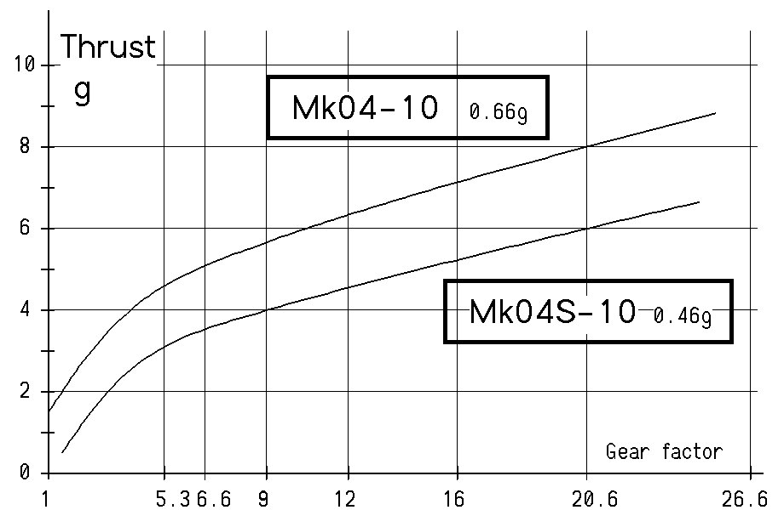
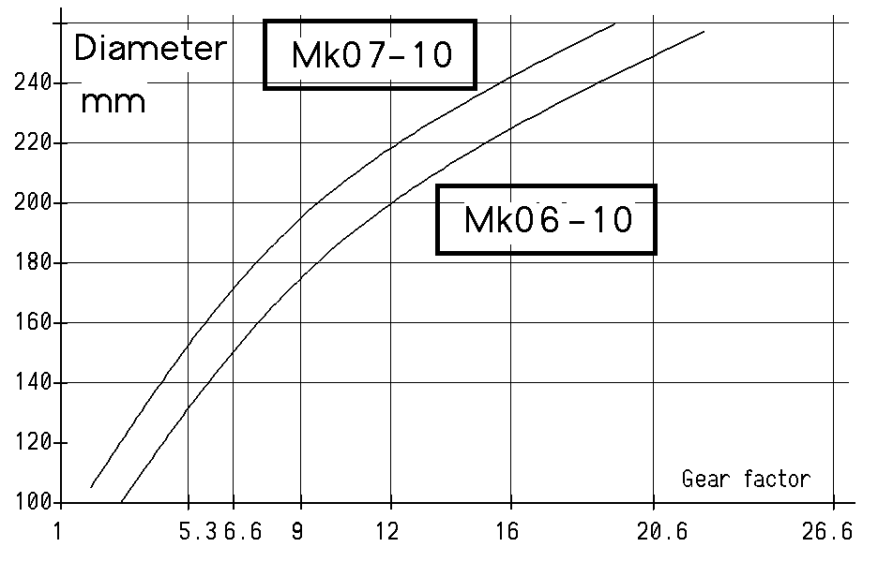 | 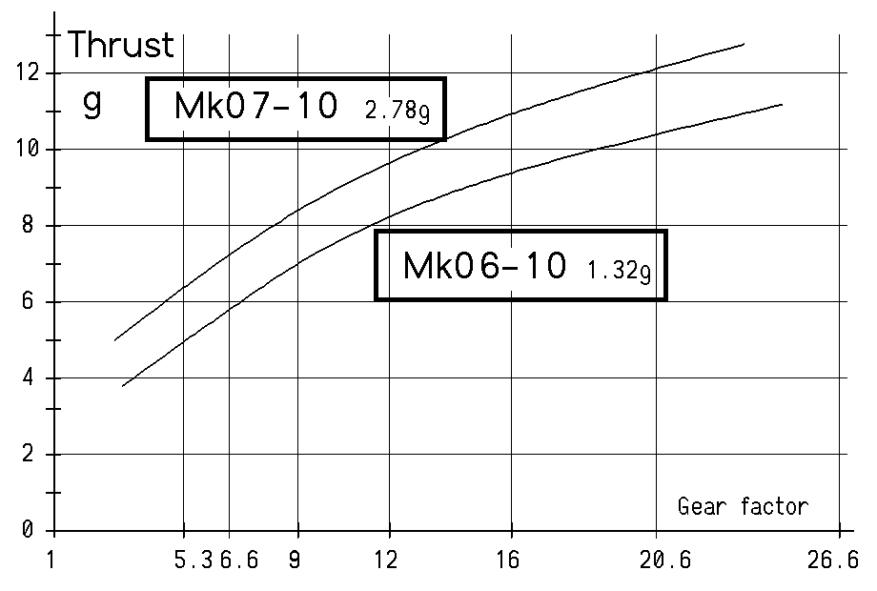

15.06.03/jdn

