CH-1092 Belmont, Switzerland  Tel +41 21 728-6156, Fax 728-6157  Email info@didel.com, www.didel.com | 
File www.didel.com/slow/propellers/PropStudy.doc

Propeller study for very slow flyers

1. Introduction

Propellers are a major problem for the slow flyer community. The commercial choice is very limited, and inadequate for 10-20 gram planes. Relationship between the diameter, the pitch, and the shape of a propeller, and the thrust has never been published.
The best match with a motor and gear box results from empirism, since modelisation and aerodynamic analysis are quite difficult to do.
The objective of this paper is to explain most aspects of the problem, and provide hints on the selection process. Many propellers have been measured and we provide charts that allow to estimate the thrust and power requirement of any good propeller. When weight is of primary concern, balsa propellers are adequate and easy to build. For 15-50 gram planes, good carbon propellers are available. Doing your own props that match your model requirements are easy to do and smarter than trying to adapt an existing prop that will not be as efficient.

2. Low Reynolds aerodynamics

The Reynolds number of a wing is equal to 65000*v*L where v is the speed and L the chord.  A model of 20 cm chord flying a 1m/s has hence a Re = 13000. A 160 mm propeller with 15mm blade width, spinning at 3000 RPM is in the Re = 30000 range. Below 40000, the viscous forces dominates, the flux is laminar and does not follow the extrados very well as shown in figure 1. The best lift/drag ratio is about 5 at Re = 5000. | 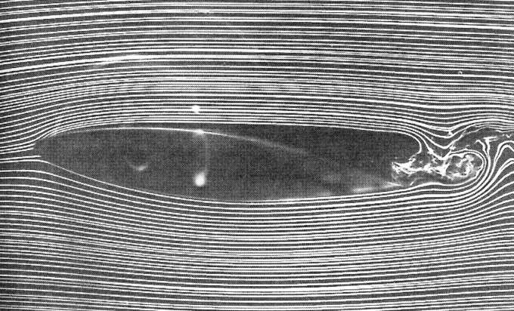
Fig. 1 Typical Flow at
Re = 40000 (from [1])

At these Re numbers, roughness of the surface and irregularities at the leading edge or a well placed turbulator wire may help (figure 2), since they create a microturbulence that prevent the early separation of the boundary layer. But how to guarantee one of these profiles on a 0.3 grams propeller?

No aerodynamic study exists in the 10k Re range, and mathematical models like ModelFoil, FoilSim or Airfoil Analysis do not support this Re range. Mathematically drawn profiles are of little help, since it is impossible to build them precisely when ultra low weight is concerned.

The only way to get solutions close to the optimum is to experiment and compare.

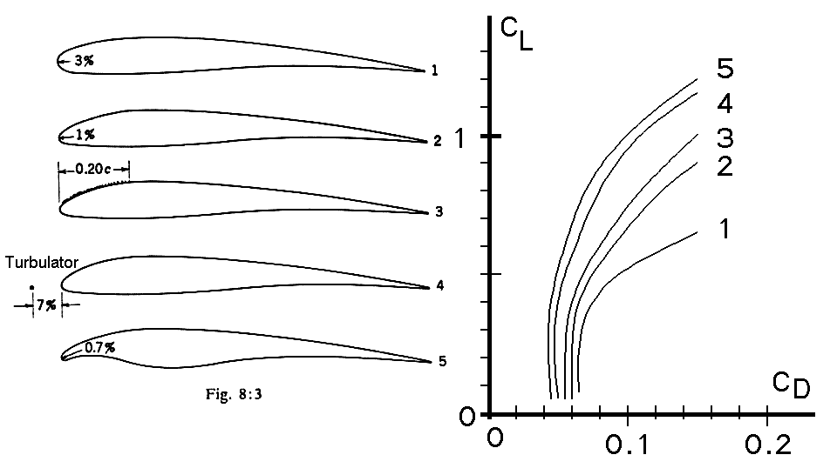
Fig. 2 Polar plots for different profiles at Re = 30000 (from [2])

3. Aerodynamic and similitude laws

Since we cannot get or easily measure the polar plot of wings and propellers, precise equations to calculate the lift and drag are of little use. We will think about relative and not absolute values, and use the sign ∝ (proportional) in place of the usual = (equal) sign we are used to [3].
For a given wing incidence, lift and drag are proportional to the square of the speed and to the area.
L ∝ v² S D ∝ v² S (1)

The lift-drag ratio L/D, the fineness, depends on the incidence. It degrades considerably when the Re number decreases (down to 5 for a Re of 10000).

With the simplified model for a propeller (figure 3), the average speed is equal to ω r, that is the thrust T is proportional to ω² r S. ω (omega) is the angular speed, expressed in radians/s. One converts the RPM value N to the angular speed ω by dividing N by 60 and multiplying by 2 π. But since we are concerned about proportionnality, ω and N are equivalent in our formulas. | 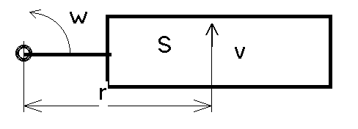
 | Fig. 3 Propeller model
We are concerned about selecting the correct size for a propeller; if we build homothetic props, the area S is proportional to r² and one recieves for the lift L (the thrust) and the drag D the relations
L ∝ N² r⁴ , D ∝ N² r⁴ (2)

The torque M is proportional to the drag D and the lever r. The power P is hence proportional to the torque and rotation speed.
M ∝ N² r⁵ , P ∝ N³ r⁵ (3)

If the lift is constant (a given model needs e.g. 10 g of thrust), N² r⁴ is constant, that is
N ∝ 1/r² , P ∝ 1/r (4)
The fineness of a blade results also from the torque, which is easier to measure
L/D ∝ L/(M/r) ∝ Lr/M ∝ constant (5)
Indeed, fineness degrades for smaller blades, due to lower Re number and less precise construction.

The Reynold number is proportional to v and r (we assume the blade width is proportional to the diameter), hence
Re ∝ N r² (6)

4. Logarithmic plots

On log-log plots, all curves should theoretically be straight line. Errors of measures, non linearities due to blade deformation are easy to recognize.
According to formula (1), the thrust vs RPM plot of figure 4 has a slope of 2, that is for 1 decade horizontally, the thrust increases by two decades.
The slope is 3 for the power versus RPM (figure 5 and formula 2), and 4 for the thrust versus diameter (figure 6 and formula 3): small props have to spin fast, but unhappily, as shown on figure 7, the power for a given thrust is inversely proportionnal to the prop diameter (formula 4): small propellers are power-hungry!

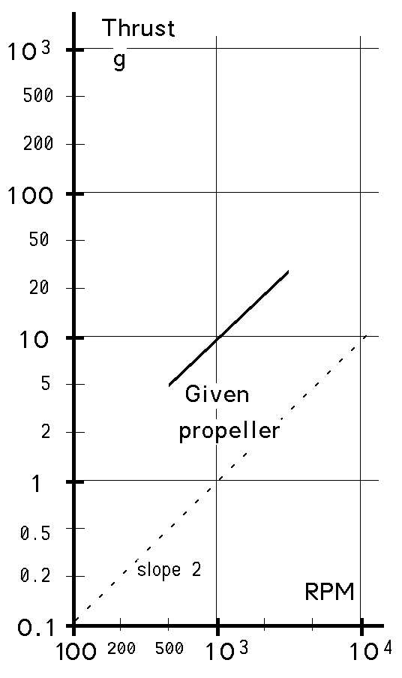 | 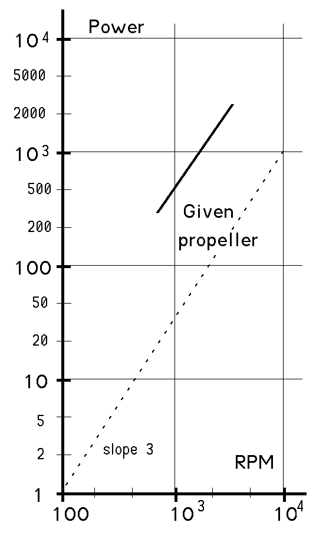 | 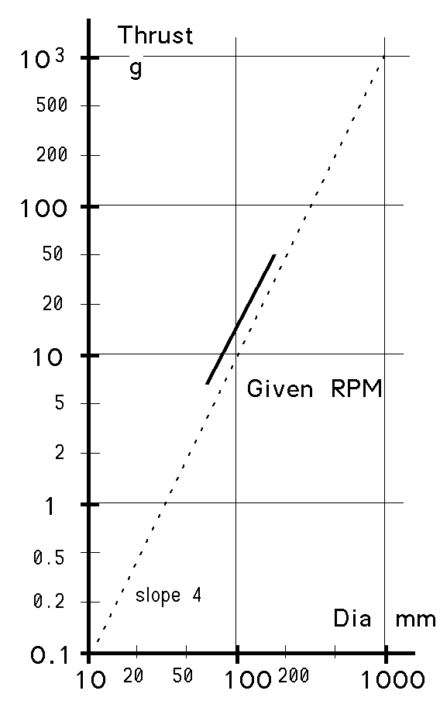 | 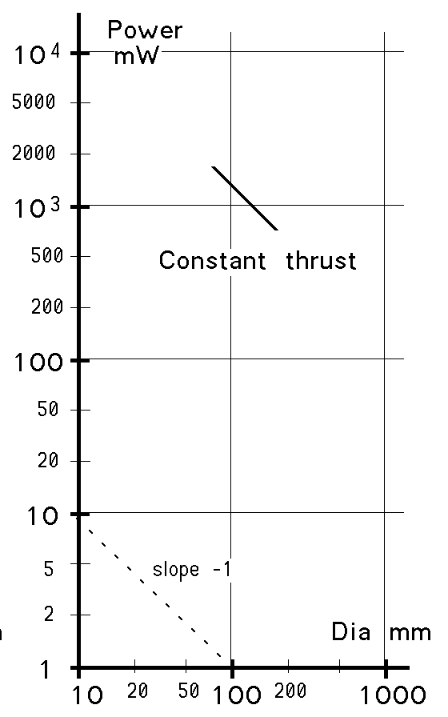
Fig. 4 Thrust vs RPM | Fig. 5 Power vs RPM | Fig. 6 Thrust vs dia | Fig. 7 Power vs dia

The plot of the torque vs RPM is not shown; it would have a slope of 2 at constant diameter, and a slope of 5 at constant RPM.

It will be seen later that these proportionnalities are well verified experimentally and this will be our way to get the proportionnality constants.

5. Constant thrust laws

How to select the prop diameter for a given thrust? Since L ∝ N² r⁴ , doubling the diameter for instance means the rotation speed must be divided by 4 for the same thrust. It is well known that adding a gearbox on a motor implyes increaseing the propeller diameter. But is it worth it ? If r’ = 2r and N’ = N/4, and if the proportion factor is the same , P’ = P ∝ N’³ r’⁵ = N/64 * 32r = N r /2. | 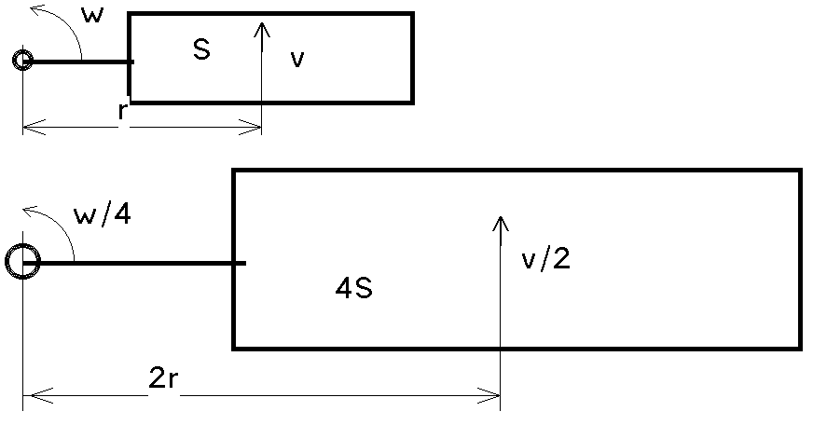  Fig. 8 Propeller model

The required power is half if we manage to double the prop diameter, and add a 4:1 gear box between the motor and the propeller. There is a clear advantage for larger propellers, but for slow flyers, they should not be heavier. Commercial large propellers are designed to spin fast and are far too heavy.

6. Measurement set-up

Measuring a propeller can be made with a simple set-up. A good motor spins the propeller. Voltage and current give the electric power, subtracting the ohmic losses and brush/bearings friction, give the mechanical power. The torque is proportional to the current (once the no load current has been subtracted) and the current constant is well documented with most motors. If the rotation speed is measured, one gets the real propeller power.
The thrust is shown by a balance. If you can get all this connected to a computer, that’s great, but expensive (and time consuming).

Measuring the rotational speed is made with a frequency meter. If the motor does not have a built-in encoder, a Hall sensor and a magnet on the shaft is the easy way to get a pulse every turn.  We use a 22mm Maxon motor with a 16 slots encoder. The frequency meter gives a value that is 16 times the number of revolutions per second; 800 correspond to 50 turn/s or 3000 RPM.  This motor has a k-factor of 5.9 mNm/A and an internal resistance of 1.7 Ohm. The no-load current is about 8 mA/V and the motor can be loaded with up to 1 Amps without significant heating. Measures up to 2 Amps are possible, but it is necessary to leave the motor to cool between measurements. Hence, this motor (specified 3.5W) can measure propellers in a power range of 10 mW to 10 W.  An A-meter gives the current, and the voltmeter is connected close to the motor in order not to measure the A-meter and line voltage drop. | 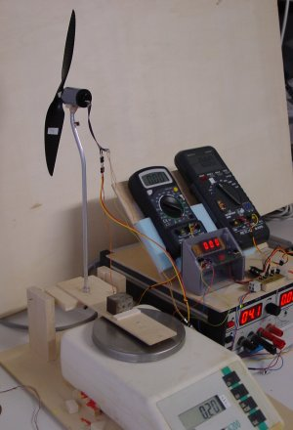
 | Fig. 9 Test set-up

Please note that all the measures in this paper are static. This is acceptable since we are interested in very slow flyers, and the experiment in a wind tunnel has shown that the characteristics were not changing significantly (less than 10%) between static tests and measures at 1.5 m/s. The pitch has to be increased if the propeller is moving in the air, but we do not believe the characteristics are significantly changed in a normal operating range.

7. Commercial propellers test

We measured several commercial propellers, pictured on figure10. Comparing the thrust vs RPM is not the best view of the propeller, since it does not take care of the torque, or of the fineness. A propeller with a wide blade and high pitch (but not too high) will always give the best thrust for a given RPM.
1 GWS orange 204mm 4.2g  2 WES black 203mm 3g  3 Lowcost red 176mm 5.5 g  4 WES black 160mm 1.6g  5 Kyosho black 155mm 3.7g  6 Rubber white 150mm 0.87g  7 Lowcost red 134mm 2.2g  8 Girosaucer white 133mm 0.7g  9 Toy plane white 130mm 2.7g  10 Todds blue 115mm 1.39g  11 Toddsblue 115mm 1.03g  (sanded by Larry Park) | 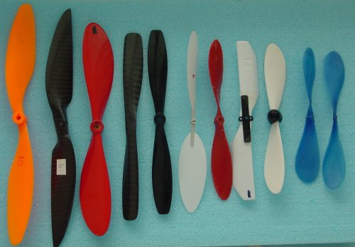
 | Fig .10 Commercial propellers
This is confirmed in the plot of figure 11, that gives the thrust vs rotation speed.  The 176 mm prop has wide blade, but uses the same power as the larger GWS .  The 150mm rubber model prop has a high pitch, and hence must be more efficient if the prop is moving at 2m/s. Measures at 3000 RPM was not valid for that too flexible propeller.  The 133mm Girosaucer blades have a simple not twisted shape and are surprisingly bad.  We do not give all the plots for these props; we will come back with more data later. | 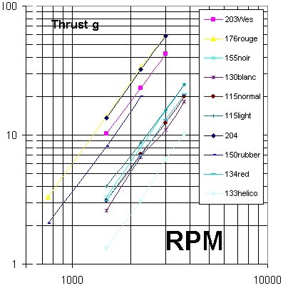
 | f 11 Commercial props: thrust vs RPM

8.Balsa propellers  We measured 80 to 240 mm diameter propellers, built with balsa blades linked with a Didel PC10 connector.  The fineness of these ultralight props is comparable to the commercial heavier props, but the maximum thrust is sometimes limited to 20 grams, depending on the thickness and density of the balsa. At high speed, the blade is deformed, and the thrust does not increase. | 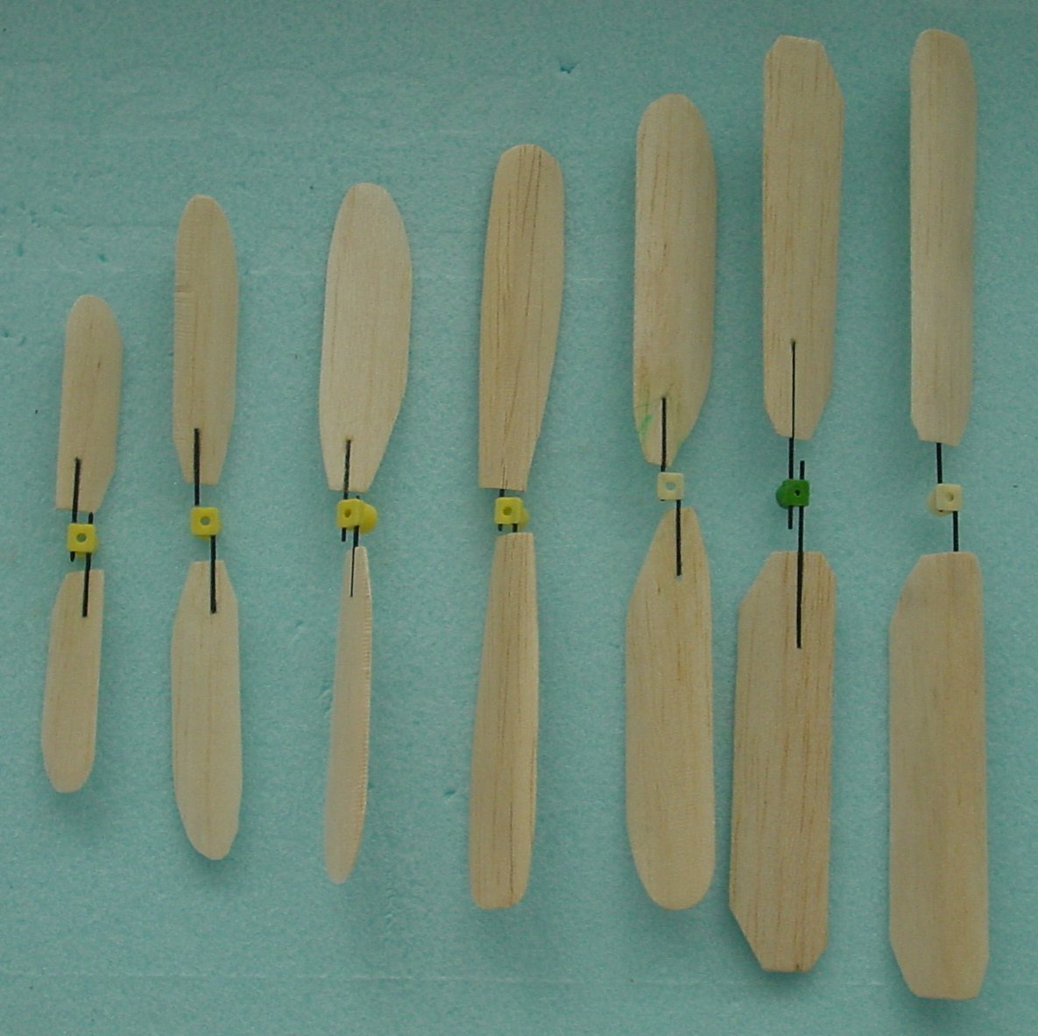  Fig. 12 Balsa props

The blades have differences in profile curvature and blade twist, but it is difficult to extract a preferred design.  The plot includes two carbon foil blades (G062 and G052) made by a friend as lighter copies of the WES160 (+73 of the weight), but apparently too flexible.  Comparing figure 11 and figure 13 is not easy. A new plot will be introduced later. | 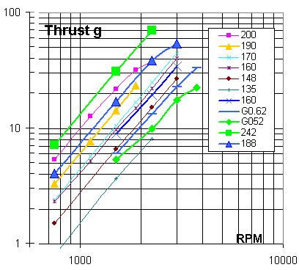  Fig. 13 Balsa props: thrust vs RPM

9. Shape influence

To check the influence of the propeller design, a series of 160 mm propellers have been built (figure 14).

The plot of figure 15 shows important differences. Propeller “a” is narrow and rather flat; it was tested with two different angles: 25 and 30 degrees, showing the importance of the pitch. Propeller “b” has a very curved profile; this miean higher thrust and drag. “h” and “i” are similar, except close to the center; a wide area there seems to be better, but it is frequently incompatible with the gearbox. The pitch of prop “c” is probably too high. The one of prop “e” is clearly too low. | 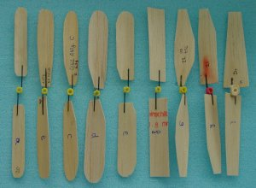  Fig. 14 160mm balsa props labeled a to i
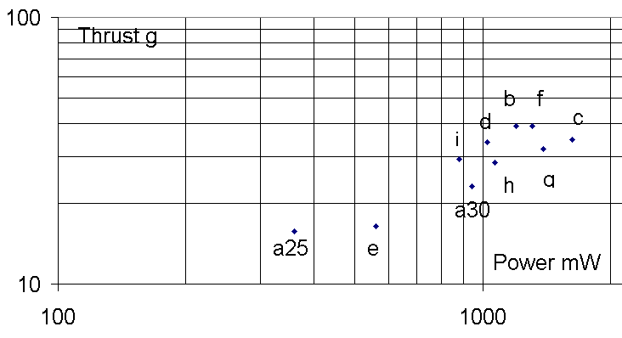
Fig. 15 Thrust versus power for 160 mm props

10. Multiblade props and symetrical props  A 4-blade 150 mm propeller has been build (figure 16) and compared with a similar two-blade prop. The thrust at 3000 RPM is 47g versus 25g, but the power is 3 W instead of 1.3, so the efficiency is much lower.  For blimps, symetrical props are required. Our tests show that a symetrical prop has about 70% of the thrust of a curved propeller. A curved propeller used backward has about 50% of the forward trust, with increased torque. | 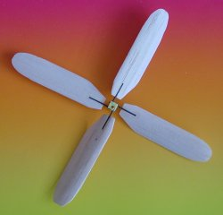  Fig. 16 4-blade balsa prop

11. Pitch influence

A 135 mm balsa prop has been tested at varied pitches. The blades are not strongly twisted (30 degrees at 20mm, 27 degrees at 40 mm, 22 degrees at 60mm) and this explains there good performance over a large angle range.

As expected, for a given rotational speed, the thrust increases with the angle (up to 27 degrees), but the fineness decreases by a factor of two between 17 and 37 degrees at 40mm distance from the axis.

We measured the motor current, which is proportional to the torque. The ratio between the thrust and the current is hence proportional to the fineness, and gives a good idea of the propeller quality. But remember that as for gliders, minimum fineness is not maximum lift. As expected, the fineness decreases with the pitch. The curve of figure 19 is a S, and the central region is surprisingly linear.
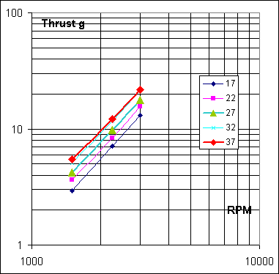 | 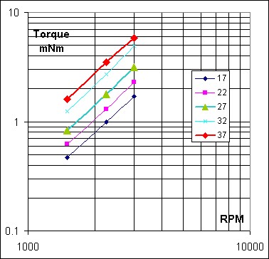 |  | 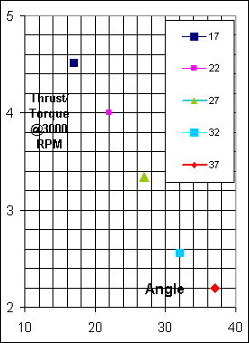
Fig. 17 Thrust does not increase between 32 and 37 degrees. | Fig. 18 Torque, that is power, regularily increases with pitch. | Fig. 19 Thrust/Torque  ratio vs angle.

12. Survey
The thrust/current T/I ratio, proportional to the fineness, seems to be a good way to compare propeller efficiency. See figure19 of the previous tests. “Comm” represents several commercial props of figure 10, between 115 and 200 mm.  “Balsa” plots several balsa prop of figure 12, between 145 and 230 mm.  “160 mm” plots several 160 mm dia of figure 13. “135 mm” plots the effect of pitch. One can deduce that commercial props are better than our balsa props, which is not surprising, but adjusting the pitch of a balsa prop makes it as good as the best commercial prop, with much less weight. | 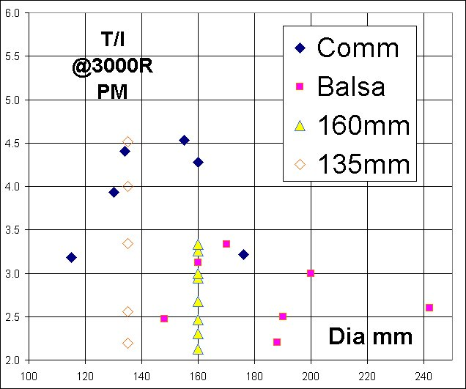  Fig. 20 T/I ratio for several props tested earlier

13. Documented results

With Excel, it always takes time until you have found a good overall representation of data and plots. We made a set of new measures on representative props, the data can be found on www.didel.com/slow/propellers/PropStudy.xls.  Figure 21 plots the thrust/dia coefficient at 3000RPM. Since the thrust is proportional to the square of the RPM, it is easy to get an idea of the thrust of a good propeller for a given speed. For instance, a 100 mm dia at 6000 RPM will give 4 * 7g = 28 grams.  What will be important when matching the propeller to a motor is the torque vs RPM (figure 22). It is not well verified that the torque is proportionnal to the power 5 of the diameter, probably because of geometric and | 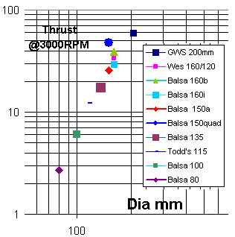  Fig. 21 Thrust vs prop diameter

aerodynamic changes. As plotted in PropStudy.xls, the fineness changes by a factor of 3 between 100 and 200 mm in prop diameter.  We can define a torque constant from that plot, corresponding to the torque at 1000 RPM, that is a value 9 time smaller that the one measured at 3000 RPM. For a 100 mm propeller, the torque constant is equal to 0.12 (table 1). If the rotation speed is 3 k RPM, the torque is 3*3*0.12 = 1.1, as one can read it on the plot. | 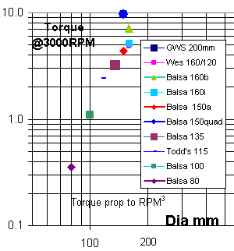  Fig. 22 Torque vs prop diameter

Figure 23 allows to estimate the mechanical power, which is proportionnal to the cube of the RPM (formula 3). The electrical power is much higher, and as it will be shown later, the thrust is at a maximum when the electrical power is about 3-4 times the mechanical power (25% to 30% efficiency). | 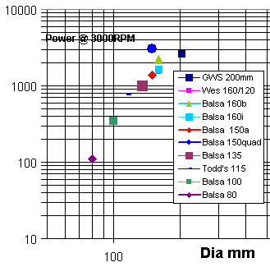  Fig. 23 Power vs prop diameter

14. Propeller formulas

From the previous data (PropStudy.xls), one can deduce the following formulas, that give the thrust of a propeller when its rotation speed is known. The coefficients correspond to a good propeller with a well adapted pitch. It is possible to find better propellers, and as mentioned above, it is possible to get more thrust with lower efficiency (higher torque and power).
We built only one 4-blade propeller; it is hence dangerous to extrapolate for 4-blades and 3-blades of different diameters, but the figures we propose sounds coherent: the thust has a lower proportionnality factor, but the torque a higher factor.
.
Diameter | 2 blades |  |  | 3 and 4 blades
Diameter | Thrust  g | Torque mNm | Power  mW | Thrust  g | Torque mNm | Power  mW
100 | 0.7 * N² | 0.12 * N² | 13 * N³ | 3 blades (estimation)  Multiply 2 blades by
120 | 1.4 * N² | 0.26 * N² | 27 * N³
140 | 2.3 * N² | 0.41 * N² | 42 * N³ | 1.4 | 1.7 | 1.23
160 | 3.5 * N² | 0.58 * N² | 58 * N³ | 4 blades (extrapolation)  Multiply 2 blades by
180 | 4.8 * N² | 0.73 * N² | 75 * N³
200 | 6.3 * N² | 0.88 * N² | 93 * N³ | 1.7 | 2.2 | 1.45
Table 1 Propeller formulas. N is the rotation speed in kilo revolution per minutes

15. Motor specifications

DC motors have good linear characteristics: the torque decreases with the rotationnal speed (see www.didel.com/microkit/moteurs/Motors.html).
The important parameters, easy to measure, are the no-load current Io, the no-load rotation speed No, the stall current Is and the stall torque Ms. The coil resistance R and the torque constant k result from these measures. The power and efficiency depends a lot on the voltage and the load (that is the propeller size).

As shown on figure 24, the maximum power is reached for half of the no load speed, which is also half of the stall current. If a propeller is too small, the motor will spin fast and since the thrust depends on the power 5 of the diameter, the thrust decreases quickly. If the propeller is too large, the motor torque is high, that is also the current and the ohmic losses.  The thrust decreases slowly when the prop diameter increases, but the electrical power and the motor temperature | 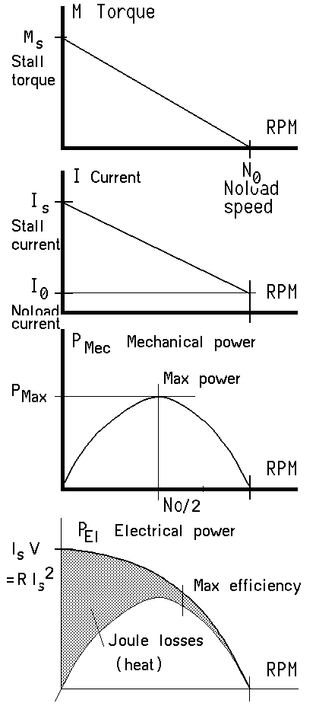 | 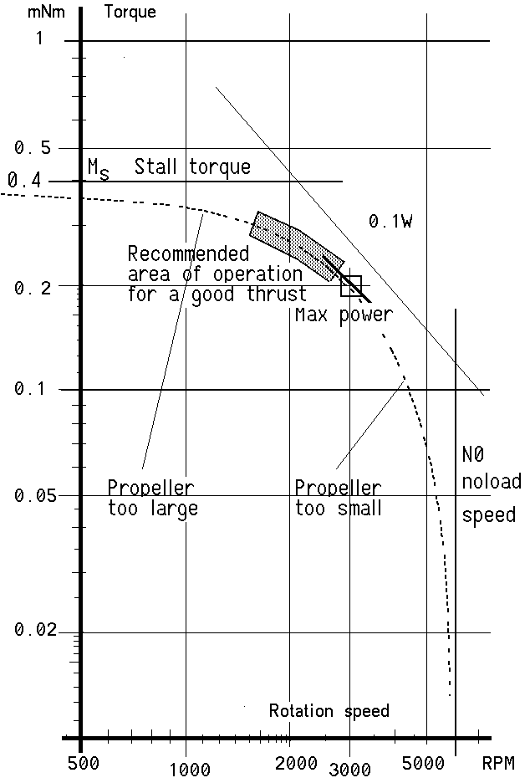
 | Fig. 24 Torque, useful power and electrical power vs RPM
increases rapidly. This will be measured in section 17.

We are concerned here only with very slow ultralight flyers, and the only solution in 2003 is to use a Li-Poly accumulator cell providing a 3.5 V average voltage during flight.

Figure 24 documents the motor torque vs RPM for an hypothetical motor. The log-log plot is unusual for motors, but as seen before, it is the only way to understand the propeller features, hence the propeller-motor best match. The domain of operation of a motor loaded by a propeller is marked with a wide area. If the propeller is too large, the motor give its maximum torque and heats up. If the propeller is too small, the torque is low and the rotation speed high, which is inefficient. This will be confirmed by the measures of figure 29.

16. Gearbox efficiency  A gearbox is always used to reduce the speed, increase the torque and be compatible with larger more efficient propeller.  We measure the torque constant k from a simple set-up (figure 25) giving the Ms stall torque and the Is stall current. A 20mm lever is attached to the motor or gearbox shaft. Measures are made with a cold motor. | 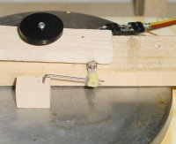  Fig. 25 Experimental set-up
After 10 seconds, the current (and the torque) decreases by 10-20%, which may be closer to the flight conditions, but is too difficult to reproduce.

When a gearbox is used, the torque constant is multiplied by the gear ratio, with some deduction due to the friction of the gearbox.

We measured two 6mm motors (Mk06L-10 and Mk06L-30) inside a set of Didel module 0.3 gearboxes. The result (figure 26) shows that well adjusted boxes have a good efficiency. At 100% efficiency, the slope is –1, as for the 0.1 and 0.5W power lines.  Clearly, the 4R16 has some friction, but the measurement errors, specially with the lower torque of the MK06-30 explain the non-linearities. | 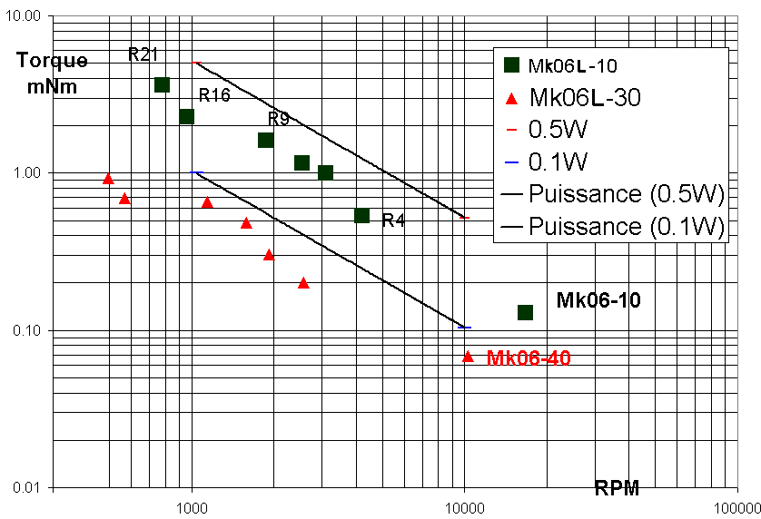  Fig. 26 Torque vs RPM for two geared motors

17. Motor measures

Comparing motors is difficult. Slow flyers motors are overvolted to get more thrust, at the expense of efficiency and life time. It is not possible to adjust the voltage and define the operating region according optimum criteria. The choice of motors is very limited, and for a given size, we are lucky if we can select between two coil resistances, and get a better match of the power and lifetime.

We tested Didel motors at 3.5V only. A set of measures were done one year ago at different voltages and the results can still be found on the Didel web site.
This means that the 10 Ohm motors, specified for 1.2V give more power than the 24-40 Ohm motors, specified for 2.4V. A low resistance motor will quickly heat, which results in poor efficiency and short life. All our measures were made with cold motors. At 70 degrees, the coil resistance has increased by 20%.

The parameters we measured are the stall torque Ms and the stall current Is, which depends strongly on the coil resistance. The torque constant k is the ratio of these two values, and is better if the magnets are high quality, the coil perfect, and the play between coil and magnet minimum. Dividing k by the square root of the resistance is the quality factor Qm that characterize the efficiency of the magnetic field of a motor.
The no-load speed No and no-load current Io are related to the friction of brushes and bearings. The no-load current is an easy way to measure the efficiency of a gearbox. An increase of 10-20% is normal, but if there is some friction, the no load current will increase significantly. It is frequently the case after excessive heating. Above 120-150 Celsius, NeFeB magnes loose their magnetization, that is the k-factor decreases drastically.

The measures and several plots can be found on Didel site: www.didel.com/microkit/moteurs/mesures/MkAllMotors.xls
Table 2 give the main characteristics of several motors (measured on a single unit). The k and Qm factor are difficult to analyse. The torque “M” at maximum power (half of the stall current) and the rotation speed “N” are the important data that can be used for matching propellers. The power (mechanical power) may be with the weight, a rough selection criteria, since the power is related to the thrust. The electrical power is about the triple, that is efficiency is in the 30% range, at max power, lass at max thrust (section 18).

Motor | R  Ohm | Weight  g | k  mNm/A | Qm | M  mNm | N  RPM | Pmec  mW | Pel  mW
Mk04S-10 | 12.1 | 0.46 | 0.2 | 0.09 | 0.04 | 36450 | 134 | 507.5
Mk04-10 | 14.6 | 0.66 | 0.4 | 0.13 | 0.05 | 28350 | 149 | 420
Mk04L-10 | 14.9 | 0.79 | 0.4 | 0.12 | 0.04 | 27000 | 121 | 411.25
Mk04S-24 | 32.1 | 0.46 | 0.4 | 0.11 | 0.02 | 22950 | 58 | 190.75
Mk04-40 | 43.2 | 0.66 | 0.6 | 0.12 | 0.03 | 17550 | 46 | 141.75
Mk04L-40 | 43.8 | 0.79 | 0.5 | 0.10 | 0.02 | 19170 | 43 | 140
Mk06S-10 | 12.5 | 1.18 | 0.6 | 0.19 | 0.09 | 21060 | 191 | 490
Mk06-10 | 12.1 | 1.32 | 0.6 | 0.19 | 0.09 | 19710 | 183 | 507.5
Mk06L-10 | 11.3 | 1.63 | 0.9 | 0.30 | 0.14 | 17550 | 261 | 542.5
Mk06S-35 | 34.3 | 1.18 | 0.9 | 0.20 | 0.05 | 12960 | 64 | 178.5
MK06-24 | 28.9 | 1.32 | 0.9 | 0.20 | 0.06 | 13770 | 80 | 211.75
Mk06-35 | 35.4 | 1.32 | 1.0 | 0.19 | 0.05 | 13500 | 66 | 173.25
Mk06L-35 | 38.0 | 1.63 | 1.2 | 0.24 | 0.06 | 14580 | 87 | 161
Mk07-10 | 10.3 | 2.78 | 1.1 | 0.40 | 0.18 | 12420 | 238 | 595
Minimot.0615-1,5S | 5.0 | 2.03 | 0.77 | 0.35 | 0.25 | 18900 | 1225 | 1225
Port.08GS107.1 | 13.0 | 3.88 | 1.98 | 0.55 | 0.26 | 13500 | 472.5 | 472.5
M20VA-8Z130 | 5.9 | 3.9 | 1.30 | 0.53 | 0.35 | 9300 | 1032.5 | 1032.5
Table 2 Main characteristics of several motors

The excel file includes also the data for the the 0615 (from Minimotor), which appear to be very good because it is overvolted (figure 27). The Portescap 08GS (from Delta Line) should work at 5V and the Mabuchi M20VA-8Z130 (10mm) is well adapted for 30g planes. | 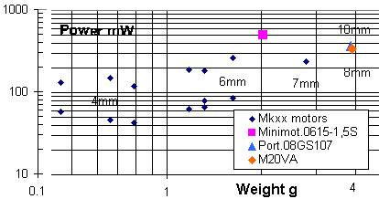  Fig. 27 Power vs weight

18. Gearbox ratio influence on thrust

Let us take a motor, the Mk06L-10 of figure 25, a 6R9 Didel gearbox and the balsa propellers of figure 12. What is the best gear ratio, and is it critical? As shown on figure28 and 29, the thrust does not change as much as expected between 135 and 190mm. Torque values are on the motor curve (see figure 23).

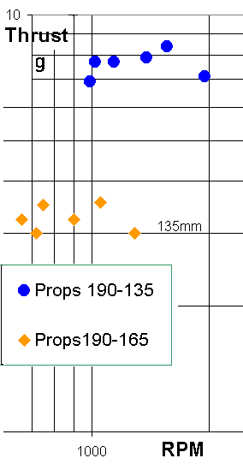 | 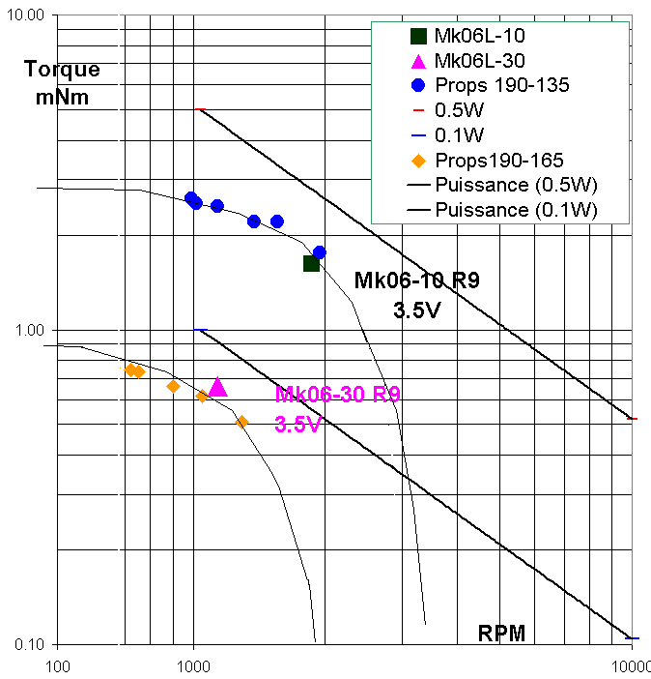

Fig. 28 Thrust and torque for different props on same motor/gearbox

19. Prop diameter influence on thrust

It is surprising to see that the thrust is not more sensitive to prop diameter. The reason is the motor torque is mostly responsible for the thrust, but the efficiency is much lower for a large propeller. On figure 28, the “good” zone is however larger than what it should be: the 135mm and 190 mm diameter props are better than the 160mm inbetween, as seen earlier. Note that the 900 mm propeller data has been estimated.

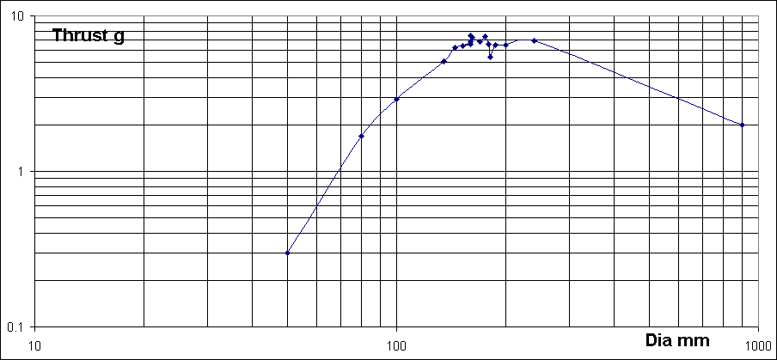
Fig. 29 Thrust for 16 balsa propellers on a Mk04-10 R9

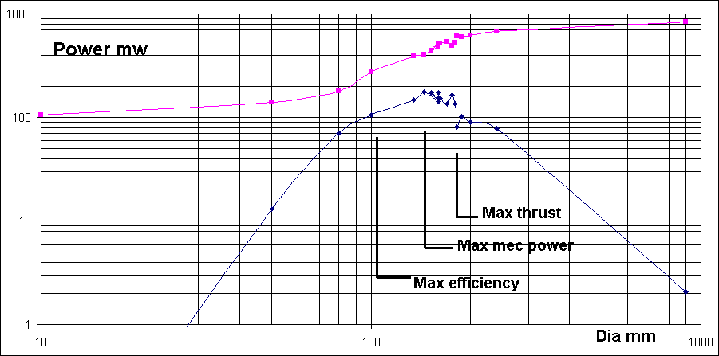
Fig. 30 Power vs diameter for 16 balsa propellers on a Mk04-10 R9

20. Practical results

Several motors have been mesured with several gear ratio and propellers, enough to get a good estimation of the thrust over a wide range of gear ratio and prop diameter. We have limited our study to 4 to 7mm motors, compatible with the 45 and 150 mAh Li-Poly batteries. We do not document the shorter and longer versions of the 4mm and 6mm motors. Table 2 can be used for doing some proportional correction. We do not document motors of a resistance lower than 10 Ohm. They are clearly more powerful at 3.5V than the 6mm motors we document, but the lifetime is questionable, and it is difficult to do precise measures at 3.5V because the motor temperature changes significantly during a set of measures. We do not document either motors of 30 ohm resistance. The thrust they give at 3.5V implies a careful construction, but they are essential when flight duration is an important parameter.

Figures 31 and 32 give the propeller diameter and the thrust vs gear ratio for the Mk04S10, Mk04-10, MK06-10 and Mk07-10. The values on the charts are the result of a large number of differant measures on a fair variety of balsa propellers, not all of them ideally shaped. The diameter must be taken as a maximum value, that indeed give a maximum thrust, but at low efficiency. The thrust depends on the pitch and aerodynamic quality. The documented thrust value is close to the maximum one can get, without loosing too much in efficiency.

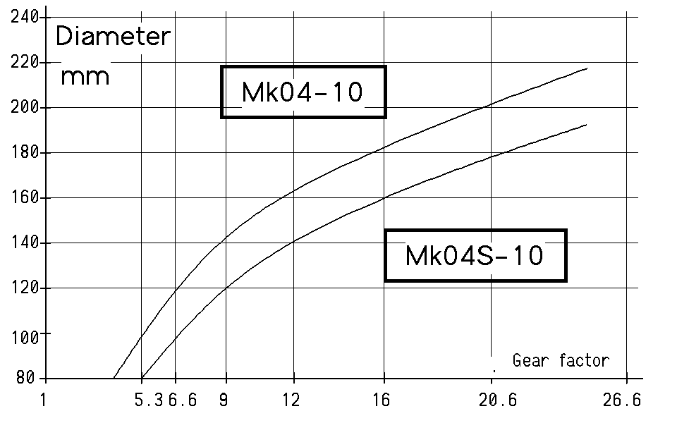 | 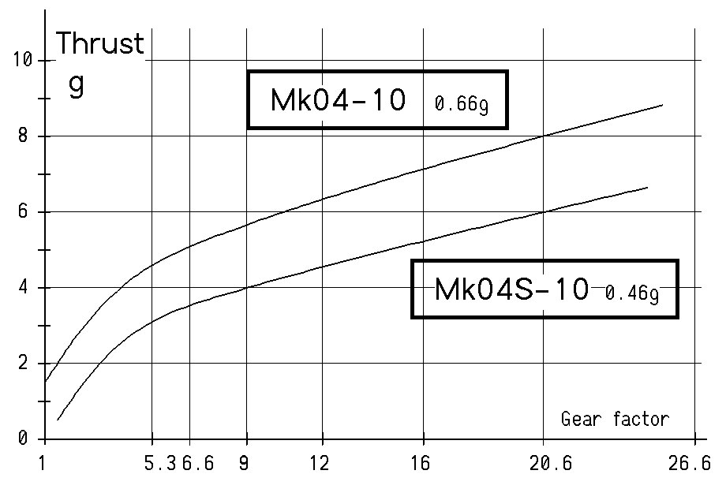

Fig. 31 Best results for a Mk04-10 and Mk04S-10

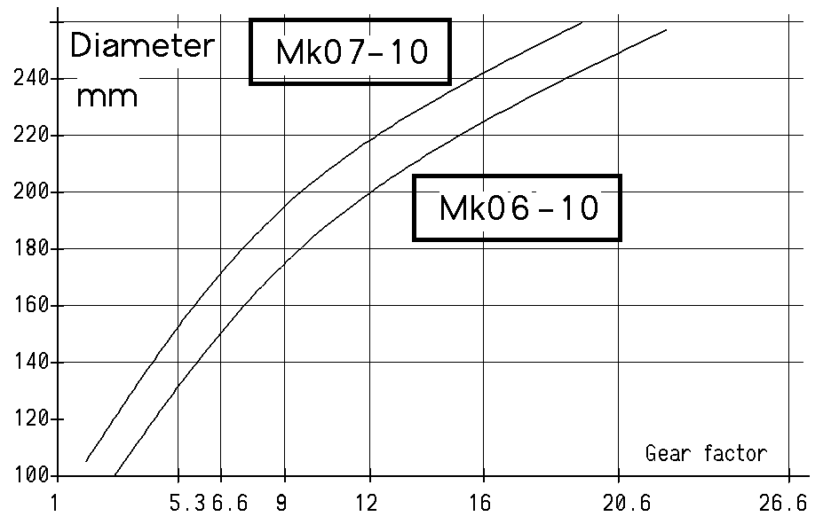 | 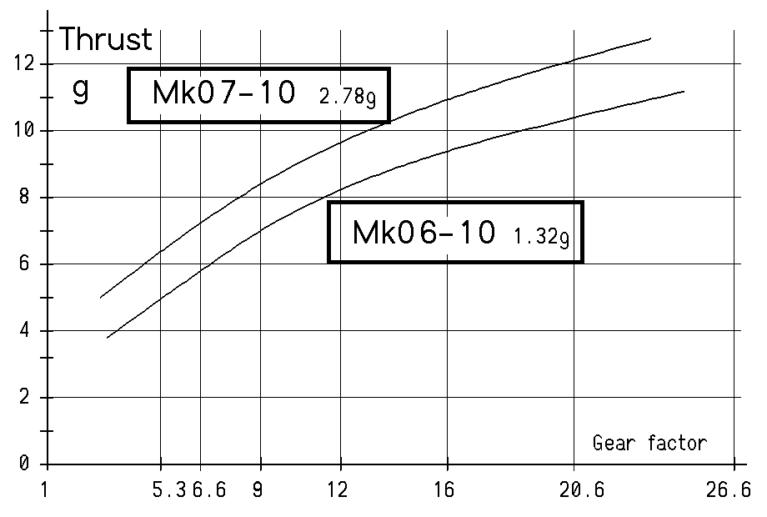
Fig. 32 Best results for a Mk06-10 and Mk07-10

The log-log plot gives the same information in a more compact way, and makes it more easy to guess the values for other motors. It includes the M20VA data, close to the Portescap and Minimotor, which just have a better efficiency. | 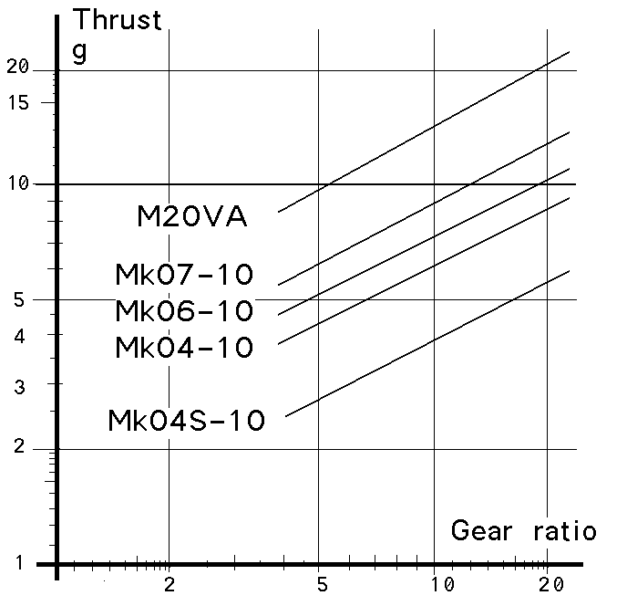

Fig. 33 Thrust vs gear factor on a log-log plot

21. Conclusion

Coreless pager motors are low power compared to the 10 and 12 mm core motors. They are also low thrust, and an important gear factor is required. The 4mm motors are surprisingly good and quite suitable for 8-15 grams models.

References

[1] Barlow, Rae, Pope, “Low-speed Wind Tunnel Testing”, Wiley 1999, 713 p

[2] Pope, Harper, “Low-speed Wind Tunnel Testing, Wiley 1966, 457p

[3] JD Nicoud, JC Zufferey, “Toward Indoor Flying Robots”, IROS 2002, pp

22.06.03/jdn 20.6.03/us

