b CH-1092 Belmont, Switzerland  Tel +41 21 728-6156, Fax 728-6157  Email info@didel.com, www.didel.com | 
File www.didel.com/slow/mirted/Wiring.doc

MIR wiring with ultralight connectors

Content
MIR circuits are delivered with the following accessories:
1 TSOP 1838 IR receiver
5 female connectors
80mm CuBe 0.34mm wire for male connectors
5cm thermo-solderablewire, triple: Gnd green, +V red, signal blue
10cm wire, double: option for lenghtening motor propeller wires
1 bicolor LED
Note: thermo-soldarable wire has an insulation that melts at 400 degrees. An adjustable hot soldering iron is required.

Initial check
We propose to put male connectors where the Birds and the propeller will be connected to. Use your own wire to connect to the battery the way you prefer (Bahoma system or JST connector and on/off switch).
Sand the IR receiver if you are very sensitive to weight. Sanding the sides and back will make the metal shielding appear. Continue sanding at your own risks. 0.22 grams with minimum of wire is still reasonable.
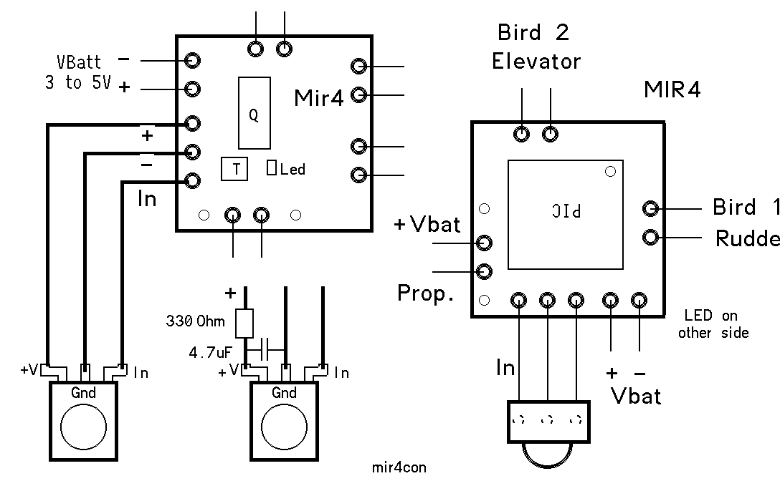
Solder the IR receiver using the colored wires in the good place. If you use a voltage booster, or if the motor is electrically noisy, it may be necessary to add a filter (4.7uf/330 Ohm) next to the TSOP1838.
Power the circuit. If the LED is not immediately bright, disconnect and check the wiring.
Switch the TED on. The led must start blinking, showing a correct IR signal is received.
Insert the bicolor LED on one of the Bird or propeller connectors and check that you can control the light intensity with the corresponding TED’s potentiometer.

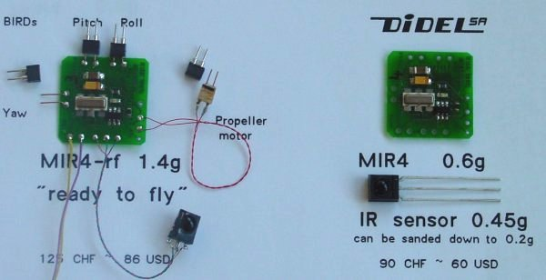

Connectors
The solution proposed by DIDEL has an excellent price/weight/flexibility ratio. Rather standard low cost connectors are used for the female connector, and very light pins are cut out of 0.34mm CuSn (Copper-Berillium) wire and maintained by balsa strips.

Female connectors are cut out shrink 64-pin sockets with a pitch of 1.78mm. See www.didel.com/slow/wiring/Plugs.doc for details.

A male connector strip is prepared by inserting 8 mm rods of 0.30 to 0.34mm CuSn in an female connector strip. Two balsa strips 1mm thick, medium to hard grade, are glued on each side of the rods and hard pressed for a total thickness of less than 1mm. One can use white glue, but the wire do not stick very well inside the balsa. Supepathic glue may be better. Do not use CA, the glue will climb by capillarity on the wire and the female connector will be permanently glued to the male you build. See www.didel.com/slow/wiring/Plugs.doc for construction details.

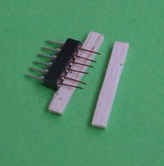 | 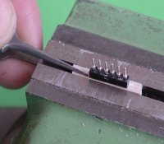 | 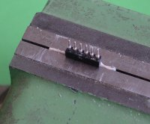

030202/jdn

