CH-1092 Belmont, Switzerland  Tel +41 21 728-6156, Fax 728-6157  Email info@didel.com, www.didel.com | 
File www.didel.com/slow/mirted/TedRa.doc

TEDRA – RC radio to IR converter

A lot of modelists have old radios lying around unused, put them to use….

TedRa is built on the PC board of the TED3 handle. But it connects to any radio and uses its joysticks. The software decodes the PPM signal of the radio transmitter before radio frequency modulation ( see for instance http://webpages.charter.net/rcfu/HelpsHints/RadioOps.html ).
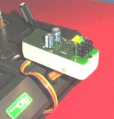
The shape of this signal is given below. The level must be 0 to 0.5V for the zero level, 3 to 5V for the one level. The width of the pulses is not critical. TedRa software adapts to positive or negative pulses. The space between pulses (positive edge) correspond to the pulse duration sent to the servos. Timing is converted to match the MIR IR protocol that uses longer pulses and pulse spacing for increased reliability.
The PPM standard specify 1 to 2ms pulses. After measuring several radios, we noticed that even with the trim, the range was narrower. We hence convert below 1.1 ms space to 0% and above 1.9 ms 100% of the Didel IR standard. 1.5 ms is 50%. The IR protocol and timing is of course the same as for TED3, compatible with the MIR receivers.

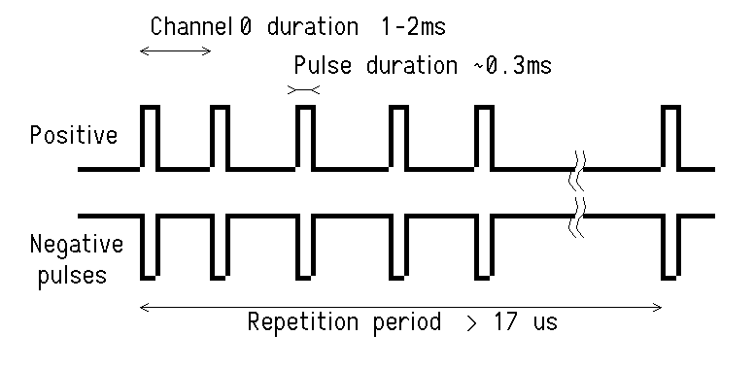 | 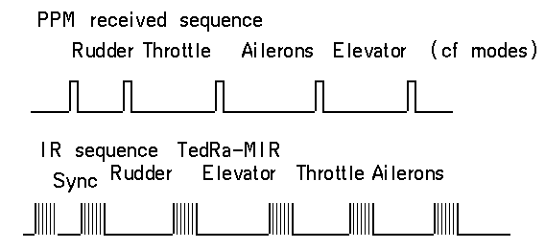

The DIDEL TedRa connector is an AMP-Micromatch 4-pin connector  Pin1 (brown) Ground  Pin 2 (red) Not connected  Pin 3 (orange) Signal (0 to 5V)  Pin 4 (yellow) Radio power supply (8.4 to 12 Volts) | 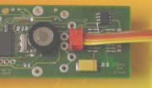
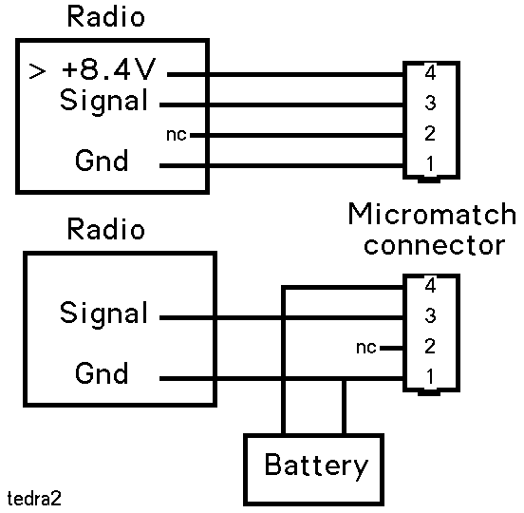
The TedRa four wire cable are either connected to adequate points inside the radio, or to the trainer plug frequently provided.

An oscilloscope is required to find where this signal is availabe, if the documentation is not complete enough. On some high grade computer radios, the HF part is a plug- in module, to be more easily compatible with the frequencies authorized in different countries. The signal can be picked up on that connector. The power supply should be at Volts to power the IR diodes.

If the signal is highir than 5V, a resistor bridge is required to bring the voltage down to 3-5V, see the Graupner 4014 doc.

An external battery can be used, as shown in the diagram.

TedRa measure the voltage, and will sound an alarm if the voltage is below 8V. A Led blinks when in operation.
The radio functionnality is not modified by the cable going to TedRa. It is recommended to remove the antenna when TedRa is connected to avoid disturbing some other radio users.

Channel assigment

Radios have different modes and it is not always possible to program the radio in order to have a given command on a given channel. The IR protocol used between Ted, TedRa and the different MIR is always the same, but one need to understand that there are two logical functions: Birds which receive positive and negative PWM pulses, and propeller motors that have only positive PWM pulses. See MIR documentation for details http://www.didel.com/slow/mirted/Mir.doc  Bird1 is assigned to Rudder, Bird2 to Elevator, Bird3 to Ailerons, but these assigmenents are up to you when you wire MIR outputs.  But the propeller motor amplifier is connected to a fixed IR channel, and it has to be assigned by TedRa software on the radio channel that corresponds to your preferred joystick.  TedRa can be strapped for 8 possible assignements, 6 of them being defined now, since we do not know yet all the possible radio modes. We can easily program any assignement.  Strapping is made by moving jumpers, as shown next. At power-up TedRa sends 1 to 8 high frequency bips, according to the mode. Then there are 1 to 8 lower frequency bips depending on the voltage (or a siren if the voltage is too low).  One more jumper (next to the buzzer) must be placed to mix Bird1 and Bird2 channels to control a V-Tail, when that function is not possible on the radio. | 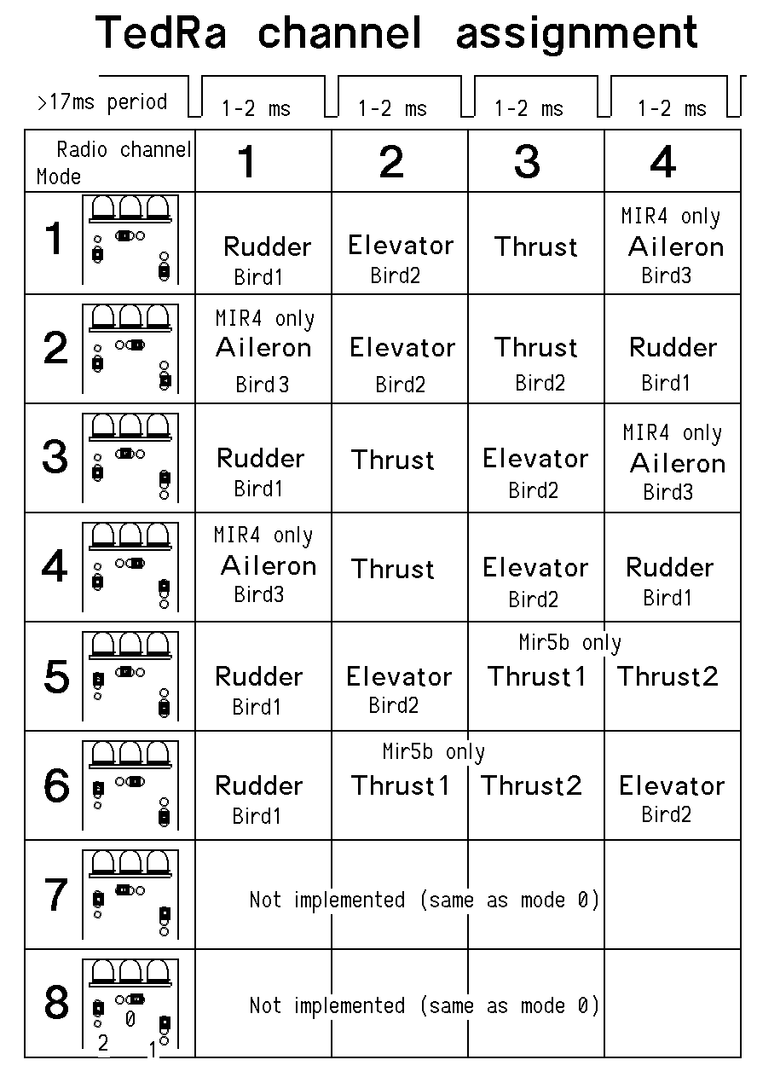

TedRa power-up and operation

At power-up, the software measures the battery voltage. If below 8 Volts at power-up, a siren sounds for 1 second. If above 8V, there are up to 8 bips depending on the amount of voltage above 8 Volts (not calibrated).

During operation, if the voltage is going below 8 Volts, there is a warning every 5 seconds. The IR transmission continues (with less power) until the battery is dead.

At power-up, the mode is defined from the straps. TedRa sends first a set of high pitch bips corresponding to the mode.

To install TedRa, one need at least a voltmeter to check that pin 1 and 4 get a valid voltage, between 8 and 11 Volts. See below examples for several radios.

An oscilloscope is required to check the output voltage. It will also make you sure that the radio is sending a valid signal. When TedRa is powered and receive a valid signal, it blinks the Led. If the Led is either continuously on or off, this means TedRa does not recognize a valid signal.

Connection to radios

We rely on our customers to send us a picture and short description of their modifications, and we will add them to the list below.

Multiplex Europa Sprint

The Multiplex Europa sprint is easy to adapt, since a DIN 5 pin connector is provided on the top of the box.
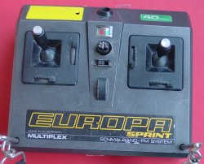 | 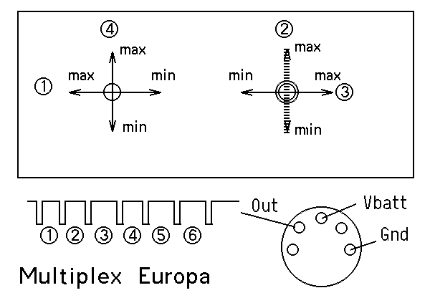

The three signals for the TedRa can be taken from the DIN connector:
DIN pin 3 toward Micromatch pin 1 (Gnd, brown wire)
DIN pin 2 toward Micromatch pin 4 (Vbatt, yellow wire)
DIN pin 4 toward Micromatch pin 3 (Signal, orange wire)

Multiplex Commander 2010

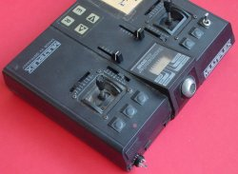 | 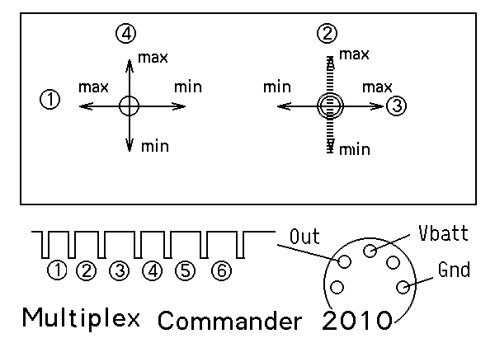

The three signals for the TedRa can be taken from the DIN connector:
DIN pin 3 toward Micromatch pin 1 (Gnd, brown wire)
DIN pin 2 toward Micromatch pin 4 (Vbatt, yellow wire)
DIN pin 4 toward Micromatch pin 3 (Signal, orange wire)

Robbe Starion

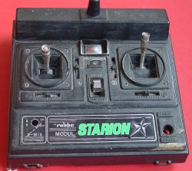 | 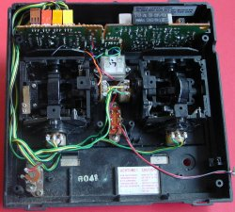

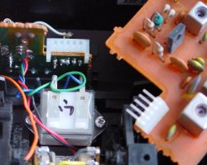 | 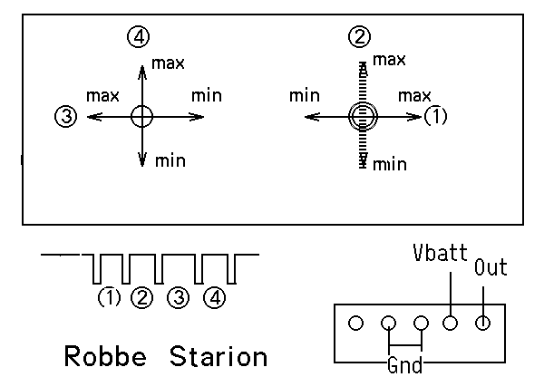

The Starion has a radio module on a separate bord. It is easy to remove that board and make a connector with a wire-wrap strip with the usual 2.54 mm pitch.

Robbe ProMars Rex

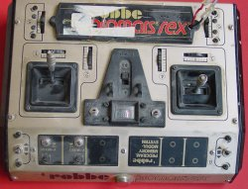 | 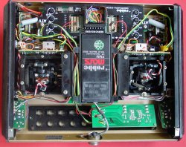

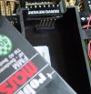 | 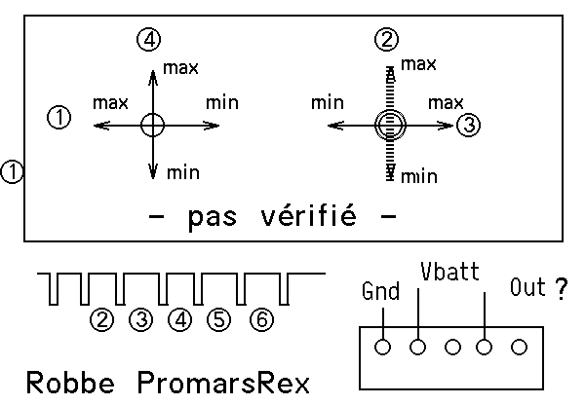
The Promars uses a radio module that can be easily removed. A connector can be inserted in place. We didn’t got any signal on the radio we tested, so we cannot guarantee our documentation.

Hitec Focus6

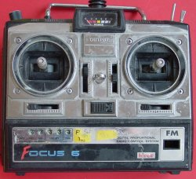 | 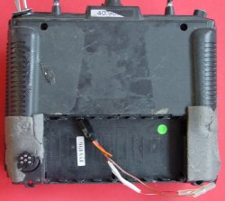

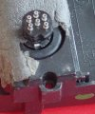 | 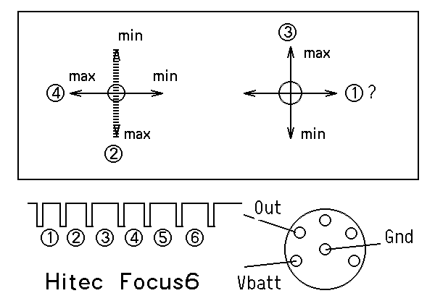
The three signals for the TedRa can be taken from the 6-pin DIN connector:
DIN pin 6 toward Micromatch pin 1 (Gnd, brown wire)
DIN pin 1 toward Micromatch pin 4 (Vbatt, yellow wire)
DIN pin 2 toward Micromatch pin 3 (Signal, orange wire)

Graupner 214

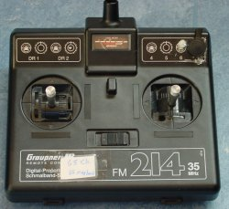 | 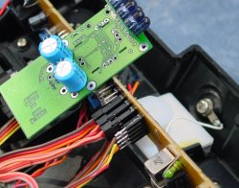
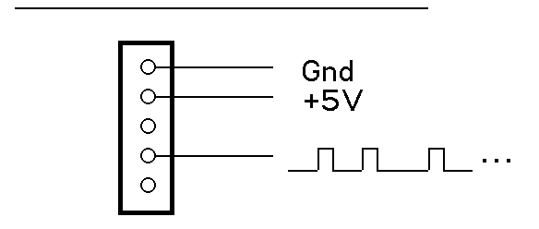

Graupner 4014

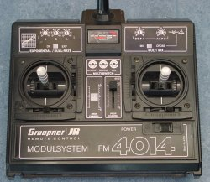 | 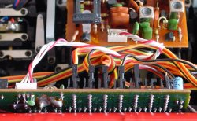

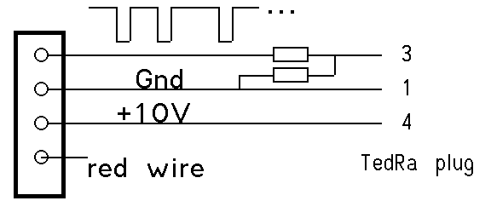 | The output is 0-10V. A resistor bridge (two 5 to 10 kOhm resistors) is required.

09.04.03/jdn 10.03.03/us

