CH-1092 Belmont, Switzerland  Tel +41 21 728-6156, Fax 728-6157  Email info@didel.com, www.didel.com | 
File www.didel.com/slow/mirted/Ted3.doc

TED3

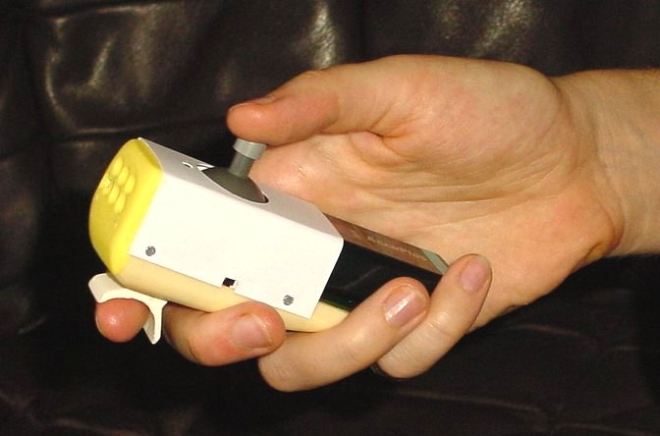
The TED3 handle weighs 100 grams and fits comfortably in the palm of the hand. It consists of a joystick for pitch and yaw control, and a lever for the throttle. In a large room, the LED array must point to the plane or the ground in front of the plane. Direct maximum distance is 6 to 10 meters. At home, reflexions allows it to point almost anywhere.

The TED has two modes of operation. The normal mode is for the usual control of a rudder and elevator. The Led is blinking fast in this mode (2 Hz).
When the joystick is depressed at power-up, the LED blinks slowly and the yaw (com0) and pitch (com1) are mixed to control the two ailerons of a V-Tail.

Ted3 power-up and operation
Insert a 9V battery or accumulator. Switch the power on.The processor will do the following tasks:
Tests if the switch on the joystick is depressed. In this case, the flag V-tail is memorized and later, the LED will do one blink at a low frequency, about every 2 seconds. Note that the switch is not so easy to get fully depressed. Listen to its click.
- Tests the voltage of the battery and plays several bips related to the voltage (not calibrated).. Five and more bips indicate a good battery (more than 8.5 volts). 9V batteries and 8.4V NiCd accumulators can be used. If the battery voltage is lower than 8V, a siren will be played. During operation, if the voltage is going below 8 Volts, there is a warning every 5 seconds. The IR transmission continues (with decreasing power) until the battery is dead.
- Reads the position of the joystick and the TED4 knob and uses that position as a center position until power down. This can permit some trim before the flight, but is is not very precise nor convenient: the displacement must be done in opposite direction, so the correction will occur when the lever returns in its no-force position.
- Starts sending the IR stream. If the joystick is not moved for 5 seconds, a small bip is given, so you will not forget to switch off TED when you have fineshed using it.

Comments for customers
A one-hand handle was our idea as part of the Celine concept, for a plane easy to carry with all its accessories in a small box. It is however expensive due to its hand-made case.
Molding the TED box in a traditional way is easy: it costs 20'000 dollars, takes 6 months and there are many subcontracters kneeded to do it. But the market of Ultra Light Slow flyers is very small and our choice was either to do nothing, or try to do something not quite up to our usuall high standard.
We clearly have, and in a next step,we will improve the construction to get a better looking TED handle. It will take us some time doing better molds and assembling fixtures. For the moment, encourage your friends to buy a TedRa, TED3 is too expensive to have manufactured for us. We will not stop the production, because TED is part of the Celine`s expensive kit, and we hope the market will hope to justify adequate investments.
Infrared has also distance limitations. IR circuits have an automatic sensitivity adjustment that has a 1-2 seconds response time, and seems to be sensitive to the frequency of some switched Neon tubes. We collaborate on the development of radio solutions, but our 0.3g weight limit for the HF part is not easy to match.
Anyway, your pleasure to fly will not depend on these problems. The handle is comfortable, you can change the stick if you prefer a longer one; it was the request of a customer to try if a longer arm would give more sensibility. All your comments will also be welcomed.

jdn/030303/17.3.03/us

