J.D. Nicoud, Mouette 5
CH-1092 Belmont, Switzerland
Tel ++41 21 728-6156, Fax ++41 21 728-6157
Email info@didel.com www.didel.com

www.didel.com/slow/mirted/Mip4.doc

Mim4 Mip4 - 4-channel miniature ESC circuit or IR receiver

Mim4 and Mip4 are 0.44g circuit that decodes the pulse stream from a radio receiver or an IR circuit and controls four bidirectionnal channel, 1Amp. A LED on the circuit blinks when a signal is received.
Mim4 decode the IR stream crated by a TED or TedRa IR transmitter. It replace the MIR3 MIR4 MIR5 family with better performances. The IR sensor adds 0.3 to 0.45g.
Mip4 suppose you can pick the signal at the output of the radio receiver, before the decoding for the generation of servo or combo signal. Nick Leicht has the lightest receiver
(0.3g), that allows for a less than 0.8g four channels combo.

Cost of Mim4 or Mip4 is 60 CHF, about 39 Euros or 48 USD.

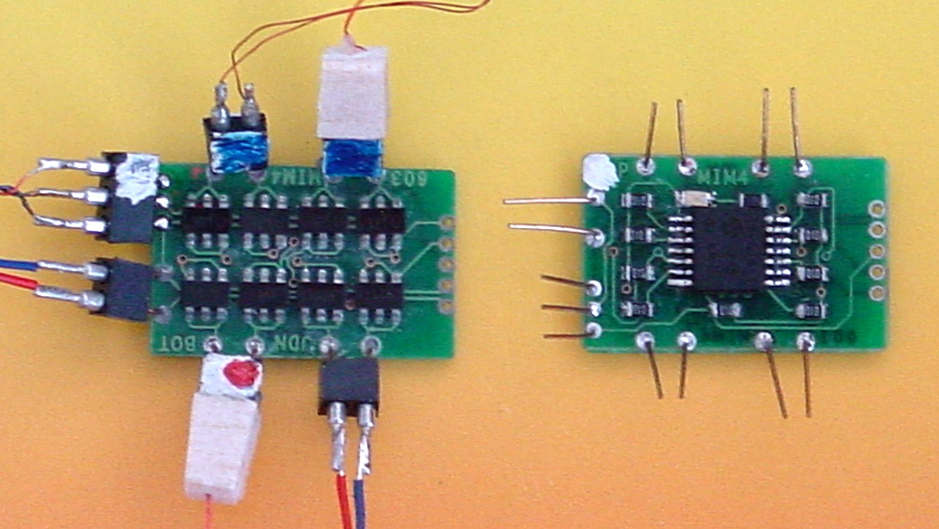
Picture of Mim4 or Mip4 (software is different)

Software options:  MIM41 MIP41 – Four bidirectionnal channels  MIM42 MIP42 – Two bidirectionnal channels and two unidirectionnal  channels | 