CH-1092 Belmont, Switzerland  Tel +41 21 728-6156, Fax 728-6157  Email info@didel.com, www.didel.com | 
File www.didel.com/slow/birds/Birds.doc

BIRDS: Micro- Mini- Nano- Pico-
A family of magnetic actuators for very slow flyers and micro-robotics

Obsolete – see the PolyBird www.didel.com/ir/PolyBIRD.pdf

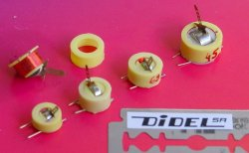
A BIRD (from Built In RuDder) is a magnetic actuator that is light enough to directly act upon the rudder, or be linked to it with a short lever.

The torque is proportional to the magnetic field of the NdFeB magnet (proportional to its mass), and to the magnetic field of the coil (proportional to the Amper-turns product). Ruijsink rule for the weight distribution in a magnetic actuator is 50% for the magnet, 35% for the coil, 15% for the case.

Similitude rules show that for the same coil size and weight, at the same voltage, the coil field, that is the torque, depends on the square of wire size and the power is related to power 4: if the wire is two times thinner, the torque is divided by 4 and the power by 16. Power influences battery discharging time. With a Li-Poly Kokam 145 mAh cell (max 400-500 mA load), a current budget could be propeller 200 mA, 2 birds 100-150 mA, radio 10-40 mA.

The larger the coil, the more torque for the same wire size; a twice as large coil will just use half the current and the power for the same torque. But if one doubles the size by doubling the diameter, with the same number of turns, (wire section increased by √2, the resistance is divided by 2, the torque and the power is multiplied by 2 (for a given voltage).
In order to increase the torque, it is the same to increase the weight of the coil or the weight of the magnet. Small magnets have a reduced efficiency, due to an higher friction on the axis, and a large magnet sets the minimum weight of the BIRD. Hence DIDEL proposes a family of actuators to fill user's need.

Name | Total weight  g | Holes distance  to shaft mm | Mag  size  mm | Mag  weight  g | Coil  res  Ohm | Coil  Wire dia  mm | Turns | Coil weight  g | Torque at 3.5V  gcm | Merit  factor 1  gcm/A | Merit  factor 2  (gcm/A)/g | Merit factor 3 (gcm/g)
Picobird | 0.32 | 2.5 3.5 4.5 | 3x2 | 0.09 | 70-75 | 0.05 | 500 | 0.16 | 0.35 | 7 | 22 | 1.1
Nanobird | 0.63 | 4 5 6 | 4.6x2 | 0.22 | 60-65 | 0.06 | 520 | 0.27 | 0.9 | 17 | 26 | 1.4
Microbird | 0.92 | 5 6 7 8 | 5.5x2 | 0.33 | 50-55 | 0.07 | 500 | 0.38 | 1.9 | 30 | 32 | 2.1
Minibird | 1.50 | 5 6 7 8 | 6x4 | 0.76 | 40-45 | 0.08 | 420 | 0.32 | 3.6 | 43 | 29 | 2.4

Merit factor 1 is equal to the torque divided by the currant. Merit factor 2 takes care of the weight; it is the most important factor for small Birds. Merit factor 3 divide the torque by the weight; it the factor we are interested in, if the power is not excessive.These factors depends on the size and construction. For the best efficiency, it is necessary to have the smallest possible coil surrounding the magnet, and the problem is to hinge the magnet in the center of the coil. DIDEL uses cylindrical magnets with a hole, diametral magnetization. This allows for a clean and efficient construction.

Coil size

Resistance and winding of the coil is important to optimize. Torque is proportional to the ampère-turn product N I. N is the number of turns, I the currant. Let us consider the NanoBird coil (coil 1).
Doubling the number of turns (coil 2) will double the current, double the weight coil, but reduce the current by half, for the same voltage. There is hence no increase in torque. Table below compare the merit factors.
Coil 3 is of the same weight, but uses a thinner wire, 0.05mm; the section is √2 smaller than the Nanobird 0.06mm wire, that is the number of turns is √2 larger and resistance is the double.
These three coils have to be compared when controlled by a low resistance bridge (MIR5), a 20 Ohm bridge (MIR3 with 6 port outputs in parallel) or a simple pair of PIC outputs as proposed on several products (140 Ohm). The difference is the voltage drop in the output drivers, that may reduce significantly the torque when the resistance is low.

Nanobird variants |  |  |  |  | 2 Ohm output amplifiers |  |  |  | 25 Ohm output amplifiers |  |  |  | 140 Ohm output amplifiers
 | N | Resis-  tance | Coil weight | Total  weight | I  @3V | Torque | Merit  1 | Merit  3 | I  @3V | Torque | Merit  1 | Merit  3 | I  @3V | Torqu e | Merit 1 | Merit 3
Coil 1 | 520 | 60 | 0.27 | 0.63 | 50 | 0.9 | 17 | 1.4 | 35 | 0.63 | 18 | 0.47 | 15 | 0.27 | 18 | 0.51
Coil 2 | 1040 | 120 | 0.54 | 0.90 | 25 | 0.9 | 34 | 1.0 | 21 | 0.66 | 30 | 0.41 | 11.5 | 0.29 | 23 | 0.23
Coil 3 | 720 | 120 | 0.27 | 0.63 | 25 | 0.62 | 24 | 1.0 | 21 | 0.52 | 25 | 0.52 | 11.5 | 0.29 | 25 | 0.36

What to conclude from that table? The amplifier internal resistance is an important parameter. A high resistance encourages a higher coil resistance, but it is not so important. For a given coil weight, the maximum torque is transmitted when the coil resistance is the same as the amplifier resistance. But it is not efficient to loose half of the power in the amplifier and have both the processor and the coil getting hot.
The merit factors 1 and 2 defined by Gordon Johnson in his RCMicroflight paper (February 2003) are good only to compare Birds of the same resistance. The merit factor 3 gives is the most representatibe, if the coil resistance is in an acceptable range

Angle of operation

The angle of operation is +/- 30 degrees. At 30 degrees, 80 % of the torque is available. For a direct control of a rudder, this angle seems to be the maximum aerodynamically acceptable, but if it is reached in flight, this means that the Bird may be too strong, and a lighter model could fit.

Central position

Add a magnet (or a less efficient piece of metal) if you need a the Bird to have a central position. The magnet is glued on the side of the Bird body, at a height that will define the equilibrium point. This of course will reduce the maximum torque you can get from the Bird.

Proportional control

Proportional control can be reached by two ways:
1) High frequency PWM given to the coil allows for a torque proportional to the PWM value. Aerodynamic force should be adjusted to compensate for a linear action.

2) Low frequency PWM will allow the control surface to move to its end (max 10-20 degrees) and stay there for a time proportional to the PWM value; this is the old galloping-ghost scheme. The plane may oscillate around its average position, but it may not noticable.
Proportional control can be reached by two ways:
1) High frequency PWM given to the coil allows for a torque proportional to the PWM value. Aerodynamic force should be adjusted to compensate for a linear action.

Implementations

The Bird family promoted by DIDEL uses a precision carter to hold the axis, and minimize the distance between the magnet and the coil, hence reducing the weight for a given torque. The magnet is a drilled cylinder, magnetized diametrally.

DIDEL birds have molded-in pins that avoid the user to handle the extra-thin coil wire. Coil wires are soldered on one end, user’s wires toward the radio circuit are soldered on the other side. But be careful, the adherence of the pin is low, and any torsion of the pins will be transmitted to the side where the thin coil wire is soldered, and this may damage the connexion.

Applications

Birds are the most efficient if they control directly the rudder or elevator, and be one of the hinge. The second hinge must be perfectly aligned. See the pictures for several design examples.

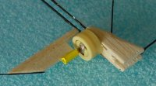 | 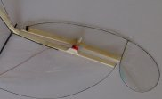 | 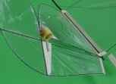

The problem is to link the bird shaft to the rudder, and have it adjustable when trying to minimize the friction. The two axles must be perfectly aligned.
One solution is to to glue a 1.2x1.2x8mm soft balsa on the arm (1.5x1.5x10 for Nano. Micro and MilliBirds). Then a paper tube of adequate diameter is glued on the rudder, after alignment.  The Bird shaft is conical (5 degees) but the problem is to find a tube of the precise diameter, so it fits with the required force. | 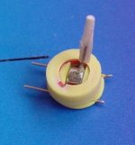 | 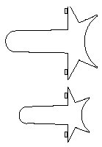

Frequently, the Birds are placed in the middle of the fuselage, and push-rods brings the torque to the rudder arm. This brings the problem of the hinge on a 10-grams plane (the moving surface weight 0.05g and the hinges should be lower), and the problem of the push-rod, that must also be very light and allow some length adjustement. | 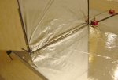  Cherub tail (David Liu) | 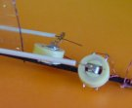

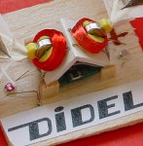
Special application
We put two Nanobirds above a 1 square cm microcontroller board. The program on the PIC 16F84 alternate the currant at different frequancies. Two outputs of the PIC are connected on each coil wires, so the voltage drop on the PIC is below 0.5V.
The wings of a Morpho have been equipped with paper tubes glued before cutting the body.

You can see a video (1.8 Meg) at
http://www.didel.com/slow/nanobird/Papi.mpg
The action without wings can be seen at
http://www.didel.com/slow/nanobird/NanoBIRD.mpg

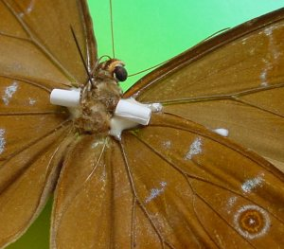
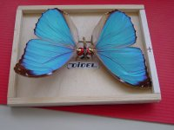

FAQ

Why these two ridges on the back of the actuator
The ridges give some thickness to better maintain the moded pins, but they have been designed to position more easily the Bird on a carbon tube fuselage.

Why is the arm so thin. It bends too easily.
Well, it is easy to bent it back. In normal operations, the efforts will never been so large. We prefered a thin lever, so the effort on the solder is not too high.

Why the arm is so thin, the Z-hook does not hold well
Yes, it is a problem to shape correctly the Z-hook. Use 0.2 mm wire, and bent it as sharp as possible, with a Z central length as short as possible (0.5mm). You need thin tweezer for this.

Why is the construction so imprecise
Yes, there is a lot of play, because it is difficult to be precise for so small dimensions. Since the actuatior generates a torque, and not a position, play has no importance. What is important is to avoid friction.

The arm solder broke, can I fix it
This should not happen in normal operation. We test every BIRD with a reasonable effort. Send us the piece back and we will analyse if the solder was weak. Do not try to fix it yourself. If you manage to desassemble without destroying the coil, the next problem is to solder the lever with the good orientation, and heat the magnet very locally, otherwise it will loose all magnetization.

260303/jdn

