DIDEL SA CH-1092 Belmont  Tel +41 21 728-6156 fax -6157  www.didel.com info@didel.com | 
www.didel.com/robots/swibot/doc/SoftE.doc

Swibot-SST – Software

The Swibot-SST uses a 16F84 PIC from Microchip to control its hardware features. The user sees variables, all critical timings are handled by interrupt. The Swibot-SST plays three demo programs, but it is primarily designed to be controlled by your own software, on the processor you are familiar with, that communicates over the serial line with the Swibot-SST. This is great for software development, because you can use any language, any development tool, any PC or PDA with a 2400 bit/s serial link. Three thin flexible wires, up to 3 meter long, connect your PC to the Swibot-SST. If you need full autonomy, you can piggy-back a small board with the processor of your choice. A 24-pin connector on the Swibot-SST is available for direct insertion of a Basic Stamp BS2-IC or -SX. You can download your Basic program on the Stamp, and get a robot with variable speed motors, an IR receiver, a loudspeaker, and a software to control the speed of the motor and know the distance and the orientation of the robot. There are also two wiskers for obstacle detection. At power-up, if one or two wiskers are depressed, demo programs are executed.

The serial communication protocol is trivial. You send an order preceeded by a parameter and you wait for the reply, which is always a parameter (two hex digits) followed by the same order letter. This means a simple handshake protocol, no queue that can overflow, and only Ascii alphanumeric characters that any language and RS232 driver can handle.

For instance, to set the speed of both motors to value 16'1A (we work only in hexadecimal), you send three characters: 1 - A - V. The Swibot-SST will immediately acknowledge with 1 - a - v. You want to stop? Send one, two or three characters: V, 0 - V or 0 - 0 - V. You will get the reply 0 - 0 - v. In most cases, a letter with no parameter will not load value zero, but ask for the current value.
The format of any reply is always the same: Two hexa digits and a lower case order letter between g and z, corresponding to the letter you have sent; this makes your sotware easy and straightforward. You are free to use upper or lower cases; the best is to use upper cases, since the Swibot-SST replies with lower cases. A simple HyperTerminal allows you to play with the robot as soon you have finished to assemble it.

The available orders allow to set the speed of the two motors separately, to read the 16-bit distance counter, to read the angle counter (resulting from the difference in step numbers between the two motors), the IR code received (Sony code, 2ms start pulse, 0.6/1.2 ms data pulses), play several bips on the loudspeaker, and measure time.

Orders without parameters |  |  | With parameter (1 or 2 hex digits)
V | 00v | Stop both motors | nnV | nnv | Set speed nn to both motors
S | nns | Read present right (starboard) motor speed | nnS | nns | Set right motor speed to nn
P | nnp | nn = Left (port) motor speed | nnP | nnp | Set left motor speed to nn
L | nnl | nn = Distance low | nnL | nnl | Set value to distance low
X | nnx | nn = Distance high | nnX | nnx | Set value to distance high
T | nnt | nn = Orientation | nnT | nnt | Set initial orientation
G | 0ng | Bip | nG | 0ng | Play tune nn (=0 to 3)
W | 0nw | Wiskers n=1 right 2 left 3 front
H | 00h | No new IR code received
H | nnh | Valid IR code received
M | nnm | Read decrementing timer (period 20 ms) | nnM | nnm | Set decrementing timer
§
U | nnu | Read presetted speed | nnU | nnu | Preset a speed for orders I, J, K
 |  |  | nnI | nni | Preset high part of distance
 |  |  | nnJ | nnj | Preset low part of distance and start
 |  |  | nnK | nnk | Preset anngle and start movement

Motors speed

For most stepping motors, the speed depends on a delay routine that defines the speed. Swibot uses real speed parameters, with a speed of 1 corresponding to 0.26mm/s or 16 cm/min. The max speed is around 16’24, that is 10 cm/s but if you accelerate the motor pregressively, you can go faster (free running wheels can go up to 16’70).
Order nnV sets the same speed to both motors. Orders nnS and nnP control independantly the right and left motor. 0V and V have an important difference. 0V stops the motor and maintains the currant through the coils. V alone cuts the power, and it becomes easy to push the robot by hand.

Distance and angle measure

The interrupt routine doing the steps at the given speed measures also the distance (in number of steps). A 16-bit counter accumulates the steps, and the value is read/assigned by the X (high part and L (low part) orders. An increment corresponds to a displacement of one step, that is 0.28mm. The low part will overflow for 72mm, and the high part for 18 meters. Of course, going backward will decrement the distance, and negative distances are represented in 2-s complement form. The PIC computes also the orientation of the robot from the difference in step numbers. A tricky division allows to have an overflow of the 8-bit angle value for one turn exactly, that is 90 degrees is equal to 16’40. The angle increases if the robot spins in the direct trigonometric sense (anti-clock wise).
Examples
To be typed on an hyperterminal or executed by a Basic or C program
20V → 20v Set speed  X → nnx Read distance in a loop  If nn=2, Distance 140mm done → 0V to stop | 20V → 20v Set speed  W → nW Read wiskers  If n=1 Obstacle right → 0V to stop motors

Displacement orders

It is convenient when controlling the robot not to have to read continuously the distance to decide when to change the movement. With the J and K orders, a distance or an angle can be preset, and the movement will stop when the distance or angle is reached. The receipt is given immediately, and this allows checking for obstacles or time-out while the movement occurs. To know if the movement is terminated, the W order gives on the high bit (bit 7) the indication the movement is still active.
Speed has to be prepared with order U. Distance high is optionally prepared with order I. The movement starts when the order nnJ is given, nn being a short distance nn (up to 70mm) or the low part of the distance, if the high part has been preset to a value different from zero. If speed is negative, the robot will back the given distance (a positive number).

Angular movements are made atfter preparing a positive speed and an angle that can be positive (0 to 16’7F) or negative (16’FF to 18’80).
Example
20U → 20u Prepare speed
80J → 80j Start a 4 cm displacement
W → nnw If nn=80, Swibot still moving
If nn=81, obstacle right befor the end of movement
If nn=0, displacement done

Power consumption

Power supply is 5 mA for the 16F84, 28mA to 36 mA for the motors, plus 7 mA for a Stamp BS2-IC. This means the battery will last 4 to 6 hours if the robot is moving. After reset, motors are off and run freely, current off in the coils; the same happens after a V order, but 0V will hold the motor in position, current on.
A nice feature is you will not forget to switch your SST off: it will deactivate the motors and bip every 10 seconds if you do not send an order, 6 minutes after power on, or 1 minute after the last received order. If you do leave the switch on, the battery will however last one week in the low power mode.
A BS2-SX is not worth: it uses 50mA and its processing power is not required since the 16F84 does all the realtime job.

Whiskers, power-up and demo programs

The two wiskers are directly connected to the LEDs. They are read by the W order. At power-up, four behaviours result from the 16F84 reading the wiskers:
- Left whisker depressed: The Swibot bips and waits for orders from the serial line
- Right whisker depressed: The Swibot accelerates and slows down, bips and waits for orders from the serial line
- No whisker depressed: The Swibot plays a tune, then moves at constant speed and avoids obstacles (switch off to terminate). With an IR remote controller, it is possible to modify the speed of the robot. See http://www.didel.com/robots/swibot/doc/Remote.com for selecting and setting a programmable IR controller. The robot recognizes the following keys: 2 - accelerate, 4 - turn left, 5 - stop, 6 - turn right, 8 - deccelerate. If a terminal is connected, the left and right speed is displayed.

Timer

A decrementing counter can be loaded at a given value. It will decrement every 20 ms, and stop at zero, but will not trigger any action when reaching zero. Usually, your software will set the timer for a time of up to 5 seconds, and test in a loop if value zero is reached.

Serial interface

RS232 uses +/- 12V signals with the line at -12V when inactive. RS232 inverting drivers are available to convert this signal to 0/5V, line at 5V when inactive, as supported by most microprocessors. It is possible, even with rather long lines in a not too noizy electrical environment, to save the RS232 drivers that cost and use power. See http://www.didel.com/robots/swibot/doc/Serie.com. For the PIC, the software is not the same, but Swibot recognizes the polarity of the receive line and adapts automatically at power-up (the connection to the PC, PDA or Stamp must hence exist at power-up, and the unit must be powered). A + sign is sent by the Swibot at the same time the start-up bips are played.

Controlling the Swibot with the hyperterminal

Set-up the terminal with 2400 bit/s, 1 stop bit, no handshake, echo on characters.
Type 10V and you will get the echo 10v, and see both motors spinning. Type V to stop them. Test all the above orders the same way.

Controlling the robot with a LOGO-like interpreter

J.C. Zufferey has written an easy to learn language, which can ve used with 10-14 years old kids. See http://dmtwww.epfl.ch/~jzuffere/Interpret.html

Controlling the Swibot with a PC or PDA program

Any language has some primitives and libraries to communicate with the RS232 line. For instance, in Borland C++, you can write:

With the free compiler from Borland (http://www.borland.com/bcppbuilder/freecompiler/), one can write

#include <windows.h>

HANDLE hCom; // handle to the comm port.

void OpenCommPort()
{
DCB dcb; // a DCB is a windows structure used for configuring the port

hCom = CreateFile("COM1",
GENERIC_READ | GENERIC_WRITE,
0, // comm devices must be opened w/exclusive-access
NULL, // no security attrs
OPEN_EXISTING, // comm devices must use OPEN_EXISTING
0, // not overlapped I/O
NULL // hTemplate must be NULL for comm devices
);

// Now get the DCB properties of the port we just opened
GetCommState(hCom,&dcb);

dcb.BaudRate = 2400;
dcb.ByteSize = 8;
dcb.Parity = NOPARITY; //NOPARITY and friends are #defined in
windows.h
dcb.StopBits = ONESTOPBIT; //ONESTOPBIT is also from windows.h

// Now we can set the properties of the port with our settings.
SetCommState(hCom,&dcb);
}

void CloseCommPort()
{
CloseHandle(hCom);
}

void SendString(const char *str)
{
DWORD dummy;
WriteFile(hCom, str, strlen(str), &dummy, NULL);
}

void ReadBytes(unsigned char *InputArray, unsigned int NbBytes)
{
DWORD dummy;
ReadFile(hCom, InputArray, NbBytes, &dummy, NULL);
}

unsigned char ReadValue(unsigned char *InputArray)
{
int i;
unsigned char Byte[2], Value = 0;

ReadBytes(InputArray, 3);

// Convert incoming characters into a integer value
Byte[0] = *InputArray;
Byte[1] = *(InputArray+1);
for (i=0; i<2; i++)
{
if (Byte[i]<0x3A) // '0' to '9'
{
Byte[i] &= 0x0F;
}
else // 'a' to 'f'
{
Byte[i] = (Byte[i] & 0x0F)-1 + 10;
}
}
Value = Byte[1] | (Byte[0]<<4);

return(Value);
}

void main()
{
unsigned char InputByte[3]; // Bytes array for the data from the robot
unsigned char dist;

// Open the comm port with the right settings
OpenCommPort();
printf("Waiting for Swibot...\n");

// Waiting for the Swibot to be switched on
while (InputByte[0] != '+')
{
ReadBytes(InputByte, 4);
Sleep(200);
}
printf("Hello Swibot!\n");

Sleep(1000); // Wait a second

// Go forward for 200 x 0.28 mm
SendString("00L"); // Reset the distance LSB
ReadBytes(InputByte, 3);
SendString("00X"); // Reset the distance MSB
ReadBytes(InputByte, 3);

SendString("10V"); // Go forward at speed 10
ReadBytes(InputByte, 3);

do // Poll the distance
{
SendString("L"); // Ask for the distance LSB
dist = ReadValue(InputByte); // Read the distance LSB
InputByte[3] = '\0';
printf("InputByte: %s\n", InputByte);
printf("dist: %i\n", dist);
} while (dist < 200);

SendString("00V"); // Stop the robot
ReadBytes(InputByte, 3);

printf("Done!\n");
Sleep(1000);

CloseCommPort();
}

Controlling the Swibot with your Basic Stamp

The Stamp has good primitives for serial communication. You have to use it in the direct mode, since at power-up the Rx line is high.

Sample program written by Maurice Wuillens:

'Programme de mesure de distance courte

'Analyse des operations:
'charger la variable distance
'emission de la constante vers le PIC (setdislow)
'charger le parametre vitesse
'emission de la variable vers le PIC (setvitesse)
'etiquette mesure
'reception de la variable valeur du PIC (getdistancelow)
'condition si valeur >= distance arret des moteurs
'saut etiquette mesure
'etiquette arret
'emission constante mothors vers le PIC (sethors)
'arret du programme

'programme edite le: 27/09/2001

'Variables du programme
'Remarques:
'La grandeur de la RAM n'a que 26 bytes.
‘Declarer le plus possible en constantes

valeur var byte 'reception du PIC
valfort var valeur.highnib 'reception du PIC,MSB
valfaible var valeur.lownib 'reception du PIC,LSB
vitesse var byte 'emission vers le PIC
distance var byte 'emission vers le PIC

'Constantes du programme
mothors con $00 'emission vers le PIC
distlow con $ff 'emission vers le PIC

'Programme principal  debut:  distance = $ff 'consigne distance  gosub setdistlow  vitesse = $0a 'consigne vitesse  gosub setvitesse  mesure:  gosub getdistancelow  if valeur >= distance then arret  goto mesure  arret:  gosub sethors  end  'Sous-routines  setdistlow:  serout 4,396,[hex2 distlow]  pause 10  serout 4,396,["l"]  pause 10  return | setvitesse:  serout 4,396,[hex2 vitesse]  pause 10  serout 4,396,["v"]  pause 10  return  getdistancelow:  serout 4,396,["l"]  serin 5,396,[hex2,distlow]  serin 5,396,[trash]  return  sethors:  serout 4,396,[hex2 mothors]  pause 10  serout 4,396,["v"]  pause 10  return

Swibot-SST – Serial cable

The Swibot-SST kit provides a DB-9 female plug, a 4-pin header for connection on the red serial connector of the Swibot-SST, two 4k7 resistors and a diode. The DB9 is too huge for us, and DIDEL has normalized a 4-pin plug named S4. The schematic is given below. One solution is to solder the components on the female 4-pin strip, as shown on the upper right corner. The diode is not absolutely required, since the PIC has good protections diodes. Diodes have a yellow mark that gives the direction. The pull-down resistor guarantees that the 16F84 software will recognize the negative transmission mode. The plug must be connected at power-up.
It is recommended to be more modular and we provide two additional female and male plugs to split the connection in three parts: a DB9 to S4 adapter, S4 extension chord, S4/232 to S4/TTL adapter. So if you need a longer extension with thinner wire, to give your robot more space to move, you just build the appropriate extension chord. And if you feel the RS232 cable toward some other robot you have is too heavy, you wire a female S4 to male DB9 adapter (not shown, the wiring is the same).

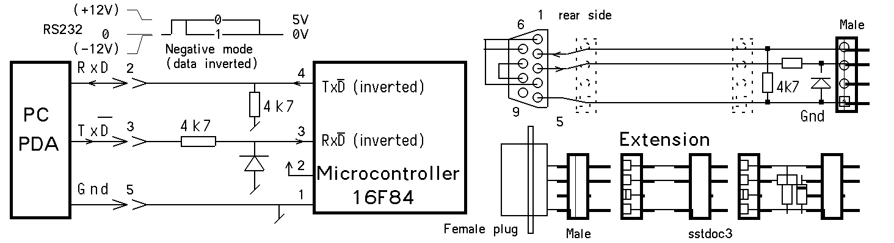

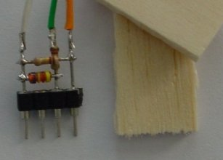 | 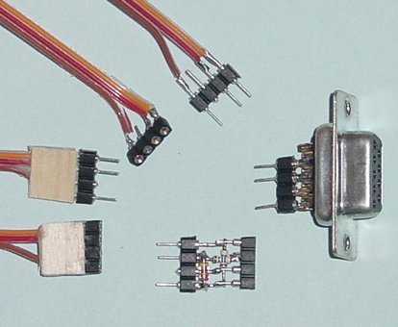
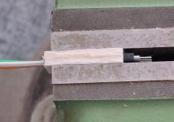 |  | 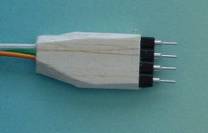

The null modem, if you need to be compatible with the “hardware handshake mode” is wired by soldering DB 9 pins 1-6-4 (brown-red-violet) and pins 7-8 (yellow-blue) together.

A nice trick for making pleasant and reliable strain-release protection is to take two pieces of 1.5 to 2mm soft balsa and depress them on the plug, using a flat wall vice, as shown on the pictures.

JDN 060202/24.09.026

