DIDEl SA CH-1092 Belmont  Tel +41 21 728-6156 fax -6157  www.didel.com info@didel.com | 
www.didel.com/robots/swibot/doc/AssE.doc

Swibot- SST - Assembly instructions

It will take you about two or three hours to assemble the kit. Required tools are a soldering iron with a thin tip (15-30W) and a small screwdriver. We provide the thin soldering wire.

Part list  a printed circuit  b 2 switec motors  X15.156  c 2 wheels  d 2 plexi supports  e 4 M1.6x12  4 M1.6x4 screws  f 2 9V battery contacts  g 1 slide switch  h 1 18-pin socket  i 1 PIC 16F84 “SSX”  j 1 oscillator  k 1 female contact strip  (4 pins red)  l 2 3mm red LEDs  m 2 10k resistors br-bl-o  1 100k res br-bl-y  1 330Ohm res o-o-br  n 1 100 nF capacitor  o 1 78L05 regulator  p 1 IR TSOP sensor  q 1 buzzer  r 1 wisker  s 2 bumpers  BS2 interface  t 5 female contact strips  (12,12,10,6,4)  u 1 male strip (4 pins)  Serial interface
  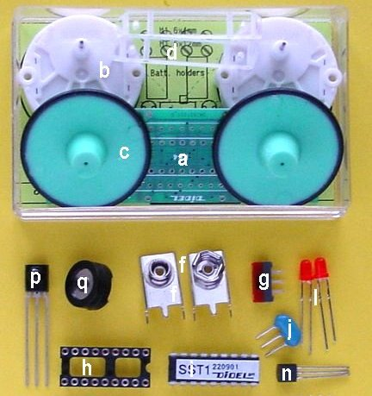
  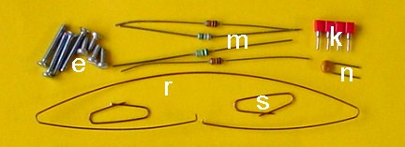
  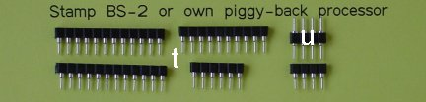
v DB-9 female connector  w 2 male strip (4 pins)  x 1 female strip (4 pins)  y 2 4k7 resistors  z 1 diode 1N4148  3-conductor cable | 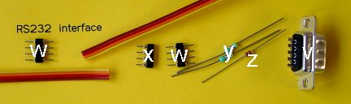

Assembly Sequence
It is recommended to follow precisely our instructions. To unsolder a component is always delicate, needs adequate tooling, and leaves visible traces. Refer to the schematic page 7 when you are not sure.

LEDs, resistors and decoupling cap

LEDs must be inserted with the short wire on the side marked with a tangent segment.  There is usually also a flat mark on the LED. Cut the leads very short (2mm), insert the LED, solder the pin on one side, check the alignment, solder the other side. Solder the resistors and the capacitor (the 330 Ohm is marked 390 on the PC board). Cut the wires very short. Keep the long cut wires for later use. | 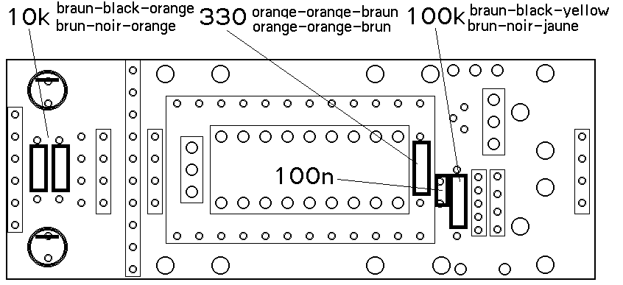

F84 socket

Double check for the orientation of the 16F84 socket. Do not fully insert the socket when you solder it. The pins must protrude the PC board by 0.3 mm maximum, in order not to touch the battery. Solder two corner pins, adjust the position, check that all pins protrude by 0.3mm max, and then solder them all. Never cut these pin short: the pins of this very flat connector are hollow and you will damage the inside spring if you cut them. | 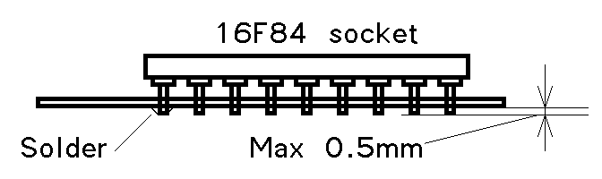
  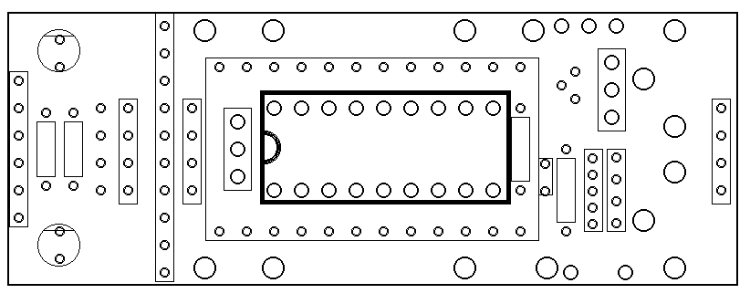

Connectors for Stamp BS-2

Female contact strips are provided for the BS-2 or BS-2SX. You do not need to solder them if you plan to control your Swibot through the serial line only. They are easy to add later if you get a Stamp or another pin-compatible processor. The 4-pin strip is black, keep the red one for the serial line. The strips are soldered like for the 16F84 socket: one pin at each end, which do not protrude by more than 0.3 mm and then all other pins are soldered. | 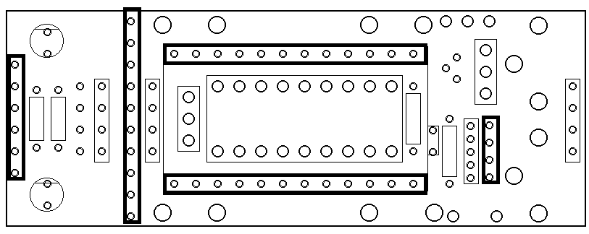
It is also important that the Stamp socket be as high as possible, otherwise the 16F84 will not allow a complete insertion of the Stamp. A 24-pin socket inbetween may have to be used in such a case. The male strip is provided to wire the cable toward the PC, as documented in the Stamp documentation.

Serial connector

The serial connector is red. You should not use it when a Stamp or other piggy-back processor is under control of the serial line and communicates with the 16F84. Again, the pins should not protrude by more than 0.3mm. | 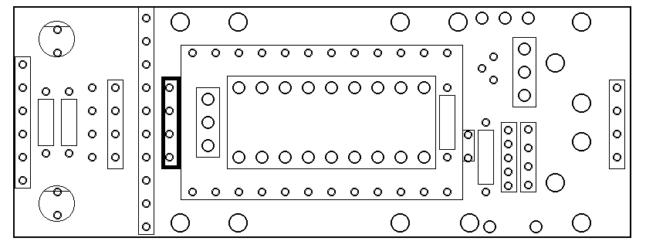

Oscillator, regulator and switch

Insert fully the oscillator (no special orientation), solder the center pin, cut all three pins very short, and solder all pins. If you do not have a precision cutter, cut the pins before insertion. Same for the 5V regulator 78L05. The switch is fully inserted, and you do not need to cut the lead short; the battery will not interfere. | 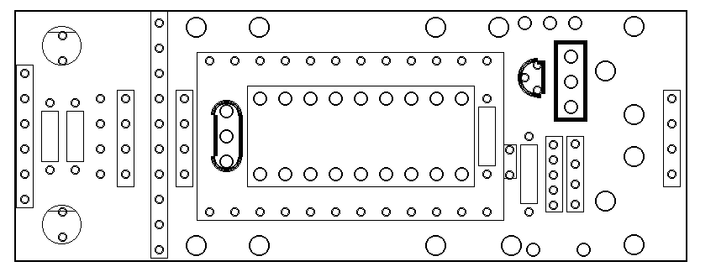

Plexi holders, IR receiver and buzzer

Use the short screws to fix the plexy holders, on the socket side. Solder the IR receiver and the buzzer. The + and – marks on the buzzer have no signification: it is just a coil. But pay attention to bend the lead to position the buzzer away from the motor. On the first PC board serie, we mis-positionned these two holes. | 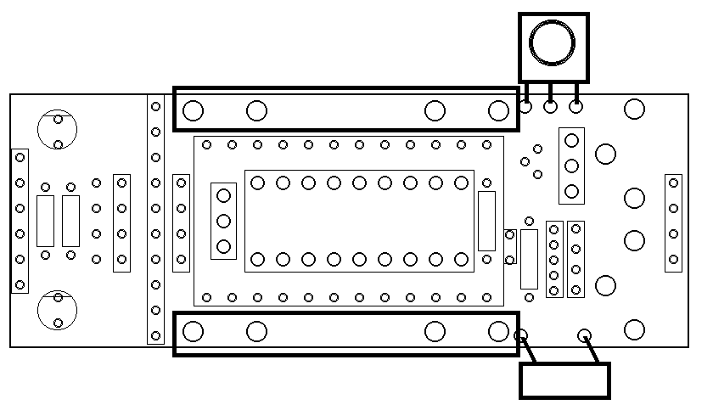
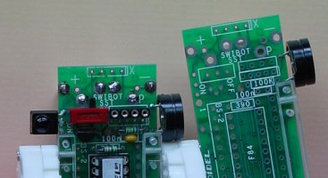

Motor

Before screwing the motors, proceed to soldering the 4 wires that go through the holes in the plastic holders and will give the connection to the upper motor pins. They should overpass the plastic by 2-3 mm, as shown in the diagram. Screw the two motors (check for the dissymmetry of the wheel axis). Solder the motor pins. | 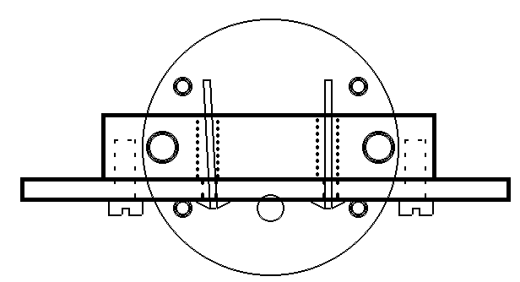

Whiskers

The Swibot whiskers have to be very sensitive. The solution is to use 0.3 to 0.4 mm berillium bronze wires with a correct shape. 0.25 mm piano wire is also acceptable, but may oxidize faster and is not easy to solder.

One CuBz wire is ready shaped at 80mm width, and the holes at ground on the PC board allow for a reliable hold, as better shown on the picture at bottom of this page. The bumpers are rather easy to insert in the corner holes, with two wires in the hole. Solder with some outside angle. Adjust the distance between the wire and the bumper to 3-5 mm by heating the solder at the | 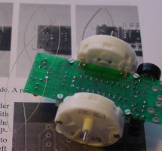 | 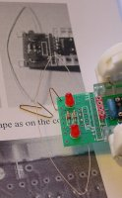
fixation points of the whisker and depressing in the adequate direction. You get some additional wire for your experiments. You can maybe detect the edge of a table with an adequate whisker.

Battery contacts

Fix the battery contacts on the battery, avoiding shorts if it is a fresh battery. The + battery sign must correspond to the + on the printed circuit, and the contacts are on the bottom side. Double check.  Contacts are not completely inserted, due to the screws. There should be about 0.5mm spacing between the PC board and the contacts. Solder the center pin, push the battery toward the robot front, so there will be an effort from the battery springs to keep the battery against the PC board (see picture). Solder the others after additional checking. | 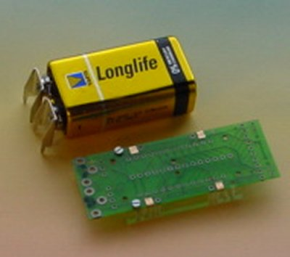
This is an important and delicate operation, since later the inclination of the contacts will maintain the battery against the robot, counter-acting its weight. Thickness of batteries vary between 15.2 and 17.4mm. If you have a thin battery, add a piece of cardboard when you do the soldering, so you will not have a problem the day you buy a thicker battery.

Wheels  Wheels are pressed with a rather important effort, well in the axis direction. Leave a half-millimeter game. If you have to remove the wheels, use a thin screwdriver or knife and push the wheel out near the axis. If the wheels start to be loose, put a small drop of cyanolit at the axis extremity. | 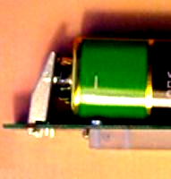

Stamp programming cable

The programming cable for the Stamp is easy to wire, according to the drawing below. For the BS2, a DB-9 female plug (DB-25 with old PC's) must be connected to the 4-pin male strip.

The optional switch on ATN line allows to leave the plug in place while doing your successive programming developments. The switch must be closed to program the Stamp, but not when some other program communicates (e.g. visual Basic).  Serial interface | 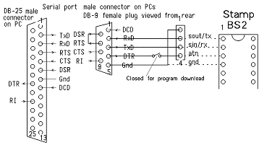

If you are not playing with a Stamp, decide how you will interface to a RS232 port. It is possible with most PCs to save the RS232 driver that costs and uses power, even with rather long lines in a not too noisy electrical environment. For the PIC, the software is not the same, but the Swibot-SST recognizes the polarity of the receive line and adapts automatically at power-up. Components for the serial interface are included in the complete kit. See the more detailed notice “Swibot-SST – Serial cable”.
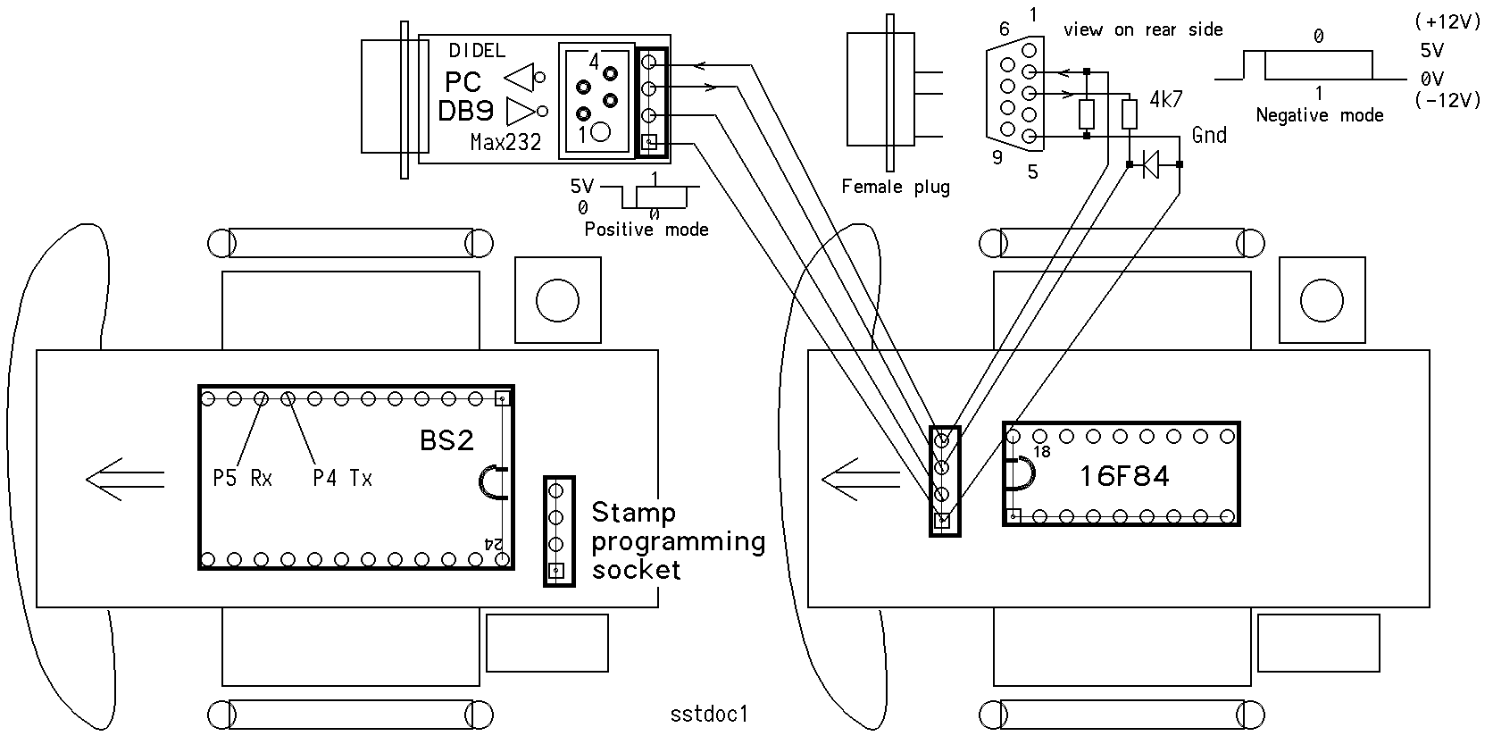

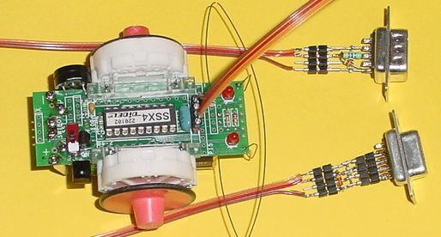

16F84 reprogramming

Connector J5, with a 2mm pitch to avoid confusion, can be used to reprogram the 16F84 on the robot directly. The connector is supplied with the PicGenial programming environment.

P-Bus extension connectors
The two 4-pin connectors marked X are planned for a 1-wire extension bus named Petra. The 4-pin connector strips for this bus are not provided. A camera and a Led plus switch panel have been developed in the past, but these devices are too expensive to manufacture.

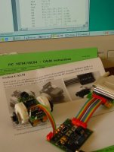 | 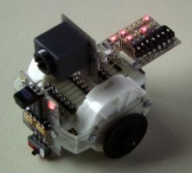

Schematic and components layout
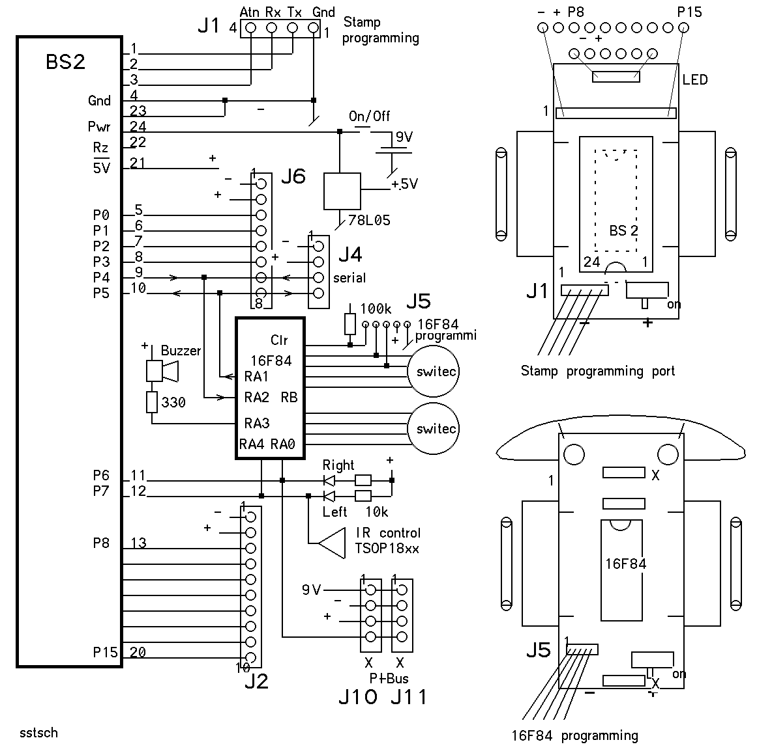

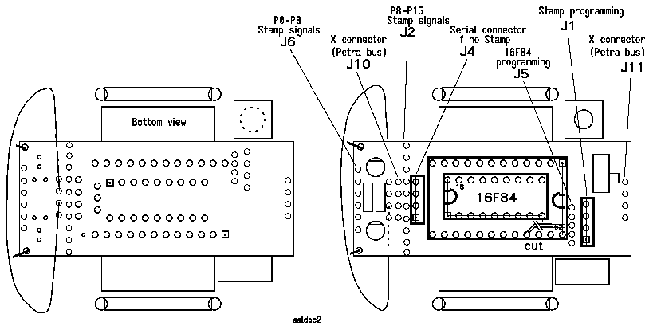

Swibot-SST Infrared Control

Tousands of different infrared protocols exist for remote IR controllers. A universal remote controller is required with the Swibot-SST, which is programmed for one of the Sony TV codes. A programmable remote controller has a booklet with the numbers that correspond to the different device’s protocols. Find on the TV pages the Sony numbers. These numbers are different for all these universal controllers, and these products change every month or so. Like for TVs, you may have to test different codes until the Swibot reacts. To help you, the left LED will blink when a signal is received. The small loudspeaker will make some noise if the decode logic recognizes a valid code. The best is to check with a scope. The ground can be attached to the wisker, and the IR signal is the left bumper contact. The timing given by the remote controller should be the following:
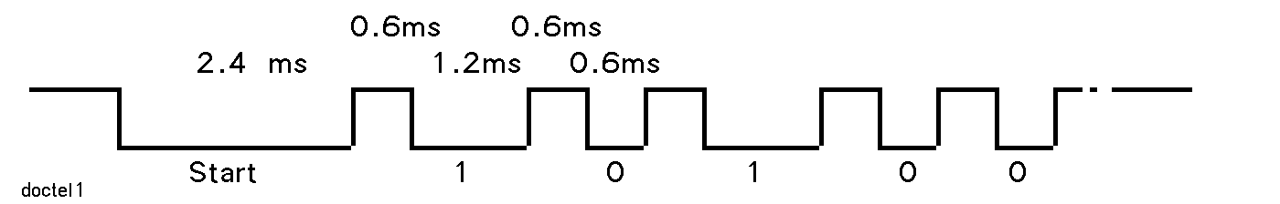

The IR code is decoded by the interrupt real time routine, and the code is written into a variable that can be read by the H order. A second read will always give the value 00 back, so when you read, a zero means no code, and something different means a code has been received and not read yet. The last received code is read; the previous unread ones are lost.

Demo program

The obstacle avoidance program you start by depressing no contact at power-up is influenced by the remote controller.
Key 5 stops the movement.
Keys 2 and 8 accelerate and slow down both motors. Every decoded key 2 code (value 16'81) increases the speed by one. A stepping motor will of-course stop if going too fast.
Key 4 increases the right motor speed, and decreases the left one, so the robot will turn left.
Key 6 increases the left motor speed, and decreases the right one, so the robot will turn right.

Don’t be surprised, Swibot is an impatient robot. If it does not get an order for 8 seconds, it makes a half-turn and starts looking for obstacles.
While controlling the speed, the robot continues to avoid obstacles. Did you realize that the 16F84 plays some tricky real time programming not to consider a IR code as an action of the left whisker? In addition, it still controls smoothly the steps of the motor, and plays tunes without alteration (they are bad enough anyway).

The obstacle avoidance program is based on the following rules:
An obstacle makes the robot turn a little bit more in the other direction. Too many close by consecutive obstacles make it do half a turn right, then left. After 32 obstacles, the robot will do a half-turn. No obstacle or IR order for 8 seconds makes also the robot do a half-turn.

