CH-1092 Belmont, Switzerland  Tel +41 21 728-6156, Fax 728-6157  Email info@didel.com, www.didel.com | 
File www.didel.com/slow/pricelist/doc/GbKit5.doc

Gearbox for ultra-light slow flyers
Assembly instructions for 4R5, 4R7 and 4R10
one stages, module 0.2 gears

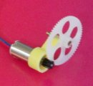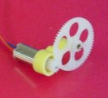 | 0.13 grams only  4R5 reduction 1:5, motor 4mm  G212 (white) and G260 gears  4R7 reduction 1:6.6, motor 4mm  G209 (black) and G260 gears  4R10 reduction 1:10, motor 4mm  G209 and G290 gears (black)

The main piece of the kit consists of the precision plastic part, with two bores. The shaft is a 0.76mm rivet. The gear appeared to be too loose on this shaft, due to the short gear bore; one cannot be ultralight and have bearings in these dimensions. The rivet is glued in the back with CA.
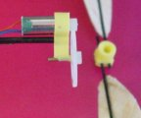 | One pinion is provided for 0.7mm shaft (Mk04/Mk04L). Ask for a 0.61mm pinion if Mk04S motor. The gear slides freely or with a small effort on the shaft. Put the smallest possible drop of thin cyano at the | 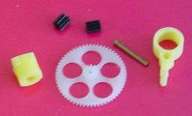
extremity of the motor shaft (the safer is to put the drop on a plastic and dip the end of the shaft in the drop) and push quickly the gear in place. It should immediately fit firmly.
Slide the motor into the gearbox and check that the fit is snug and the gear engages freely with a minimum of play. If required, use thick CA or Superphatic to glue the motor so you get a chance to remove it by using the adequate solvant.
The gearbox has a 1mm bore to be attached to the fuselage. The hole can be drilled or reamed up to 1.3mm.  A PC07 prop connector (0.03g) is provided. I allows to build a balsa prop of 100-120 mm diameter, providing a 1.5 to 2 grams thrust at 60-80 mA (motors Mk04-40 and Mk04-24).  A second PC07 with a central 1.2mm post is provided for CR props.  Ultralight balsa props compatible with the PC07 connector are available from www.smarttoolsinc.com/  The MC5030L propeller from microinvent.com, sold by Didel, has the best thrust/weight ratio. | 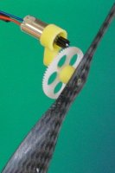
050210/040614/jdn

