CH-1092 Belmont, Switzerland  Tel +41 21 728-6156, Fax 728-6157  Email info@didel.com, www.didel.com | 
File www.didel.com/slow/pricelist/doc/GbKit25.doc

Gearbox kit for very slow flyers
Assembly instructions for 4R25-02, two stages, module 0.2 gears

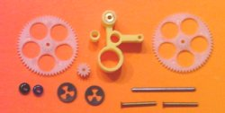 | 4R25 reduction 1:25, motor 4mm  G212 and G260 gears

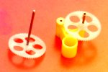
The main piece of the kit consists of the precision plastic part, with its 0.80 mm brass bearings. The shaft is a 0.78mm steel axis. The gear is slightly loose on this axis and must be glued with a drop of CA at te extermity. Do not have CA going along the shaft.

The intermediate gear is maintained by a 0.76mm rivet, to be inserted in the only bore. Put the rivet in the gear, and press on the rivet, well in the hole direction.

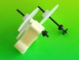
Now you can insert the main shaft with its gear. Slide the provided “perl” on the back end of the shaft as a washer, and next the Quicklock fastener, centered and depressed with the extermity of your digit. You get one more pearl and fasterer in case you loose one.

Install the pinion gear on a MK04S motor. The G212-063 gear slides freely on the 0.60mm axis. For other 4mm motors, the bore must be enlarged to 0.71mm. Insert the gear on the motor, put the smallest possible drop of thin cyano at the extremity of the motor shaft. It should immediately fit firmly.

Slide the motor into the gearbox and check that the fit is snug and the gear engages freely with a minimum of play. If the motor is loose, don’t glue it, but put a thin layer of cyano inside the bore, wait until well dry, and hold the motor by friction only.
Put a small drop of good quality fluid oil on all the axis.
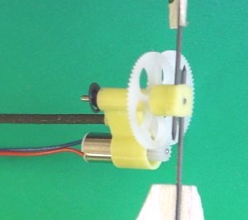
The gearbox has a 2mm bore to be attached to the fuselage. An adapter is provided for 1.3mm carbon tubes from WES. Unhappily, the diameter of these tubes may be between 1.2mm (the adapter is loose) and 1.4mm (file the tube, no hope to redrill or ream the adapter).

Note that the adapter bore is tilted by 5 degrees. This is planned to compensate the torque of the motor. Orient the adapter correctly when gluing it on the rod.
030516/jdn

