CH-1092 Belmont, Switzerland  Tel +41 21 728-6156, Fax 728-6157  Email info@didel.com, www.didel.com | 
File www.didel.com/slow/pricelist/doc/GbKit1.doc

Gearbox kit for very slow flyers
Assembly instructions for one-stage boxes

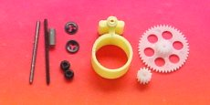 | 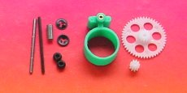
xR4 reduction 1:4 x=motor 10,12mm  G309 and G336 gears | xR5 reduction 1:5.33 x=motor 6.7,10,12mm  G309 and G348 gears
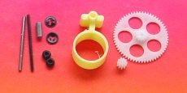 | 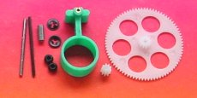
xR7 reduction 1:6.6 x=motor 4,6,7,10,12mm  G309 and G360 gears | xR9 reduction 1:9 x=motor 4,6.7,10,12mm  G309 and G381 gears
- Carbon shaft not supplied with these boxes -
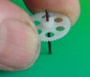
The main piece of the kit consists of the precision plastic part, with its 1.00 mm brass bearings. There are two choices for the shaft, a carbon rod 0.95 to 0.98mm light axis or a 0.98mm steel axis. We experimented that CR do not wear, but you may be more confident with the 0.1g heavier steel shaft. Press the gear onto the shaft as shown.
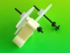
Now you can assemble the main shaft. Slide the provided “perl” on the back end of the shaft as a washer, and next the Quicklock fastener, centered and depressed with the extermity of your best digit. You get one more pearl and fastener in case you loose one.
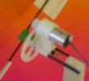
Install the pinion gear on the motor. For 4 and 6mm motors, the first part of the gear slides freely on the axis (0.71 and 0.81 mm bore on one side). Put the smallest possible drop of thin cyano in the middle of the motor shaft (the drop must be much smaller than the diameter), and slide quickly the gear as far as possible, without any important axial effort on the motor axis. It should immediately fit firmly.
For motors with 1mm axis, the gear has a 0.97 mm bore and must be press-fitted on the axis. For a 7mm pager motor, axial effort must be avoided. Either you follow our recommendations for maintaning the back of the motor axis, or you ream out the gear to 1.00 to 1.01 mm and use some cyano to maintain it on the axis.
Slide the motor into the gearbox and check that the fit is snug and the gear engages freely with a minimum of play. If the motor is loose, don’t glue it, but put a thin layer of cyano inside the bore, and hold the motor by friction only. Put a small drop of good quality fluid oil on all the axis.
The gearbox can be attached to the fuselage with two 1.4mm carbon rods distant of 5.5mm.

