CH-1092 Belmont, Switzerland  Tel +41 21 728-6156, Fax 728-6157  Email info@didel.com, www.didel.com | 
Filehttp://www.didel.com/slow/mirted/Radir.doc

RADIR – RC radio to IR converter.

Radir is a board that converts the PPM signal of a radio transmitter into a powerfull IR stream. The PPM signal is usually available on the traniee's plug (also named "buddy socket"). The power, 8 to 12V, 0.3A is taken from the same plug. For a better understanding of RC radios, see http://webpages.charter.net/rcfu/HelpsHints/RadioOps.html ).
The problem is that the trainee's plug are not well documented, and one need a scope to do some reverse engineering. With a scope, one can find the required signals in any radio. Flight simulator developers have a similar problem: connecting your radio to the parallel plug of a PC, so you can fly their simulated planes with your radio. Most of the detailed information of the appendix has been found this way. If your radio is not listed, search a simulator for it."Buddy box" is the name of the adaptaing cable they discribe.

The shape of the PPM signal is given below. The level must be 0 to 0.5V for the zero level, 3 to 5V for the one level. The width of the pulses are not critical. Radir software adapts to positive or negative pulses. The space between pulses (positive edge) corresponds to the pulse duration sent to the servos. The processor modulater converts the PPM signal into sets of 20 pulses at 40 MHz.  The PPM standards specify 1 to 2ms pulses. After measuring several radios, we noticed that even with the trim, the range was narrower. We hence convert below 1.1 ms space to 0% and above 1.9 ms 100% as 1 to 2ms IR pulses. 1.5 ms is 50%. | 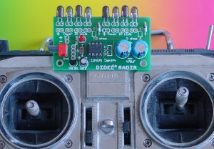
This IR protocol is not the same as for TEDRA, and is not compatible with the MIR receivers. The new MIBxx receivers must be used.
Simultanous usage of several IR transmitters is not possible in the same room.

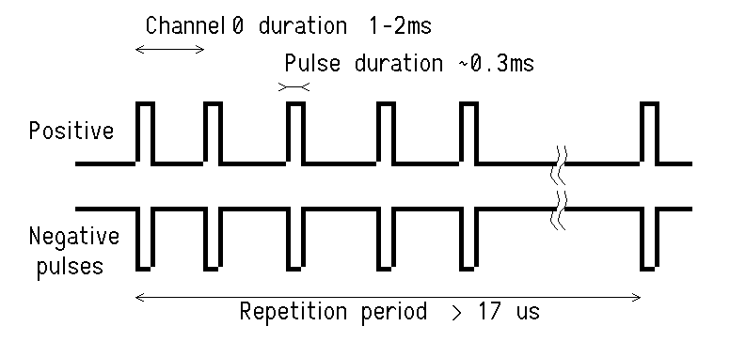 | 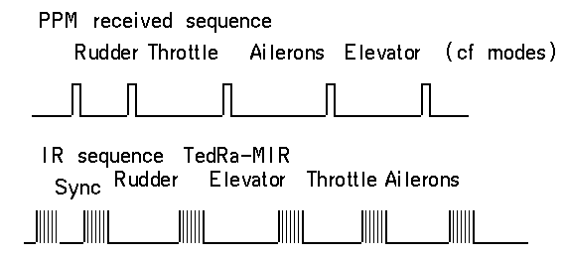

The DIDEL Radir connector is an AMP-Micromatch 4-pin connector  Pin1 (brown) Ground  Pin 2 (red) Not connected  Pin 3 (orange) Signal (0 to 5V)  Pin 4 (yellow) Radio power supply (8.4 to 12 Volts) | 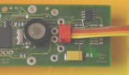
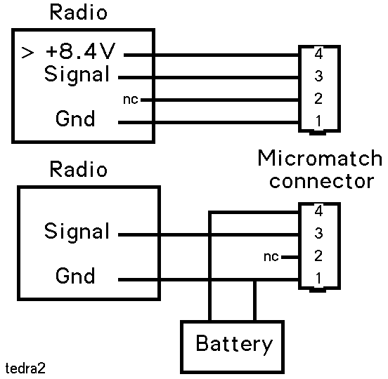
The Radir four wire cable is either connected to adequate points inside the radio, or to the trainee's plug frequently provided.

An oscilloscope is required to find where this signal is availabe, if the documentation is not complete enough. On some high grade computer radios, the HF part is a plug- in module, to be more easily compatible with the frequencies authorized in different countries. The signal can be picked up on that connector. The power supply should be at Volts to power the IR diodes.

If the signal is higher than 5V, a resistor bridge is required to bring the voltage down to 3-5V, see the Graupner 4014 doc.

An external battery can be used, as shown in the diagram.

A Led blinks when in operation.
The radio functionnality is not modified by the cable going to TedRa. It is recommended to remove the antenna when TedRa is connected to avoid disturbing some other radio users.

8 additional diodes can be soldered if required.

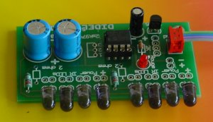 | 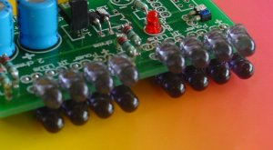

Radir is available as a kit easy to solder since there are no SMD components. Cost is only 40 CHF, about 32 USD
The 8 additional diodes are sold for 10 CHF.
The assembled and tested version costs 70 CHF.

Connection to radios

We rely on our customers to send us a picture and short description of their modifications, and we will add them to the list below. As mentionned before, flight simulators document several trainee's plug, but they do not say on which pin the power can be found (use a voltmeter).

See http://myweb.absa.co.za/eric.brouwer/radio_connections.htm for
Futaba (FM), Conquest FM FG FM 4VF, 6VA, 6VH, 6DA 6YF, 6YG, 6XA, 6XAs 6XH, 6XHs 7U, 8U, 9Z
Futaba (AM) FG Series, FP-T7FG FP-T6FG, FP-T5FG FP-T4FG, FP-T4FN FP-T5FN, FP-T6FN

Futaba 9, 9C Cirrus (900 FM) Cirrus Four-XL, Six-XL For Cirrus 6, s

Tower Hobbies System 3000 4FM, 6FM
HITEC Focus 4, Focus 6,Laser 4, Laser 6, Flash 4, 4X, 5, 5X Prism 7, 7X,Eclipse 7
JR Quattro, F400 , F400EX, XF421EX, XF622, XF631, XP642, XP652, XP662, XP783, XP8103, 10 Series
Airtronics Radiant RD6P, RD6H RD6000 Series Vangaurd Series VG4R, VG6DR, VG6H VG400, VG600
Sanwa VG400 MPX Picoline Digifleet, Omega

See http://n.ethz.ch/student/mmoeller/fms/index_e.html for
Robbe Terra Luna
Futaba Skysport Robbe 4-channel
Robbe Starion Hitec Flash 5
Europe MPX sprint Graupner FM 314
FM-SS PROFESSIONAL 7/14

Fire Electronics microprop proportionally 4/6
Robbe Promars
Futaba-F14
Graupner MC-15 JR FM6014 / PCM18

Didel had only several radios to analyze. Thanks to Urs Szymanski and J.C. Zufferey

Multiplex Europa Sprint

The Multiplex Europa sprint is easy to adapt, since a DIN 5 pin connector is provided on the top of the box.
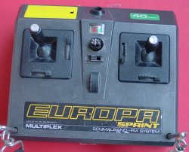 | 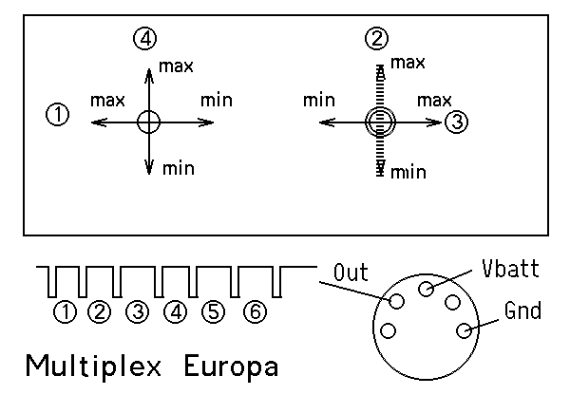

The three signals for the TedRa can be taken from the DIN connector:
DIN pin 3 toward Micromatch pin 1 (Gnd, brown wire)
DIN pin 2 toward Micromatch pin 4 (Vbatt, yellow wire)
DIN pin 4 toward Micromatch pin 3 (Signal, orange wire)

Multiplex Commander 2010

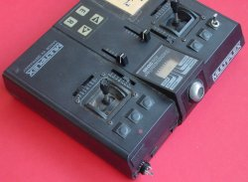 | 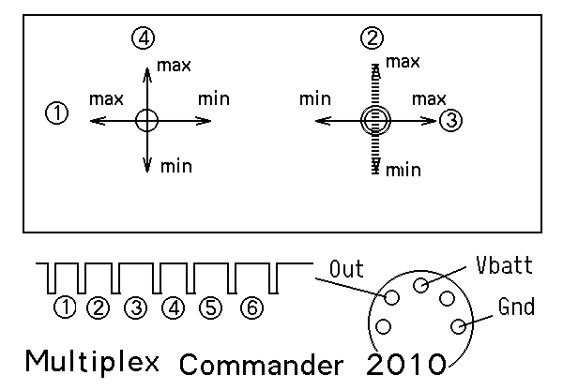

The three signals for the TedRa can be taken from the DIN connector:
DIN pin 3 toward Micromatch pin 1 (Gnd, brown wire)
DIN pin 2 toward Micromatch pin 4 (Vbatt, yellow wire)
DIN pin 4 toward Micromatch pin 3 (Signal, orange wire)

Robbe Starion

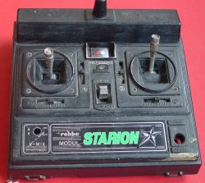 | 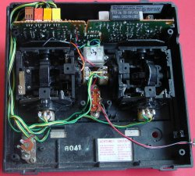

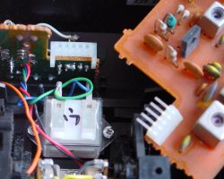 | 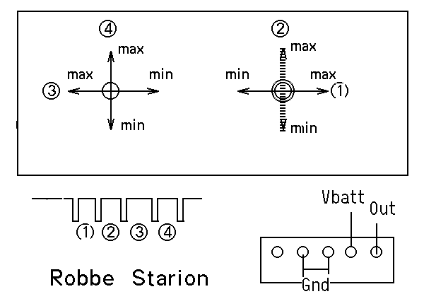

The Starion has a radio module on a separate bord. It is easy to remove that board and make a connector with a wire-wrap strip with the usual 2.54 mm pitch.

Robbe ProMars Rex

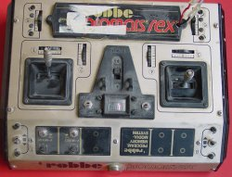 | 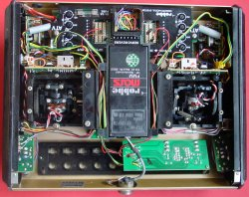

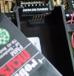 | 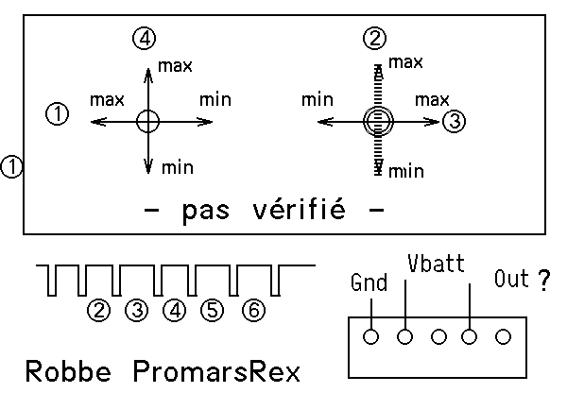
The Promars uses a radio module that can be easily removed. A connector can be inserted in place. We didn’t got any signal on the radio we tested, so we cannot guarantee our documentation.

Hitec Focus6

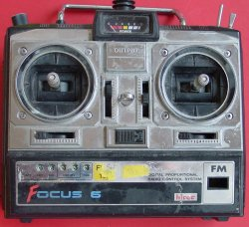 | 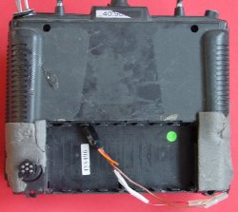

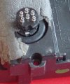 | 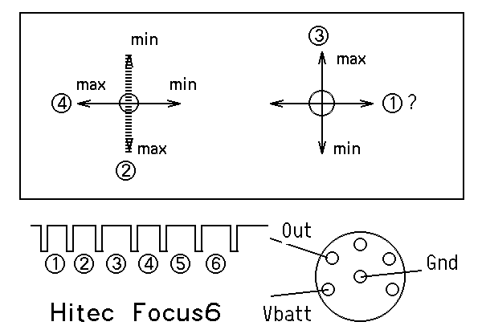
The three signals for the TedRa can be taken from the 6-pin DIN connector:
DIN pin 6 toward Micromatch pin 1 (Gnd, brown wire)
DIN pin 1 toward Micromatch pin 4 (Vbatt, yellow wire)
DIN pin 2 toward Micromatch pin 3 (Signal, orange wire)

Graupner 214

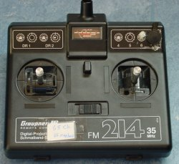 | 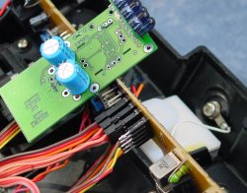
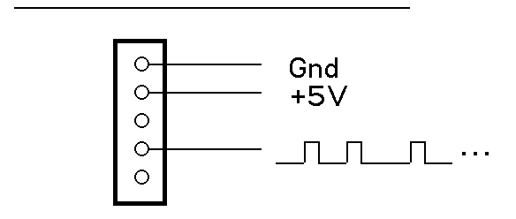

Graupner 4014

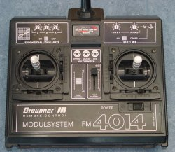 | 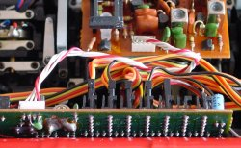

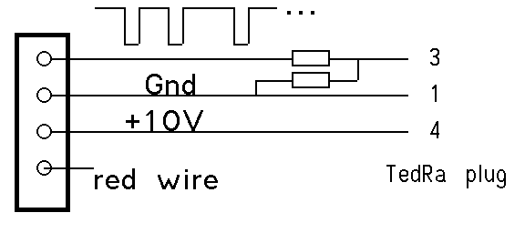 | The output is 0-10V. A resistor bridge (two 5 to 10 kOhm resistors) is required.

JR347
Robert Throssel from UK (robert.throssell@baesystems.com) has adapted Radir on his JR347. Ask him for details. | 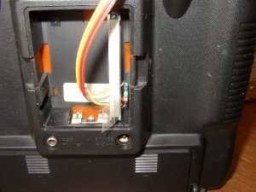

040928/jdn 041009us

