J.D. Nicoud, Mouette 5
CH-1092 Belmont, Switzerland
Tel ++41 21 728-6156, Fax ++41 21 728-6157
Email info@didel.com www.didel.com

www.didel.com/slow/mirted/Mip4A1.doc

Mip4A1 - 1-channel miniature ESC circuit

Mip4A1 is a 0.31g elecronic speed controller that decodes the 1-2 ms signal for a servo and controls one bidirectionnal channel, 0. 5 Amp.  A LED on the circuit blinks when a signal is received.  Cost is 45 CHF, about 27 Euros or 36 USD. | 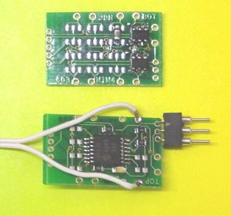

Mip4B2 - 1-channel miniature ESC circuit

Mip4B2 is a 0.42g circuit that decodes the 1-2 ms signal for two servos and controls two bidirectionnal channels, 0.5 Amps each.
A LED on the circuit blinks when a signal is received.
Cost is 52 CHF, about 33 Euros or 42 USD.

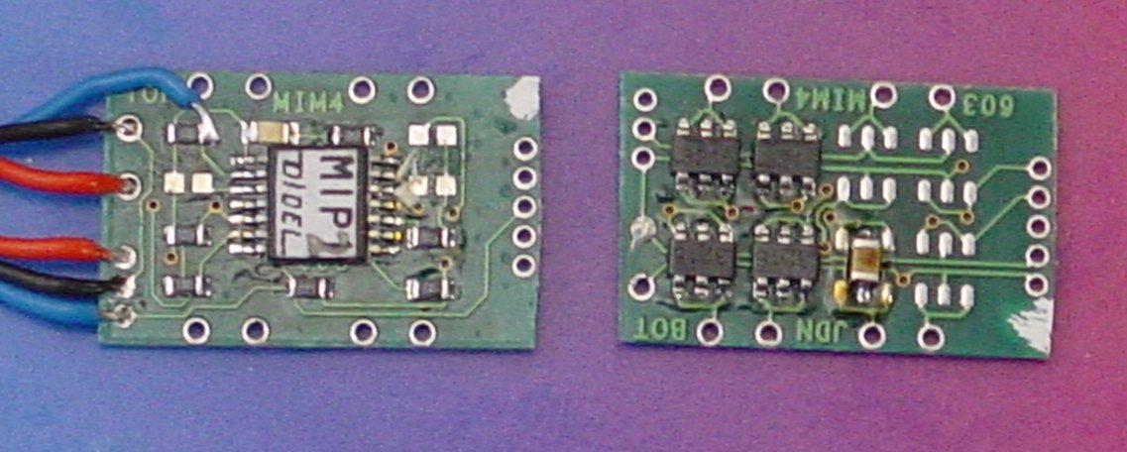

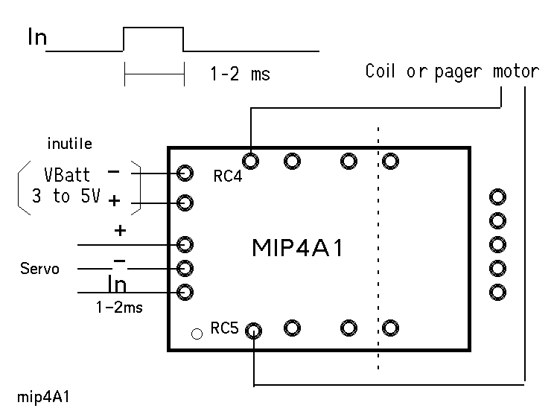 | 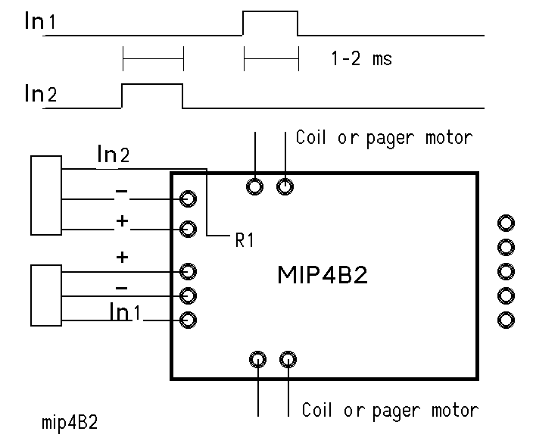

jdn 040118/us 0401

