CH-1092 Belmont, Switzerland  Tel +41 21 728-6156, Fax 728-6157  Email info@didel.com, www.didel.com | 
File http://www.didel.com/slow/mirted/IRsensors.doc

Comparing IR sensors

IR sensors used for IR reception do not exist in a small enough package. They have to be sanded down and we reply here to two questions: Does the sanding down degrade the performance, and is the TSOP 34838 better than the NJL21H380A. Didel was not able to get the NJL21H380A in medium quantities from the Swiss distributor. Many thanks to Mike Cripps (EFlight designs) who does the order for us in US (Mouser).  Price is comparable (1 USD in medium quantities). Pinout and external size is similar. |  | 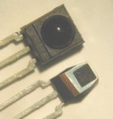  TSOP 34840 and top shield view | 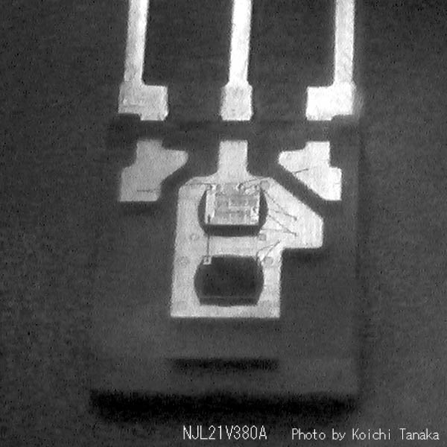  NJL21H400A inside (photo tanaka)
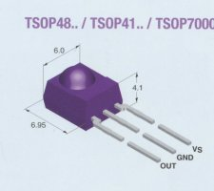 | The NJL21H380A does not have a top shield and can be sanded down to 0.1g (and even less), while the TSOP cannot go much below 0.3grams.  Selection of a 40 kHz circuits (TSOP 34840 or NJL21H400A) depends on the transmitter modulation frequency, but the filtering band is very wide (see later).

Pictures of TSOP and NJL sanded down. | 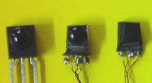 |  | 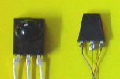
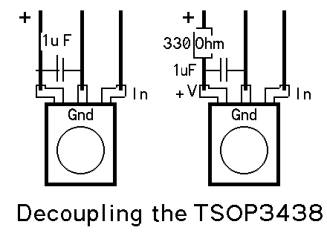 |  | 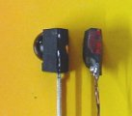 |  | 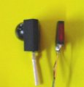

It is good to have a filtering capacitor (0.1 to 1 uF) close to the receiver (absolute requirement with the NJL) . A serial resistor (300 Ohm) is also recommended, but we do not put it for mechanical reasons and because we feel it is not essential.

As explained in www.didel.com/slow/mip/Ira.doc, the transmitter sends bursts of IR pulses that are filtered by the receiver. The PPM format (1-2 ms spacing between pulses) is used on DIDEL transmitters.
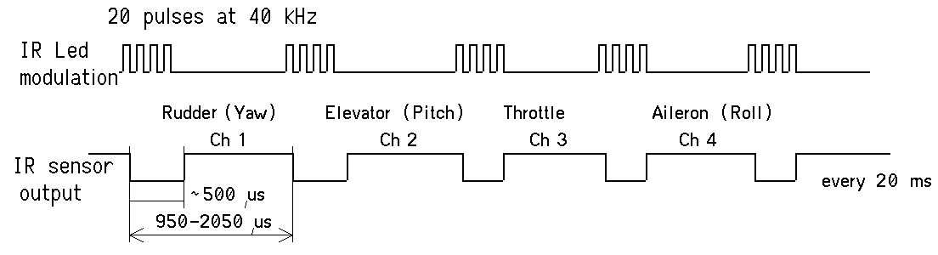

Comparing the TSOP and NLJ

Both manufacturers propose circuits at different frequencies, 36, 38, 40, 42 kHz. We built a generator to modify the frequency and we noticed that the filtering is very poor. Both the TSOP and the NLJ at 38 kHz decode signals in a 30 to 50 kHz range with no noticeable loss.The TSOP has a wider band. When the signal is weak, the TSOP can suddenly loose it without any change of distance. If the signal intensity recovers smoothly, a significant increase is required. But if the signal is interrupted for a fraction of second, the TSOP recovers the signal immediately without any intensity change. This confirm what Alan Sherwood fro Austalia had noticed: "If the Rx loses the signal due to range, I have to move the Tx back much closer to the Rx, to within 4-6 metres, before it regains the signal. This is repeatable. It will, however, regain at longer range if I cover the IR LEDS with my hand then quickly expose them.

The oscilloscope shows that the NLJ is faster recognising the signal, but it widens the pulse.
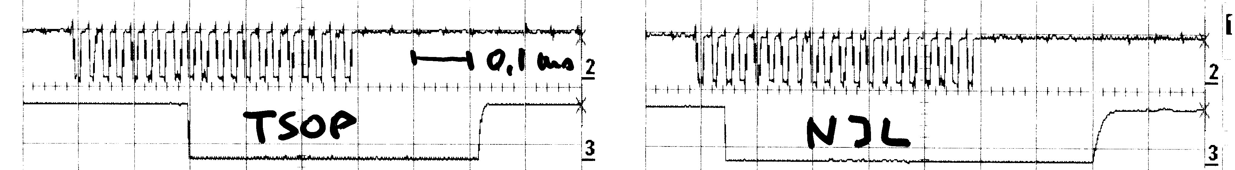

For comparing the sensors, the test consisted in aligning 2 TSOP and 2 NJL and hiding the transmitter below the table until the signal vanished. A 4-track oscilloscope pictures the signal. The first two tracks correspond to the the NLJ, the last two to the TSOP.  As a first result, sanding down does not influence in a noticeable way the sensitivity. All the shots below are made with the sanded sensors. | 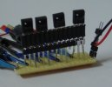 | 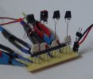

The first oscilloscope shot (0.5 ms between vertical lines) confirms that the NLJ widens the 0.5 ms pulse to 0.7ms. The software must adapt to this. The second shot (10 ms between vertical lines) correspond to a good reception for all sensors (less than 5m direct view).
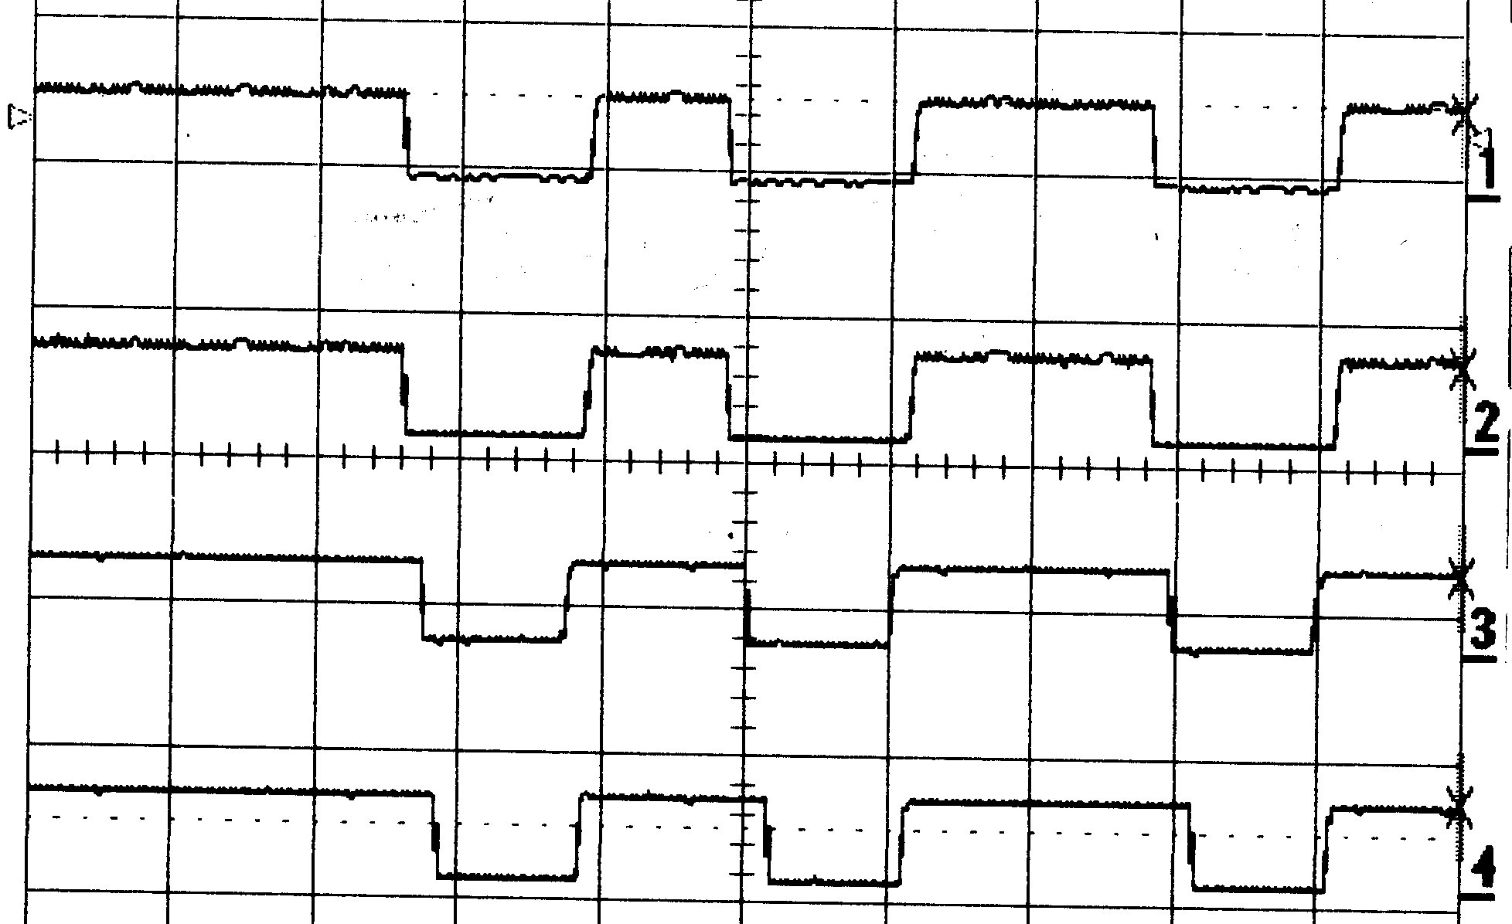 | 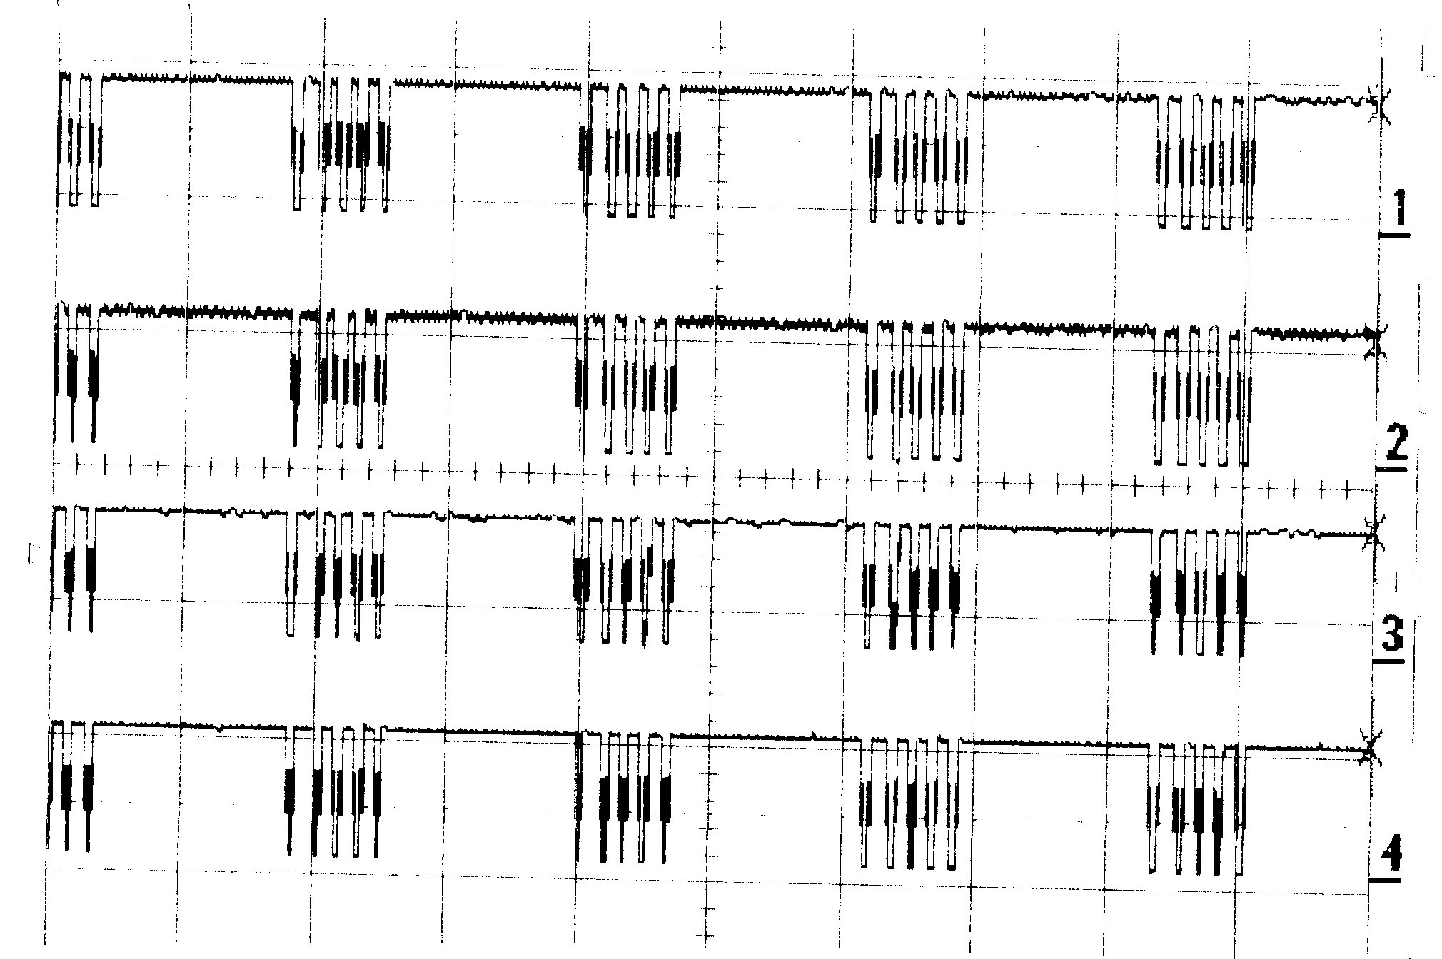

If the signal get weaker, The TSOP loses it first. A additional significant attenuation is required before the NLJ looses pulses. We guess the distance is 50% longer (not enough space in the lab to do the testing).  One additional weak point of the TSOP is an important hysteresis in the sensitivity, as mentioned before. | 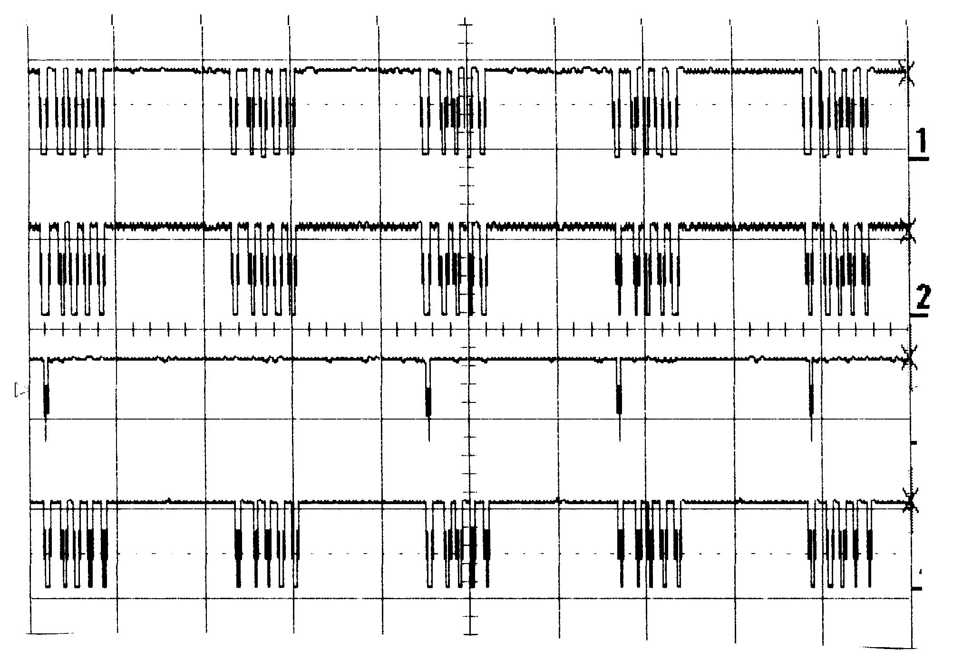
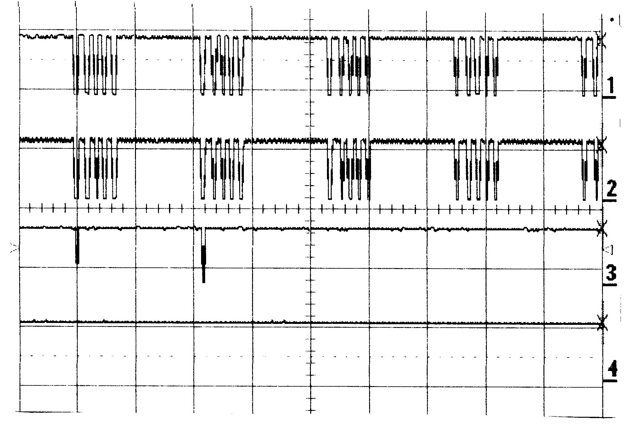 | 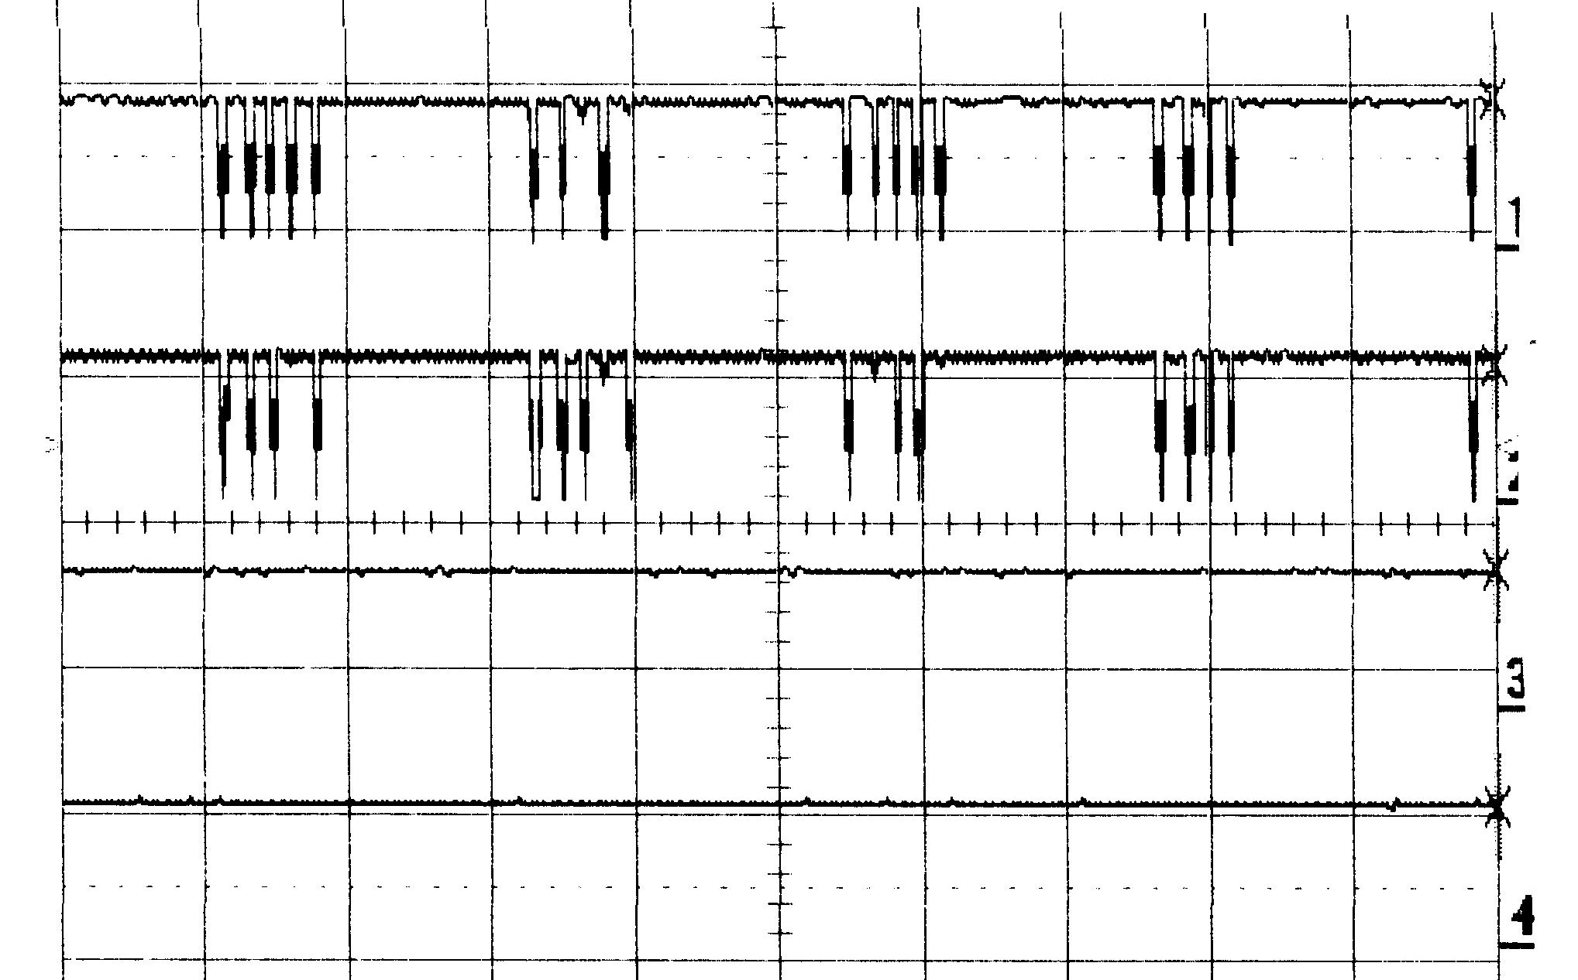

At 3 Volts instead of 5, there is no noticeable change in the sensitivity of both sensors.

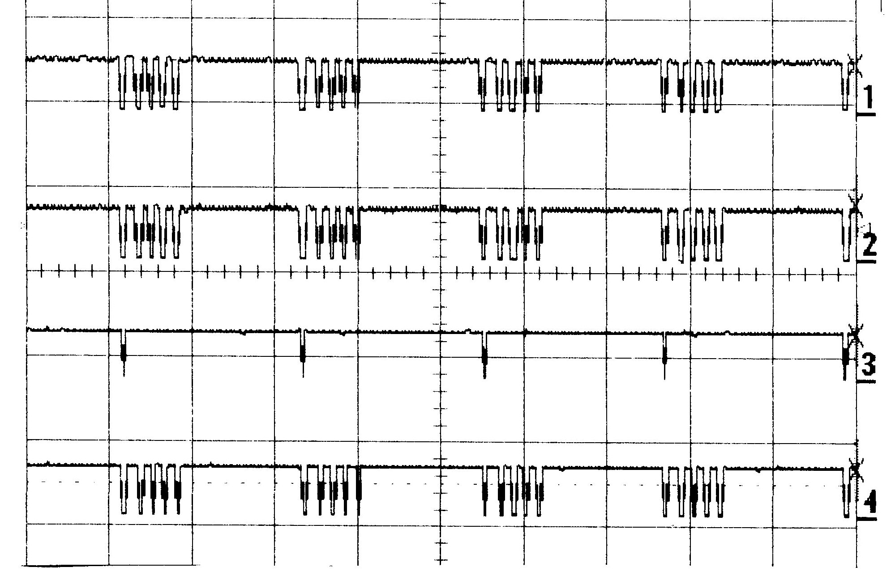 | 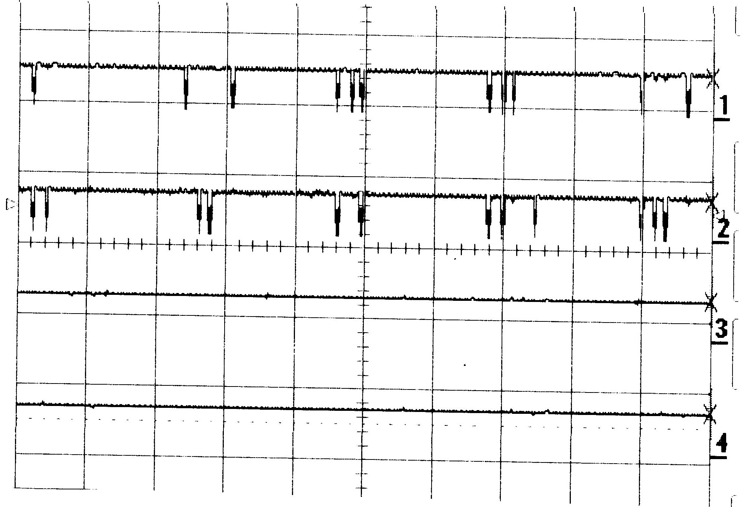

When there is no signal (transmitter off), the TSOP increases its gain and gets noise pulses. The NLJ stays quiet. This seems contradictory with the reduced sensitivity of the TSOP compared to the NLJ, but there are some tricky electronics inside these chips.  In conclusion, The NLJ seems to be better in all aspects and Didel will stop providing the TSOPs. | 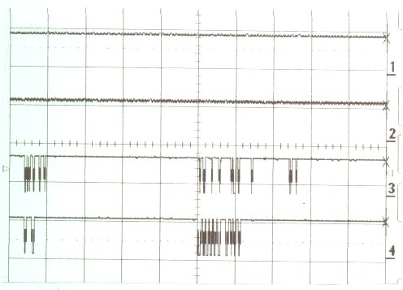

jdn 041128us/071204

