CH-1092 Belmont, Switzerland  Tel +41 21 728-6156, Fax 728-6157  Email info@didel.com, www.didel.com | 
File http://www.didel.com/slow/mirted/Emir.doc

EMIR – IR transmitter with battery charger
Obsolete – see http://www.didel.com/Ir/FamEmIr.pdf

Thanks to its collaboration with Plantraco (www.plantraco.com), Didel has developed a 3 and 4-channel convenient IR transmitter with two joysticks. It is powered by 4 AA batteries and includes a 2-position battery charger for 20 to 140 mAh batteries. Acoustic feedback monitors the voltage of the battery and warns you if you do not switch off after usage.

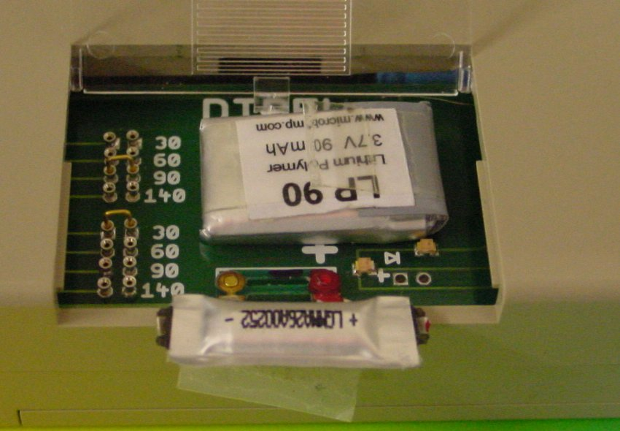
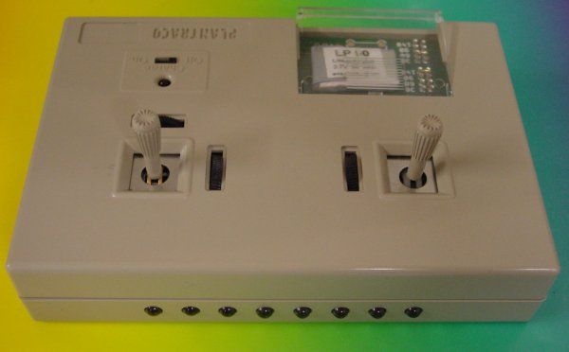

Infrared transmissions are perfect for very slow flyers, and have the advantage of not being disturbed, or disturbing radio users. IR receivers are the lightest that exist, down to 0.15 grams.
Fly IR at home or fly in a model exhibition or meeting, not bothering other's frequencies, controlling your 1m/s model !
IR was pioneered by Zigras in 1997-2001, but he had to stop when he ran out of the 200 boxes with one joystick he had been able to get and adapt with his own electronics.
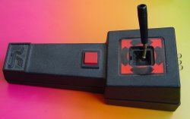 | 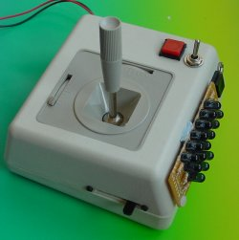 | 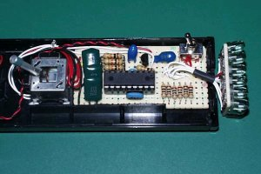
Zigras model | Zigras model | Tanaka transmitter

Koichi Tanaka in Japan is providing all the documentation on his IR transmitter and receivers, see http://www.cityfujisawa.ne.jp/~toko/pic/index.html.

Didel developed the Ted handle, so the Celine could be packed with the transmitter in a small box, and the TedRa, to be connected on a radio. Both products are not available any more, Ted is replaced by the EMIR discribed here, and TedRa by the RADIR adapter having up to 16 diodes, which stays the est solution for those prefering to fly with their usual radio.

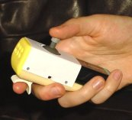 | 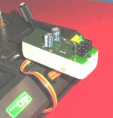 | 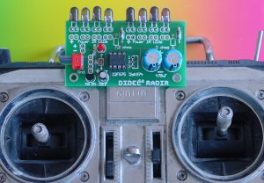
Ted | TedRa | Radir

On the EMIR, the two joysticks have been wired as below. The throttle direction has no return spring. There is no possibility to change the assignement, but we may provide a software solution if there are enough requests for one of the several other ways found on radios.

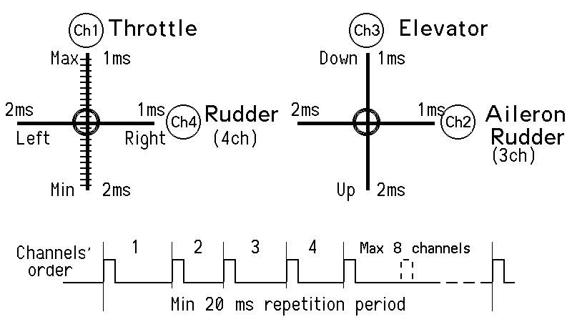

The joysticks used on the EMIR have a stupid limitation oft 45 degrees, manufacturers take time to addapt. Tanaka dismantled the Noble joystick and filed the opening square to avoid having a loss of amplitude at 45 degrees.

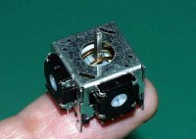 | 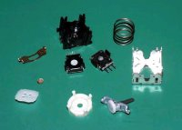 | 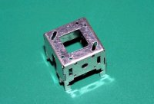

Didel software solution on the EMIR is to give the min and max pulse duration of 1/2ms for 75% of the amplitude of the joystick. The effect of the trim potentiometers is to shift the 1-2ms window.
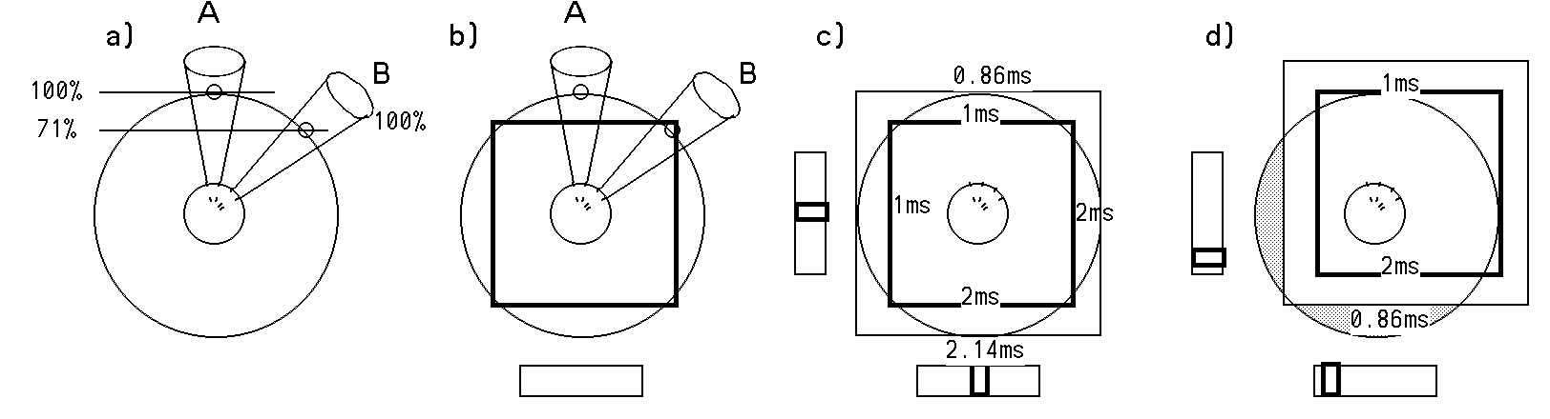

Two EMIR models are available. EMIR has four channels, but the rudder joystick on channel 4 does not have an associated trim. The corresponding analogue input has been replaced by a voltage source, so you get an idea of how good your batteries are when you power-up:
- If the voltage is below 5.6Volts, you get a bad noise ate power-up and bips every 2 seconds if you continue.
- If the voltage is below 4.9Volts, you get a waning at power up, but no bips as long the voltage is above 5.6V
- If the voltage is between 4.8 and 5.2Volts, you get 1 to 4 clear bips at power up, about one bip per 0.1 volt.

EMIR is available for the price of 140 CHF, about 95 Euros or 120 USD.

EMIR-4T has a trim on channel 4 and no voltage measurement; it is more expensive due to the need to add a slot for the trim on the Plantraco box.

EMIR-4T is available for the price of 160 CHF, about 105 Euros or 140 USD. It is not sure if it will be maintained as a product.

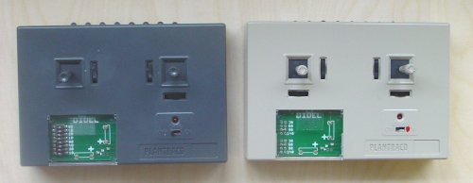

The on/off switch has three positions. Full left, the battery is off. In the middle position, the charger only is active. Full right, the LED next to the switch is on, and EMIR emits a certain number of bips. Five on Emir-4T. A variable number (1 to 4) on EMIR depending on the voltage on the battery.
If there is no action on the joystick for about two minutes, a decrescendo is played, and the power is cut on the LED, to save the battery. Power is re-established as soon a joystick is moved.

1.5V AA batteies have to be used for maximum power. NiCd batteries can be used, but the soft will consider the voltage is too low, and you will get only 40% of the Infrared power; it may be enough in most cases.

As IR receivers, Didel proposes the Mb2x and Mb4x controllers, see www.didel.com/slow/mip/Mbxx.doc

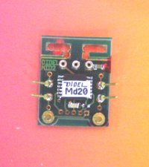 | 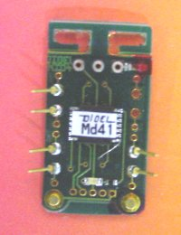 | 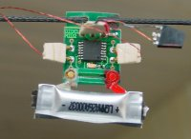
jdn050203/us271204

