CH-1092 Belmont, Switzerland  Tel +41 21 728-6156, Fax 728-6157  Email info@didel.com, www.didel.com | 
Filehttp://www.didel.com/slow/mip/Mdxx.doc

Md4x – 4/6-channels

Md2x – 2/3-channels

Miniature controllers for base radio or IR receiver

Didel controllers have a PPM input provided by a radio or IR receiver. Outputs are transistor bridges of 0.6 Amps. Several models exist to match your model constraints. They are based on two PC boards with Bahoma magnets. They are compatible with the Emir and Radir transmitter, and apparently also with the Tanaka transmitters.
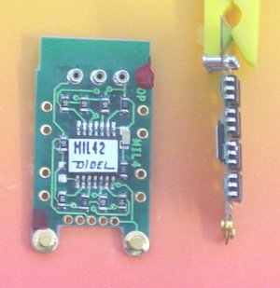 | 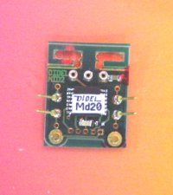
Md4x with 4 bidirectional bridge and bahoma plug  0.58g with magnets and connectors  60 CHF, ca 39 Euros or 48 USD | Md2x with two bidirectionnal bridges  0.38g with magnets and connectors  50 CHF, ca 33 Euros or 40 USD
Software options:
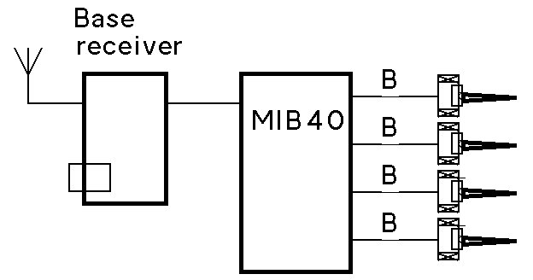 | 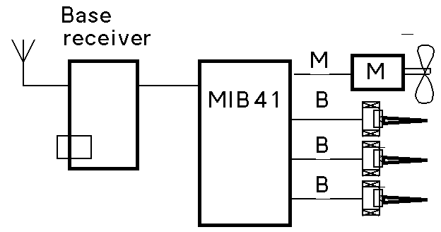 | 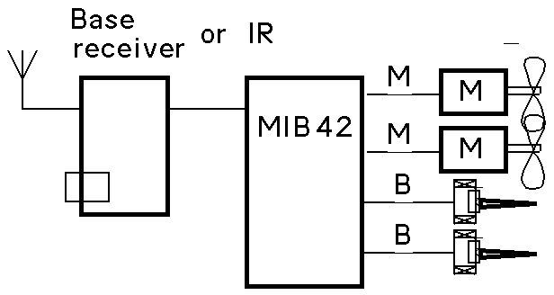
Md40  Helicos, blimp see Md4x doc | Md41  3 or 4-channel planes Md4x doc | Md42  Twin motor planes Md4x doc
 |  | 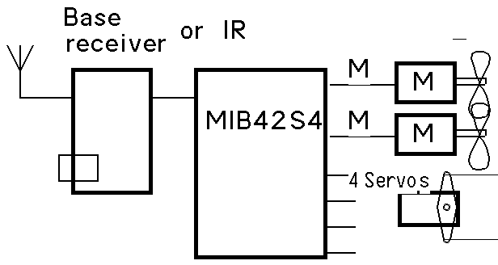
 |  | MIB42S4 – not yet programmed
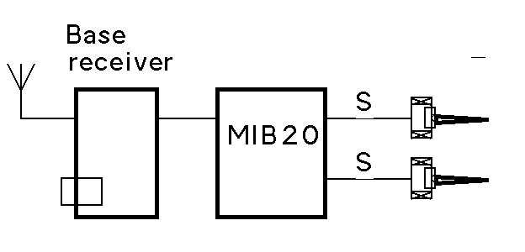 | 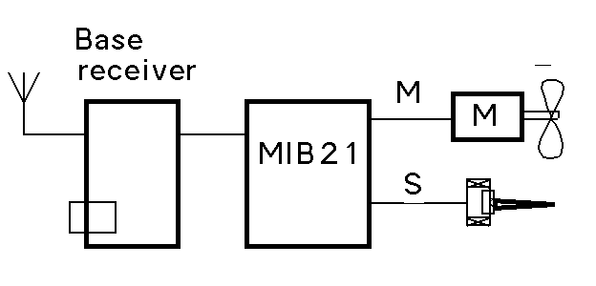 | 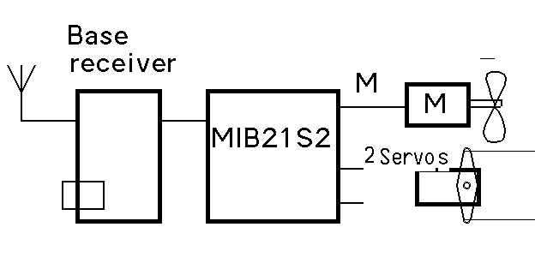
Md20 see Md20 doc  For Gasparin or rubber motors and gliders | Md21 see Md21 doc  Simple 2-channel plane | Md21s2 see Ms21s2 doc  3 channel plane with 2 servos

Radios transmit the joystick positions as PPM signals, supposed to be min 1ms, max 2ms, center 1.5ms. Return-spring joysticks return a pulse close to 1.5ms. Trottle is supposed to be in non active position, with a value close to 1ms or 2ms pulse, depending on the radio. At power-up, the controllers checks that the PPM information exists and is in the good range
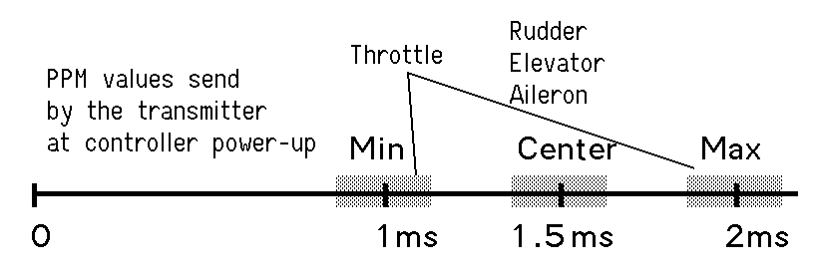

Default channel sequence on MDxx controller
 | chan1 | chan2 | chan3 | chan4 | Application | Availability
2ms= | no powerright | right | up | right up
Md20 | not decoded | Rudder | Elevator | ignored | Gasparin, rubber, glider | now
Md21 | Throttle | Rudder | ignored | ignored | Simple plane | now
Md22 | Mot/act | Mot/act | ignored | ignored | Blimp
Md22M | MotLeft | MotRight | ignored | ignored | Twin with diff. drive
Md21S2 | Throttle | Rudder servo | Elevator servo | ignored | Normal plane with servo | now
Md2S2M | Throttle | Elev1 | Elev2 | ignored | V-tail plane
Md4x
Md40 | Mot1 | Mot2 | Mot3 | Mot4 | Blimp, helico | now
Md41 | Throttle | Ailerons | Elevator | Rudder | Normal aerobatic | now
Md41M | Throttle | Elev1 | Elev2 | Rudder | V-tail
Md42 | Throttle1 | Throttle2 | Elevator | Rudder | Twin motor | now
Md41S2 | Throttle | Aileron/Rudder | Elevator | 2 servos | e.g. with landing gear
Md41S4 | Throttle | Aileron servo | Elevator servo | Rudder servo | chan 5 landing gear
Click on first column items to get details
Note on PPM 1-2ms to actuator conversion

On several radios, the PPM signal never goes below 1.05 ms, or above 1.95 ms. MDxx controllers provide a 0% to 100% action in this range. This limit slightly the sensitivity, but guarantee a 100 % action with all radios, even if trimmed. Indeed, in the figure below, the straight line is a stair, with 32 steps for the full range.
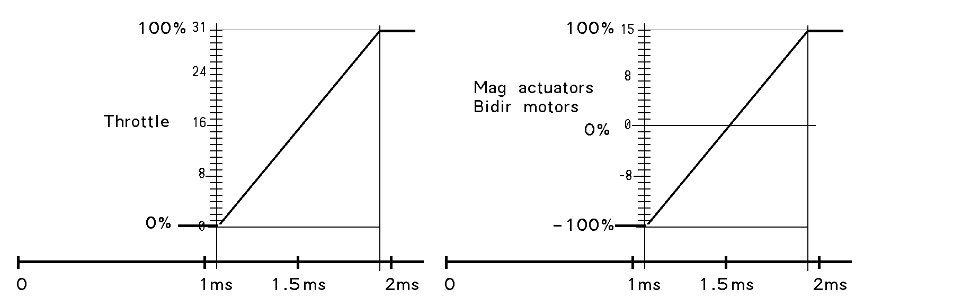

0411226jdn/041009us

