CH-1092 Belmont, Switzerland  Tel +41 21 728-6156, Fax 728-6157  Email info@didel.com, www.didel.com | 
File http://www.didel.com/slow/mip/Ira.doc

Didel IR solutions and evolution path

1. Model control

Nowaday, infrared control (IR) is the lightest solution for controlling a very slow flying plane. It is fully suitable for home flying, and works well even outside when distance is kept short, say below 5-10 meters. Radio components are getting smaller, and adequate radio receivers will be available in a near future, but IR will stay due to its advantages.

IR sensors are light, down to 0.1 gram. It will take some time until radio receivers will be as light, but base radios in the range of 0.3 to 0.5 grams will surely appear in 2005.
Didel proposes a modular solution that gives the flexibility to migrate from IR to radio, not touching the plane wireing , when the technology will be here. The weight penalty is less than 0.3 grams and a further advantage is switching between radio and IR will be done in seconds. There are places where radio control is not suitable or not allowed; IR is always possible, exept in full sun.

The receiver must be a plug-in module. Now one changes the quartz to work on a different frequency. With Didel concept, one changes the receiver, and uses on the same plane one day IR, another day 40 Mhz in Europe, another day 72 MHz in US, etc.

The key idea is to separate on the plane the receiver, that depends on the transmitter, and the controller, that depends on the model. The receiver, an IR or radio module, maybe Bluetooth some day, plugs on the controller. When everybody will use this concept, you will fly a friend's model with your own radio just by plugging your own base radio module on your friend's plane!  The model (plane, glider, helico, boat) uses several actuators and motors that require a given number of channels to be controlled; this has nothing to do with selecting a radio frequency. The receiver must be a plug.in module that converts the radio or IR signal and does not split the signal for the different channels. The controller do this job, taking care of the motors and actuators that control the plane. | 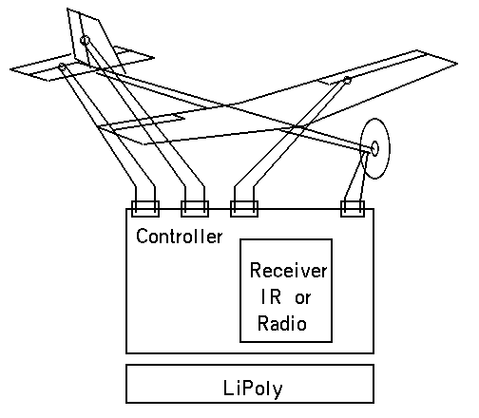  Fig 1 Receiver as a plug-in module

The transmitter encode and mix the joystick position into a PPM stream before converting to an adequate radio signal. The physical link is of no concern to the model. Didel works on the logical link that does not care how the data will be transmitted, and leaves to specialists the delicate technology of recognizing and radio or IR signal among parasistic signals.
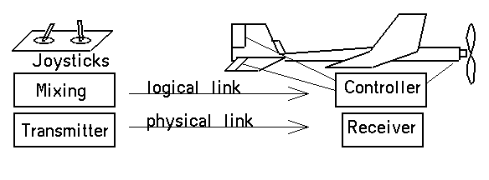
Fig 2 Logical and physical link between the transmitter and the model

Traditionnal radios receivers have one output connector for every channel. Before the channel separation, the receiver gets from the radio high frequency (HF) part a PPM serial stream, explained in section 3. Using the PPM format for the IR stream provides the required compatibility between IR and radio. A three pin connector (ground, power, signal) links the receiver and the controller. The general usage of LiPoly batteries specify 3 to 4.2V for the power supply.
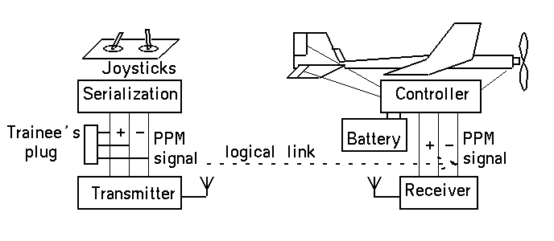
Fig3 PPM logical link

At the radio transmitter level, the PPM signal exists between the controller that mixes the joystick information and the HF part. The PPM signal is frequently available on a connector that allows the connection of a second transmitter, used by a trainee, the radio part of which is not used.

2. Traditional radio solution

Radio receivers have different frequencies and are either narrow band, with a removable quartz, or wide band, responding to all frequencies of the band.  3-pin connectors (power and signal) are usually provided for the servos, but the pinout and connectors may vary from one manufacturer to another. These connectors contribute significantly to the receiver weight.  Fig 3 Typical RC system | 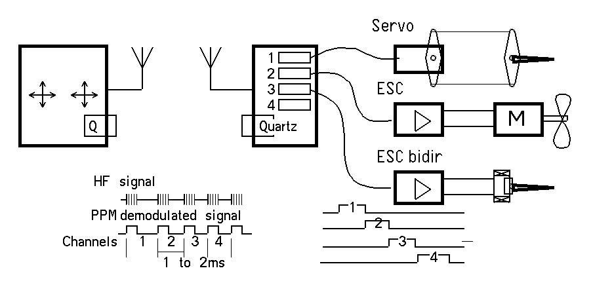

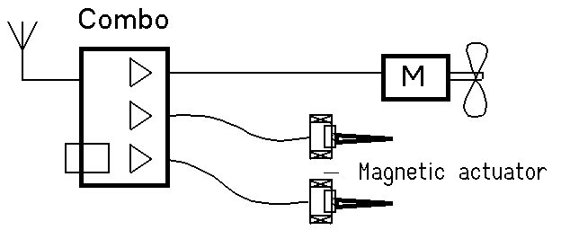 | Combo receivers include weak or strong amplifiers for the propeller motor and the magnetic actuators.  Fig 4 Typical Combo (JMP, Coural, RFFS)

3. IR versus radio

IR remote controller sensors include a photo sensor and an integrated circuit that amplifies and filters the received light (fig 5). Only 40 kHz pulse (+/- several kHz) are recognized by the circuit, the output being active low when a 40 kHz signal is received.Streams of 20 pulses (500 ms) are compatible with PPM standard. IR receivers filter noise and output the envelope of the pulses (fig 8).
Using one of the many IR protocols that exists for TV IR remote control is not adequate.

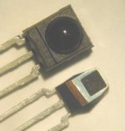 | 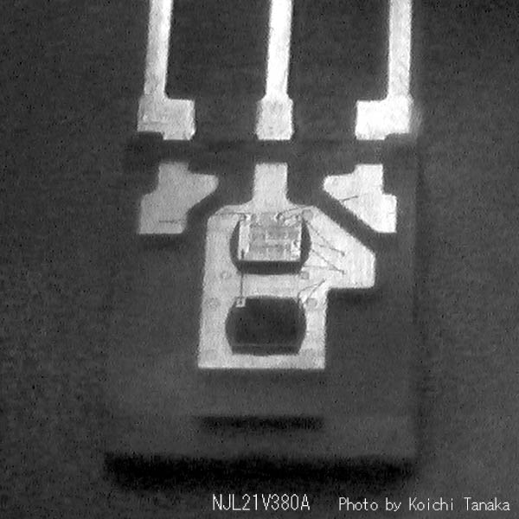
Fig 4 TSOP 34840 and shield view | NJL21H400A inside (photo tanaka)

The 3-pin package of the lightest IR sensors is rather heavy (0.5 grams), specially for the TSOP 34840 that includes an additional shielding. The NJL21H400A used by Tanaka does not include the top shielding and is lighter. Very light SMD phototransistors exists, but one need to add some own electronics to amplify and filter the signal.

IR sensor packages can be sanded down if one understand their construction. Following pictures shows several TSOP and NJL devices brought to a minimum weight. One need of course to keep some plastic around the silicium chips and metal legs, and not excessively heat the circuit when machining.

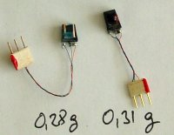  Fig 5 Sanded down TSOP receivers. | 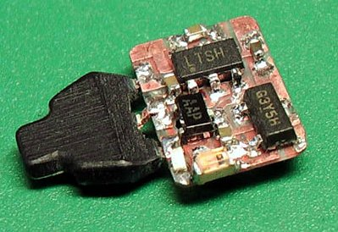  Tanaka receiver and sanded NJL sensor (0.3g)

Radio receivers includes the channel separation, and combo receivers include amplifiers for the propeller motor and magnetic actuators. They weight 1.5 grams and more. The receiver part, named the base receiver, converts the radio signal of a given frequency into a PPM signal. The PPM signal is then separated by a microcontroller.

Very light base receiver, that compete with IR receivers, have been designed. The Nick leichty 27 MHz receiver pictured below , weights 0.2 grams.

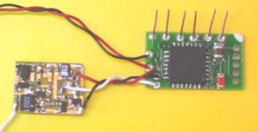  Fig 6 Nick Leichty base receiver and MIP3 (0.65g total).  Right: the blue wire is the PPM output. | 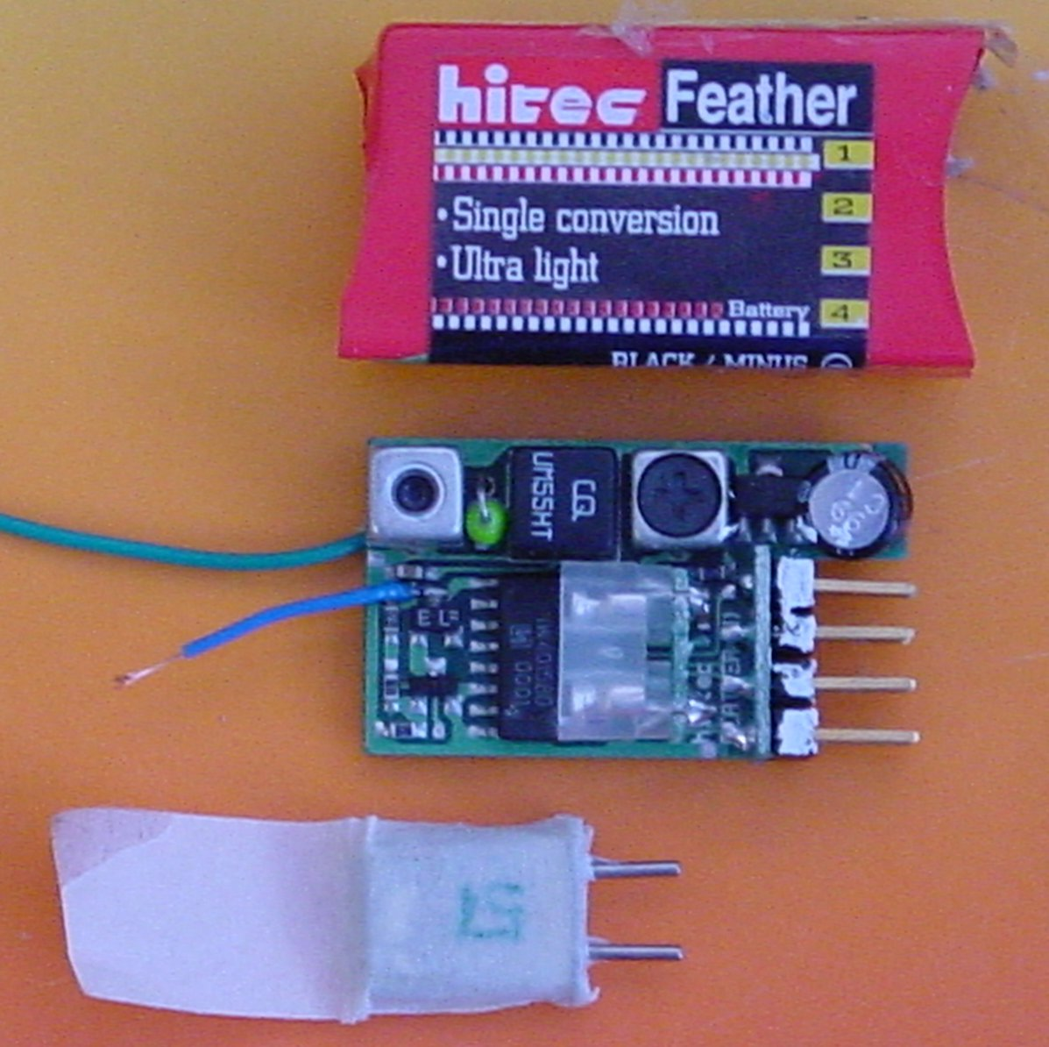

4. PPM standard

PPM (Pulse Position Modulation) is a simple way of sending up to 7 analog values on a single line. A stream of 8 pulses separated by a 1-2 ms duration (max total of 14 ms) is repeated every 20 ms.
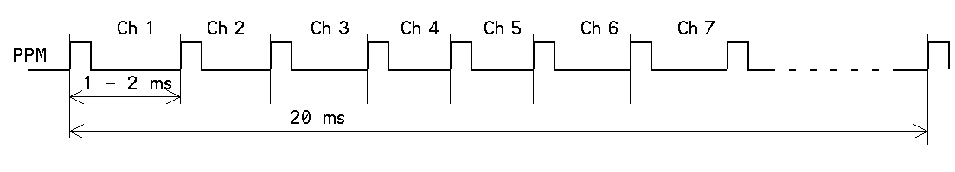
Fig 7 PPM signal

The duration and the polarity of the PPM pulses may differ; the distance between pisitive edges is what is important. Radio transmissions frequently us 200 to 400 microsecond pulses. IR is 500 microsecond at the transmitter side.
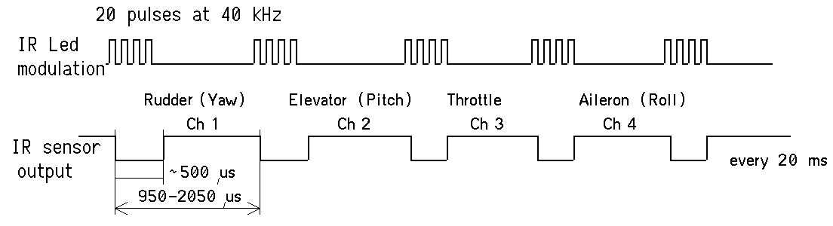
Fig 8 IR pulses with PPM compatible format
5. Channel sequence  All radios do not assign the joystick motions, the pulse duration and the channels in the same way. We standardize on the Graupner JR, as shown in figure 9.  Differences between radios was not a problem with multiplug receivers: the servo plugs had to be changed of position according to the transmitter.  With combos, e.g. on the JMP combo, the throttle channel is recognized because it is a 1 or 2 ms pulse at | 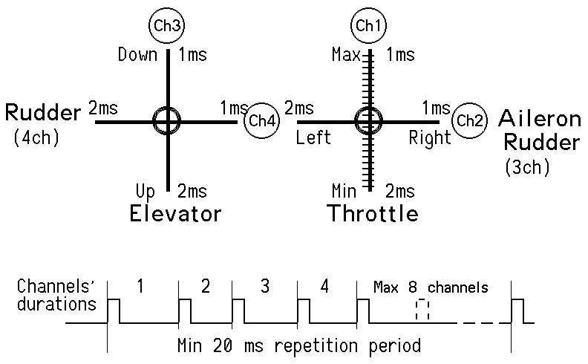  Fig 9 Joystick to channel assignation

power-up, while the other channels are 1.5 ms (joystick in the middle). The rudder and elevator may anyway have to be switched according to the transmitter. JMP documents the following situations found on radios:
Channel | a | b | c | d
1 | Throttle | Aileron (Rudder*) | Aileron (Rudder*) | Aileron
2 | Aileron (Rudder*) | Throttle | Elevator | Elevator
3 | Elevator | Elevator | Throttle | Rudder
4 | Rudder | Rudder | Rudder | Throttle
Fig 10. * 3-channels models. Bold shows the Graupner and Didel order .

Didel receivers adapts also to the pulse duration: some radios have 1ms for min throttle, other 2ms.

Remember, the objective is not to have to change the wiring when switching form a radio or IR; with very small planes, it may be cumbersome. A future MC41 version is planned to reorder the channels, with a special assignation sequence has to be played with the joystick at power up and then stored in Eeprom. This will allow to assign e.g. the right up joystick on the elevator, as several radios do it.

6. Didel IR transmitters

Didel controllers are now the new MIB family with Bahoma connector. Mib2 is 2 or 3 channels, Mib4 is 4 to 6 channels. Smart actuator solutions are prepared for still lighter planes.
MIP4 circuits (no Bahoma magnets) are still available till end of stock. MIM4 circuits are identical, but they are programmed with our 2002 IR protocol.

The transmitter/receiver IR solutions follows two paths: using your preferred radio, or buying a special low cost transmitter. Using an existing radio implies to connect an IR converter on the trainee's plug (see end of section 1).
What is available now is the Emir and Radir adapter, that connects on the trainee's plug of your radio. If a trainee's plug is not available or not documented, you need a oscilloscope to do find the signal. See www.didel.com/slow/xx/Radir.doc for the detailed Radir documentation. Radir is delivered as a low cost kit, or assembled with the plug for your radio, when documented.

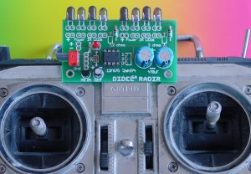 | 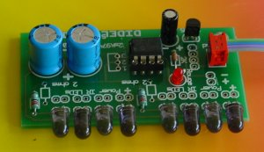
Fig 11 Radir installed | Radir close view

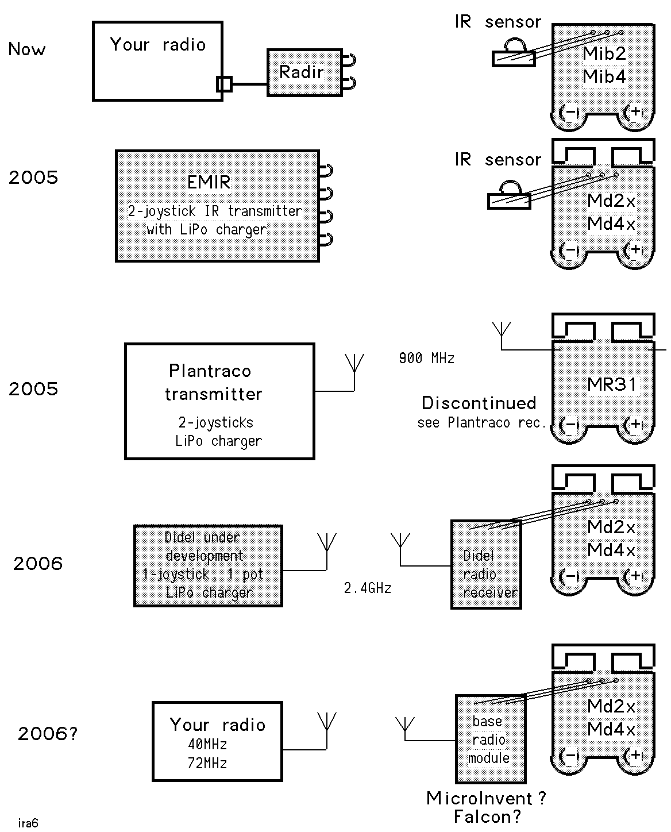
Fig 12 Evolution path
Didel uses the Plantraco boxes with two joysticks (developed for a Blimp) and has an IR transmitter that includes a Bahoma battery charger.  Fig 13 Picture of the EMIR Infrared Transmitter box with Battery charger for two Lipos (10 to 14mAh switch adjustable). | 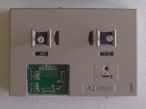

There are good hope to get early 2006 a lightweight radio solution to be plugged in place of the IR sensor. Contacts have been taken with MicroInvent and other radio manufacturers. Nick Leichty may provide his 27 MHz receiver as pictured in figure 5. If you are a radio or controller designer, see our recommendations for compatibility (www.didel.com/slow/xx/xx.doc): accepting a standard always widen the market.

7. Perspectives

The base receiver concept could bring a significant simplification in the wiring of models. Microcomputers got their flexibility (adding memory, disks, peripherals) from a bus system. We can do the same with PPM, and have a 3-wire bus going to the actuators, thus saving connectors and wires.
The difficulty however is to assign the channels, not having space for switches, but for standard systems as below, the units are pre-assigned.
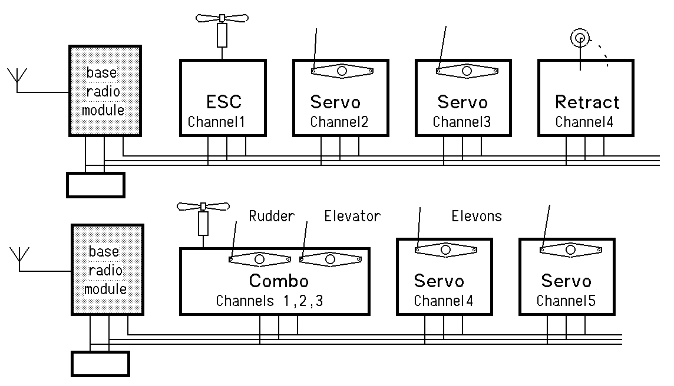
Fig 14 PPM bus

8. Didel controllers

Didel controllers have a PPM input provided by a radio or IR receiver. Several models exist to match your model constraints. They are based on three PC boards

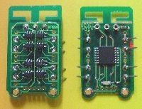 | 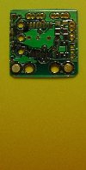 | 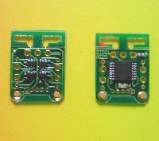
Fig15 Md4x with bahoma plug  4 buffered bridges for motors or Birds  0.58g with magnets and connectors | Mx31  2 buffered bridges for Birds and one power output for propeller | Md2x with two buffered outputs for motors or Birds  0.38g with magnets and connectors

Several software options are associated with these modules.

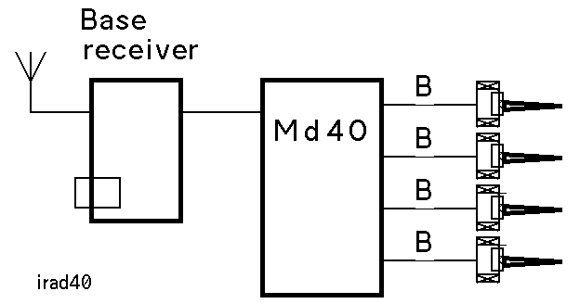 | 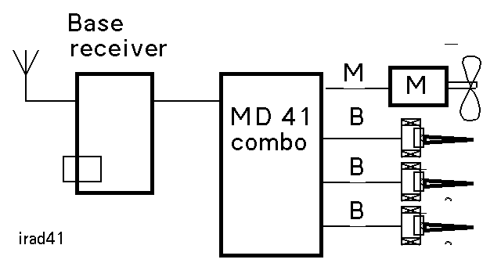 | 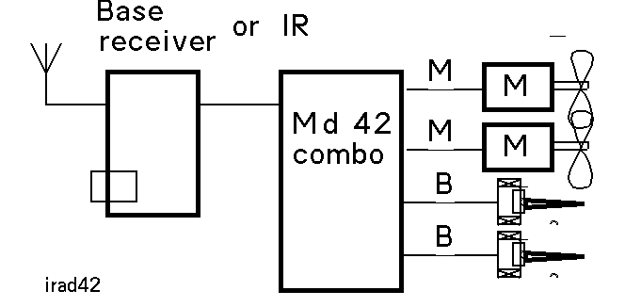
Md40  Helicos, blimp | Md41  3 or 4-channel planes | Md42  Twin motor planes
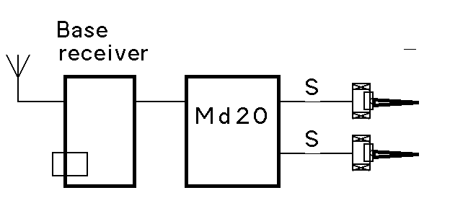 | 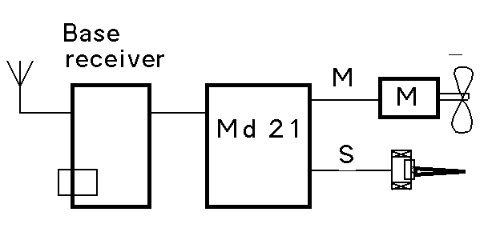 | 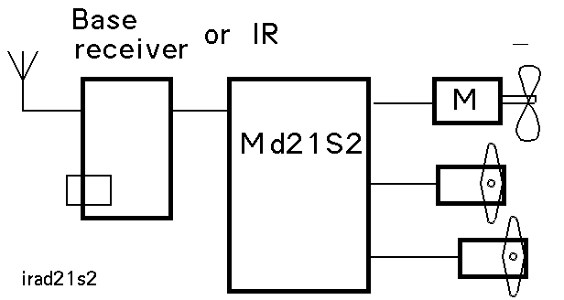
Md20  Gasparin motor, blimp, boat, car | Md21  2-channel planes | Md21S2  3-channel planes with servos

Fig 16 Mdxx programming options.

8. Bahoma batteries

Didel controllers and battery chargers include the Bahoma battery connector, so convenient for ultralight planes. Documentation is found on www.didel.com/slow/magnets/Bahoma.doc and www.didel.com/slow/magnets/LipolyMag.doc.
The Bapi-M and Bapi-B pieces makes the adaptation on any plane and any light battery easy. The additional weight compared to compeeting solutions, 0.1 to 0.3g, is really worth the convenience.

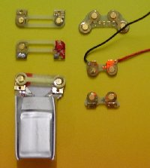 | 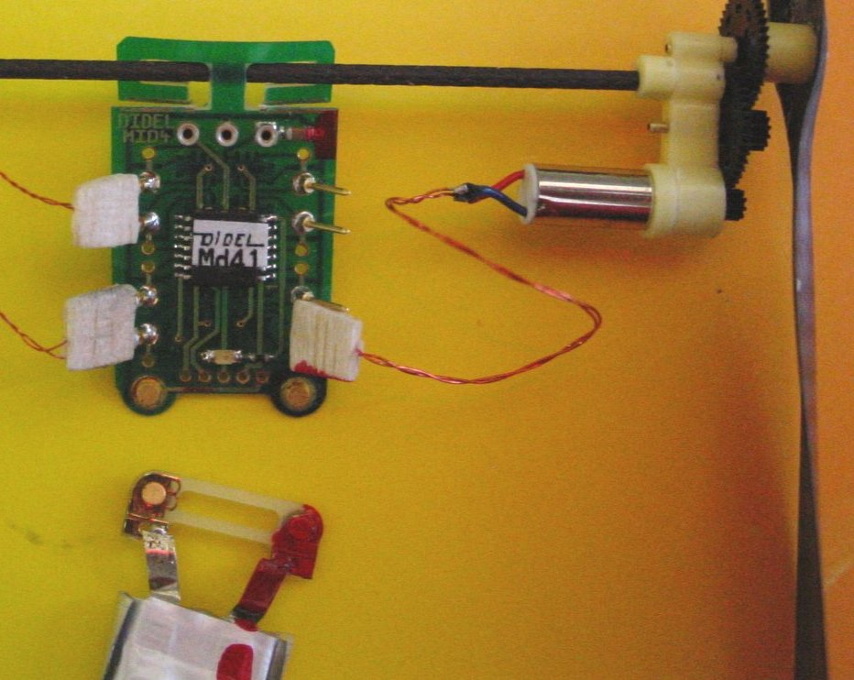
Fig 17 Bapi-M (on model) and Bapi-B pieces (on battery) | Lipo 20 mAh on Md41

Didel has developed the Tricha, a compact charger that charges up to three cells at the same time, allowing continuous flights with 4 cells: three in charge while one is flying!
A Bapi-M and two wires is easy to be made to connect the Bahoma batteries on any charger.
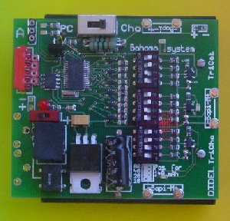 | 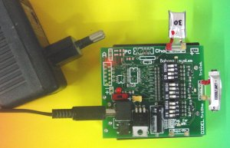
Fig 18 Tricha has jumpers to charge 10 to 150 mAh LiPoly batteries | Tricha with battery holder can be used on the field. Use a plug transformer at home.

9. Conclusion
Didel has now a clean and complete concept for ultralight models. The modularity allows for an easy change of the receiver and the battery, adding a minimum weight. These concept is used on the Didel microCeline, a 5.2 gram RTF plane you can fly even in a small house.

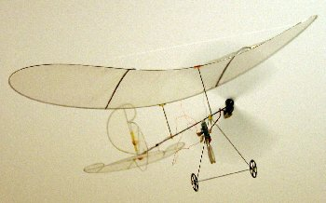 | Fig 19 The 5.2-grams 3 channels miniCeline RTF See the videos on www.didel.com  jdn041024/uz041009/jdn051022

