CH-1092 Belmont, Switzerland  Tel +41 21 728-6156, Fax 728-6157  Email info@didel.com, www.didel.com | 
File www.didel.com/slow/magnets/Plugs.pdf
Connectors for ultra-light slow flyers

Connectors at a pitch down to 0.8mm mm exist, but they are very expensive and/or are optimised for interconnecting circuit boards. 1.27, 2 and 2.54 mm single-in-line connectors are easier to get, but the plastic casing weights a significant amount compared to the pins. | 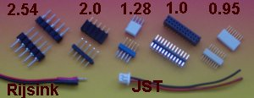

The requirement for ULS connectors are the following:
- ultralight male and female connector
- possibility to solder directly the wires
- low price
- thin wires, flexible (< 0.5mm in diameter) or thermo-soldarable magnet wire, 0.07 to 0.18mm).

The basic options for a 2-pin connector are:  - 2.54 mm pitch, strain relief with heatshrink sleeve, 0.19g  - 2mm pitch with plastic molded connectors and balsa strain relief, 0.10g  - Didel pins with balsa case, 0.04g. | 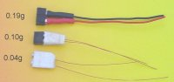

New July 2009. We propose cheaper connectors
Female 2.54mm strips for 0.50mm pins are 36mg when the plastic is removed.  The male with platic are 47mg per pin. Adding the solder, a 2-pin connector wights 0.2g, which is heavy compared to the weight of Ir1. Ir2 or Ir3.  1mm pitch connectors are heavier due to their plastic body that cannot be removed.  Cost for 10-pin strips male+female : 3 CHF | 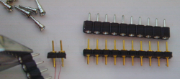

The solution proposed since 2005 by DIDEL has an excellent price/weight/flexibility ratio.
32 pins and 32 sockets are included in a 10 USD kit, that also includes ultra-thin solder.  0.04 g balsa plugs are built with these pins. | 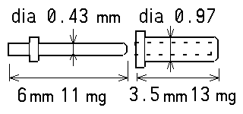 | 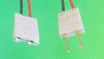

Power plugs  As a general rule, a power source has a female connector with a red mark on the positive side. Polarized power connectors have a male pin for the 0V/Gnd. With the Bahoma system, there is no more need for power plugs and on/off switches.  PC board connector  Didel has 1mm hole on their PC boards, so either female sockets or male pins will fit. We prefer male pins for the actuators, slanted to facilitate the plug insertion. | 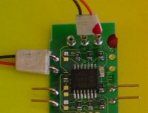

The art of soldering

We assume that the modeller has a fine tip (<1mm) soldering iron. As with glue, less is always better. A good solder joint is bright and shiny. Wires to be soldered must always be tinned. Depending on the wire coating, this is not always easy. As a general rule for heat-solderable wires (magnet wire or litz wire), use rosin-core solder (1.2mm diameter) that includes flux, and get a big drop of solder at the tip of the soldering iron, embedding the wire in the solder drop. This works well with solderable magnet wires. If the wire is not well tinned when getting out of the drop, add more solder (and hence more flux) to the tip and reinsert the wire. This technique can also work with enamel coated wires that are more difficult to solder, but you will need higher heat on your iron. | 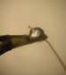

Extending magnet wire, e.g. to connect a Bird actuator having an home-made coil, is delicate. The two thin wires are difficult to align and they must be parallel where they are soldered. Four stable hands are required, and at these sizes, the usual third hand gadgets are cumbersome. Our trick is to put to small lumps of children’s clay on a 1 x 2 cm piece of brass or lead. With tweezers, the wires can be positioned and maintained in the proper orientation when soldering. It is still not an easy task, and you need magnifying lenses or a binocular to succeed with less than 0.2 mm wires. | 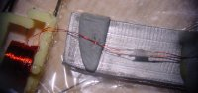

Selecting wires
The main choices for wire are plastic insulated wire versus thermo-solderable magnet wire. Many people do not like solderable magnet wire because they have difficulty soldering them (see above for how to do it). The reliability is as good as for plastic insulated wires, and in both cases depends much on the strain relief on the connector. The drawback of thin insulated wires is the insulation is very difficult to cut without nicking or cutting some of the wires. It can also be difficult to cover the wires well with solder without it wicking up with wire by capillary action and ruining the flexibility outside the connector. Crimping wire on JST-like connectors is simple if you have the tools, but the wire is not flexible, and not in our weight range.

 | Wire diameter mm | Resistance Ohm/m | Weight g/m
Insulated wire (Stabler)
 | 0.55 | 0.8 | 0.56
Thermo-solderable magnet wire
AWG 33 | 0.18 | 0.67 Ohm/m | 0.24
AWG 36 | 0.12 | 1.4 Ohm/m | 0.12
AWG 39 | 0.09 | 2.7 | 0.06
AWG 41 | 0.08 | 4.4 | 0.037

The wire must be thick enough that the voltage drop is acceptable - less than 0.1 volt. To get an idea, let us consider two kinds of equipment: a BIRD actuator (50 mA) and small motors (200 mA). Usually, the BIRD is at some distance of the receiver, but the propeller is much closer. Table 4 shows what should be planned for a total of 0.1g for the wires, about double for insulated wire of the same copper diameter.

Wire | Current | Length for 0.1 V | Distance | Weight
AWG 36 | 50 mA | 1.4 m | 70 cm | 0.08 g
AWG 33 | 200 mA | 0.7 m | 35 cm | 0.08 g

Balsa plugs
For light weight and strain relief, balsa plugs with Didel pins or sockets are lights and reliable. For a female connector, solder the wire on the pins while they are still inserted into the header. Use a minimum of solder. Cut 6mm strips of very soft balsa, 1 to 1.2mm thick. Cut the strips wide enough to cover the pins. Put white glue or superphatic on one side of the balsa strips, and “sandwich” the plugs between them. Press with your fingers, and then with a modified clothespin.

For a male connector, you need to drill a thin (1.2 to 1.5mm) piece of aluminium or thermal resistant plastic with two 0.5mm diameter holes so the pins are aligned at the required distance. You can also use a female connector strip or IC socket with a 2.54 mm pitch.
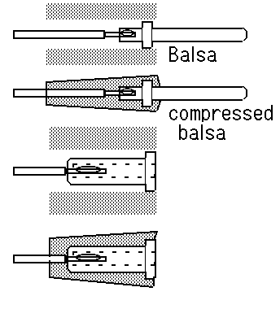 | 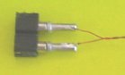 | 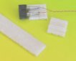
 | 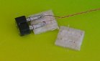 | 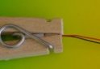
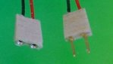 | 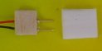 | 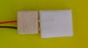

Useful gadgets

For pressing the balsa plugs together, get old fashioned wooden clothes-pins. Cut them short, and if there is a notch for small wires, fill-it.  When depressing balsa, you can take advantage of the positive or negative conicity (you will understand when you try!). |  | 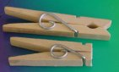
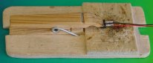 | A small clothespin is convenient to hold a plug when soldering. As an additional convenience, magnets hold the piece on steel a base plate. Otherwise, the support is too light and would move too easily during soldering.

Didel connector kit  Price for a kit of 32 female pins, 32 male pins,  plus 20cm of 0.27mm ultrafine soldering wire:  12 CHF, about 10 USD or 8 Euros  (still available in 2009 in limited quantities) | 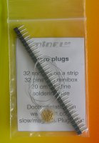

jdn 040905/mc090719

