CH-1092 Belmont, Switzerland  Tel +41 21 728-6156, Fax 728-6157  Email info@didel.com, www.didel.com | 

Ultralight connectors  DIDEL now has ultralight male and female connectors permitting a general usage on less than 10 grams planes, since the 2-pin plug weighs only 0.04g.  Female: dia 0.97mm, length 3.8mm, weight 0,018g | 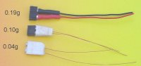

Male: out of dia 0.47mm CuBz wire, weight 0.01g. Pins are cut with precision plyers that makes one end perfectly clean for insertion.  The pins can be soldered on existing combos, or assembled to build ultralight multicontact balsa connectors, male, female or hermaphrodit.  Price for a kit of 32 female pins, 32 male pins, plus 20cm of 0.27mm ultrafine soldering wire:  9.70 CHF, about 8 USD, 6.4 Euros or 200 CZK | 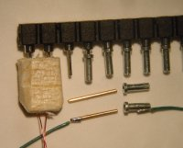

jdn041001/uz041008

