CH-1092 Belmont, Switzerland  Tel +41 21 728-6156, Fax 728-6157  Email info@didel.com, www.didel.com | 
File www.didel.com/slow/magnets/BapiPub.doc

obsolete – see www.didel.com/vole/LipoPub.pdf

Connect small LiPoly batteries with magnets

Use two small PC boards with press-inserted magnets to hold the battery under your ultralight plane. You add 0.12 grams, but you save a connector or a switch. And it is so convenient.  Connect the Bapi-B pieces to your battery (20, 45, 60, 90 or 140 mAh). The magnets have a retention force of 30 grams. The battery will fall down in case of harsh landing.  Add the Bapi-M piece on your model or use the Didel MD2x or MD4x infrared receivers that includes the magnets. |  | 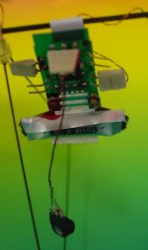 |  | 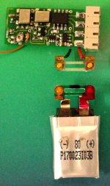
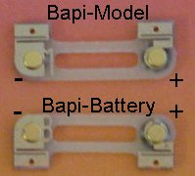 | 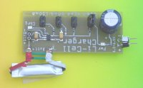 |  | 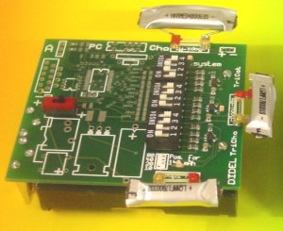
  Add the Bapi-M pieces to your LiPoly charger, or use the new Didel Tricha, that charges up to 3 cells, so you can fly non stop with 4 batteries.
The Microblimp, a nice design from Plantraco  (see http://www.plantraco.com) is using the Bahoma standard (90 mAh cells).  The charger is included in the transmitter. | 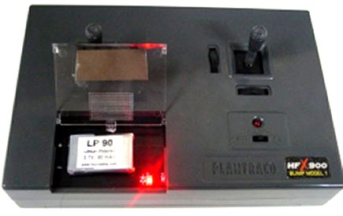 |  | 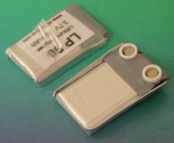

The Bahoma specifications and Procedures for fixing the magnets are detailed in the documents www.didel.com/slow/magnets/Bahoma.doc and http://www.didel.com/slow/magnets/BapiLipo.doc.

Price for one Bapi circuits with two press-fitted magnets is
1.10 CHF, about 0.9 USD or 0.80 €
Specify Bapi-B (for battery) or Bapi-M (for model side).

BaBeKit - Bahoma Beginner's kit – Special offer: 6 Bapis for 5 CHF (25% off)
Experience shows you need 6 Bapis to start efficiently to apply the Bahoma concept
- 1 Bapi-M for your model plane
- 1 Bapi-M for wiring an adapter toward your battery charger
- 1 Bapi-M for wiring an adapter toward a voltmeter, or for a second plane
- 2 Bapi-B for batteries
- 1 Bapi-B for wiring an adapter toward a 3 to 4 Volt power supply with A-meter, so you can test quietly your electronics, servo, propeller thrrust and measure currents.

jdn050110/us0501
CH-1092 Belmont, Switzerland
Tel +41 21 728-6156, Fax 728-6157
Email info@didel.com, www.didel.com
File www.didel.com/slow/magnets/BapiPub.doc

Connect small LiPoly batteries with magnets

Use two small PC boards with press-inserted magnets to hold the battery under your ultralight plane. You add 0.12 grams, but you save a connector or a switch. And it is so convenient.

Connect the Bapi-B pieces to your battery (20, 45, 60, 90 or 140 mAh). The magnets have a retention force of 30 grams. The battery will fall down in case of harsh landing.

Add the Bapi-M piece on your model or use the Didel MD2x or MD4x infrared receivers that includes the magnets.
Add the Bapi-M pieces to your LiPoly charger, or use the new Didel Tricha, that charges up to 3 cells, so you can fly non stop with 4 batteries.

The Microblimp, a nice design from Plantraco
(see http://www.plantraco.com) is using the Bahoma standard (90 mAh cells).
The charger is included in the transmitter.

The Bahoma specifications and Procedures for fixing the magnets are detailed in the documents www.didel.com/slow/magnets/Bahoma.doc and http://www.didel.com/slow/magnets/BapiLipo.doc.

Price for one Bapi circuits with two press-fitted magnets is
1.10 CHF, about 0.9 USD or 0.80 €
Specify Bapi-B (for battery) or Bapi-M (for model side).

BaBeKit - Bahoma Beginner's kit – Special offer: 6 Bapis for 5 CHF (25% off)
Experience shows you need 6 Bapis to start efficiently to apply the Bahoma concept
- 1 Bapi-M for your model plane
- 1 Bapi-M for wiring an adapter toward your battery charger
- 1 Bapi-M for wiring an adapter toward a voltmeter, or for a second plane
- 2 Bapi-B for batteries
- 1 Bapi-B for wiring an adapter toward a 3 to 4 Volt power supply with A-meter, so you can test quietly your electronics, servo, propeller thrrust and measure currents.

jdn050110/us0501

