CH-1092 Belmont, Switzerland  Tel +41 21 728-6156, Fax 728-6157  Email info@didel.com, www.didel.com | 
File www.didel.com/slow/magnets/Bahoma.pdf

Battery Holder using Magnets (BaHoMa system)

September 2006 update

BaHoMa is a convenient system for holding Lipo batteries on a light plane. Connection is instantaneous and the Lipo fall in case of a crash, reducing the effort on the structure. Then put the Lipo on the charger, no thin plug to handle, just drop it at about the good place.
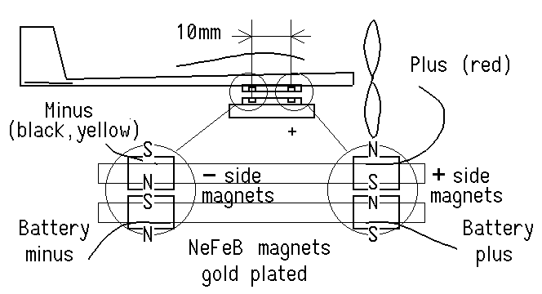

Standardization
In addition to the polarity of magnets and the electrical polarity, the distance between the magnets must be normalized. Anybody will then be able to borrow a friend's pack, and just put the battery on a Bahoma system charger. We are concerned only about less than 200 mAh LiPoly batteries weighting up to 4 grams.
The BH10 standard specifies 10mm between magnets, and 1.5 mm diameter magnets. 2mm magnets or more are possible and compatible.
The BH5 standard specifies 5mm between magnets, saves a little weight and is good for 30 mAh and smaller Lipo batteries.

Dia1.5x1.2mm magnets (0.01g each) have an attracting force greater than 30 grams, hence 60 grams for both. High temperature magnets needs larger size for the same force. Gold plated magnets guarantee a low contact resistance.

Plantraco patented a guard ring and put plastic pieces on its batteries to avoid a short if the battery is inadvertently put on some conductive surface.
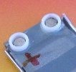 | 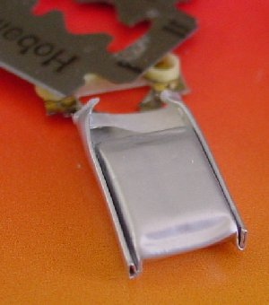 | 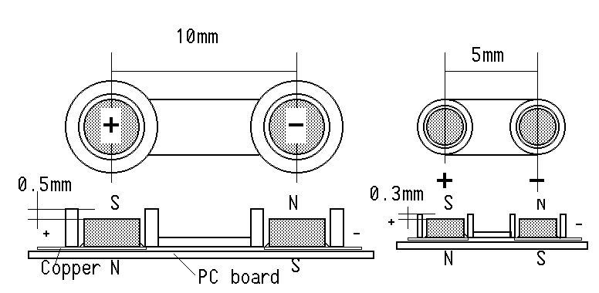

Establishing a reliable contact between the magnets and the Lipo or the receiver PCB needs some understanding. Soldering is only possible with high temperature magnets (grade 30, > 180°) and low temperature solder (< 135°), using an adequate soldering iron. Conductive glues are expensive and the result is difficult to guarantee if not done industrially.
DIDEL proposes small precision circuit boards with press-fitted magnets, named Bapi (for “Bahoma bracket piece”) and Bami for the smaller 5mm pitch.. Weight with two magnets is 0.082 grams, hence 0.16 gram for the pair, which is less than a connector or switch.

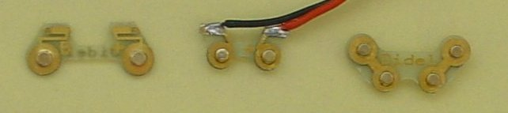

The Bapi/Bami circuits have two tabs on which solder can be applied for connection to the battery tabs or the wires toward the receiver. When soldering, the heat must not travel toward the magnet. The Bapi-B (on the battery side) and the Bapi-M (on the model side) are not identical due to magnet orientation, like male and female power plugs.  If the Bapi is not applied on a surface, it is important to protect the other side with some nailpaint or other light insulation. Due to the need of soldering on the rear side, the Bapi-pieces are not protected on the back when delivered.  If guard rings are not available, a plastic tab | 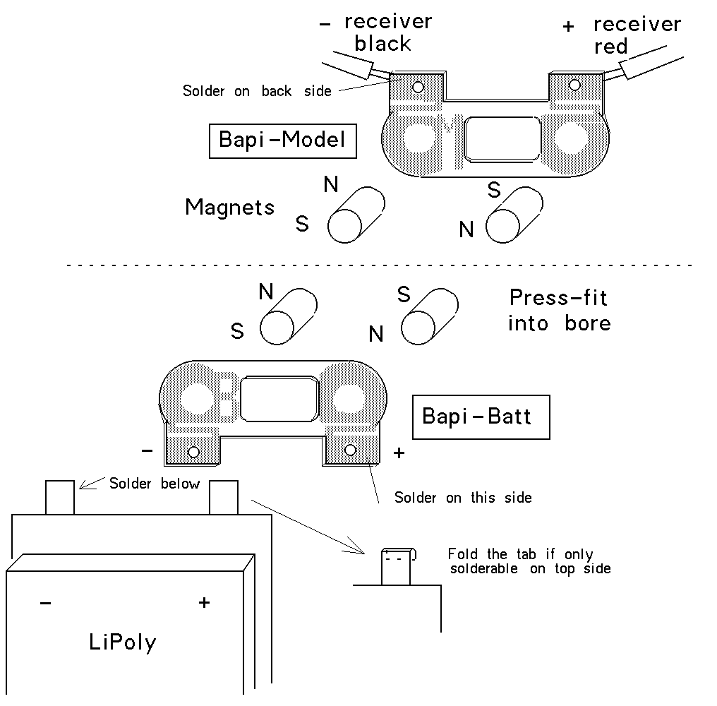

Connection to the battery  When the Bapi-B is soldered, if one looks to the battery hanging on the plane, the positive tab is right and the visible pole is the north pole. | Connection to the plane  When the Bapi-M is soldered and applied on the plane, the positive tab is right and the visible pole is the north pole
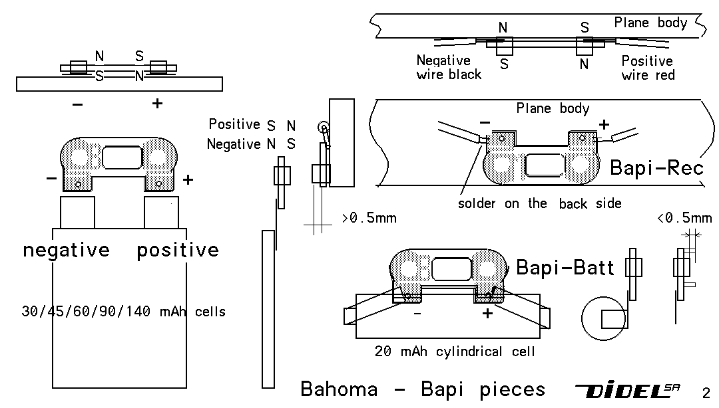

How to recognize the North pole?
If you have a compass, it is easy - the south pole of your magnet will attract the north pole side of the compass, usually red. Paint the south pole of the magnet red and glue it at the end of a balsa rod. It will be your reference piece for testing polarities. See BapiLipo.doc for more. | 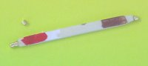
If you do not have a compass, build it! Glue two magnets with the same orientation on a stick of balsa. Let it float on a glass of water, and put red paint on the south direction.

Never heat the magnets!
The major problem is to not heat the magnets above 150 degrees, by conductivity or by accident. The heat propagates through the copper PC board when you solder, or the magnet suddenly attracts the soldering iron tip. A small touch and the magnet is useless and must be changed! | 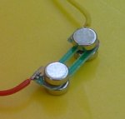 | 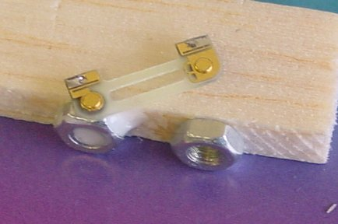

Preparing a battery
Detailed explanations using the Bapi pieces can be found at www.didel.com/slow/magnets/BapiLipo.docThe picture on the left left shows several results.  The non-contact side of the Bapi must be protected to avoid shorts on this side. Use soft balsa, paper labels or nail paint.  It is good to have a Bapi-B with two wires going to your usual battery connector, and a Bapi-R with wires going to your preferred voltmeter, in order to check Li-Polys. | 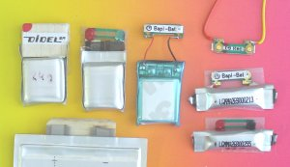

jdn 060913

