CH-1092 Belmont, Switzerland  Tel +41 21 728-6156, Fax 728-6157  Email info@didel.com, www.didel.com | 
File http://www.didel.com/microkit/gears/Gears.doc

Mod 0.3 and 0.2 gears

Didel now has a complete set of module 0.3 and module 0.2 gears.  For a module m, the nominal diameter (mid-teeth) of a n-teeth pinion or gear is n • m millimeters.  The pitch (nominal distance between two teeth) is n • 3.14.  The distance between two shafts carrying gears of n1 and n2 teeth is (n1+n1)/2 + x. The clearance x is 0.01 to 0.04mm depending on the precision of the gears and the bores. | 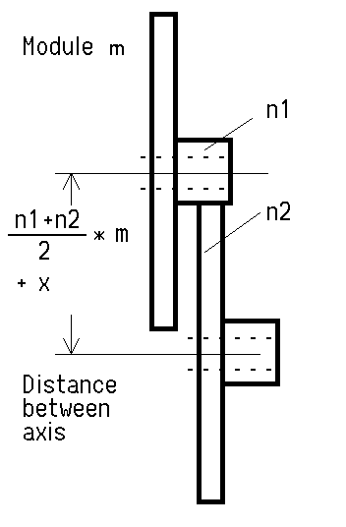 | 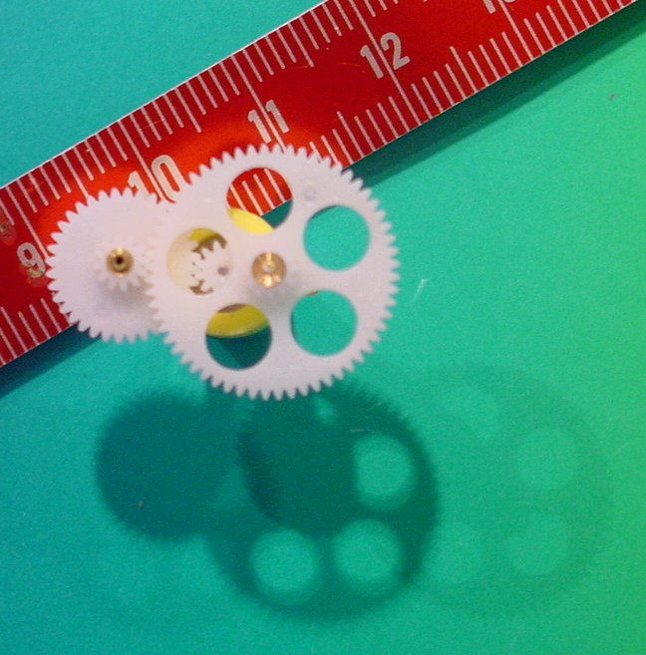

Module 0.3 pinions, gears and worm

 | Number of Teeth | Nominal dia (mm) | Ext diameter | Length/ thickness | Bore diameter | Weight | Cost CHF
G309 | 9 | 2.7 | 3.3 | 3.6 | 0.62 0.72 0.82 0.97 | 0.02 | 1.60
G312 | 12 | 3.6 | 4.2 | 3.4 | 0.78 0.97 | 0.04 | 1.40
G336 | 36/12 | 10.8 | 11.4 | 3.0 | 0.80 | 0.13 | 4.10
G348L | 48/12 | 14.4 | 15.0 | 3.0 | 0.79 | 0.15 | 6.60
G360L | 60/12 | 18.0 | 18.6 | 3.0 | 0.73 | 0.18 | 6.60
G681L | 81/12 | 24.3 | 24.9 | 3.0 | 0.75 | 0.34 | 10.40
G336C | Crown gear cancelled
GW383 | 1 Worm gear | 2.4 | 3.0 | 8.0 | 0.61 | 0.04 | 7.20
G348S | 48/12 36 slots | 14.4 | 15.0 | 3.0 | 0.75 | 0.19 | 7.60
G360S | 60/12 60 slots | 18.0 | 18.6 | 3.0 | 0.74 | 0.25 | 8.60

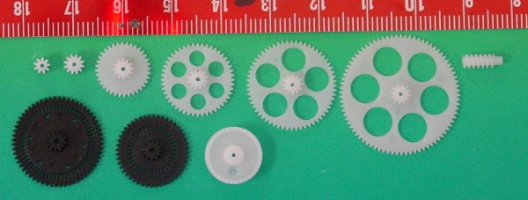
Material: POM. Manufactured in China

Module 0.2 pinions and gears

 | Teeth number | Nominal dia (mm) | Ext diameter | Length/ thickness | Bore diameter | Weight | Cost CHF
G209 | 9 | 1.8 | 2.2 | 2.5 | 0.61 | 0.006 | 2.90
G212 | 12 | 2.4 | 2.8 | 2.5 | 0.63 | 0.011 | 2.60
G240 | 40/12 | 8.0 | 8.4 | 3.5 | 0.77 | 0.046 | 8.50
G260 | 40/12 | 12.0 | 12.4 | 2.5 | 0.79 | 0.067 | 9.10
G290 | 90/12 | 18.0 | 18.4 | 3.5 | 0.77 | 0.140 | 11.80

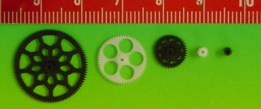

Material:POM, The black gears are Swiss made, high precision.

