CH-1092 Belmont, Switzerland  Tel +41 21 728-6156, Fax 728-6157  Email info@didel.com, www.didel.com | 
File www.didel.com/slow/propellers/Reduc02.pdf

Mod 0.2 gearbox kits for 4 mm motors

Didel offers a family of grearbox kits using M0.2 gears. A kit includes the ultralight body, a 2mm adapter with a 1.4mm 6 degrees slanted bore., the gears, the rivet shafts, and a PC02 connector

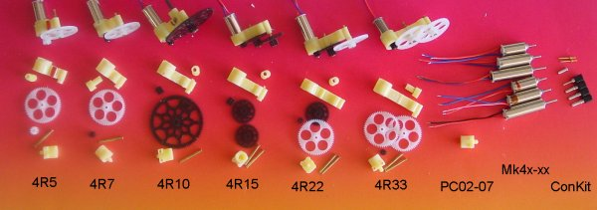

4R5 | 4R7 | 4R10 | 4R15 | 4R22 | 4R33
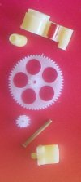 | 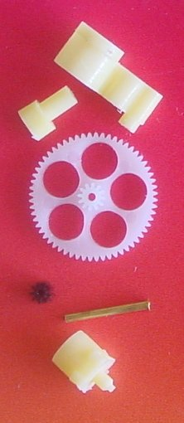 | 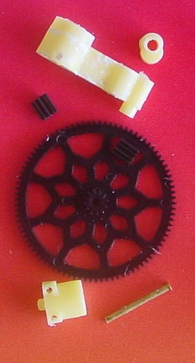 | 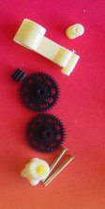 | 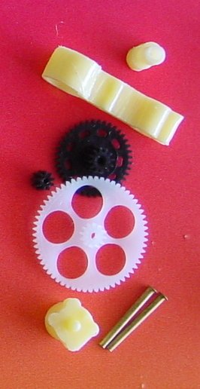 | 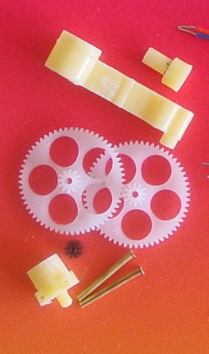
Notice that the adapter for 1mm carbon rod is drilled with a ~5 degree angle and can be rotated for adjusting the down and side thrust.

Possible motors and expected thrust with a 4R10 box and a single cell Lipo (estimated from the measures made in 2002) | 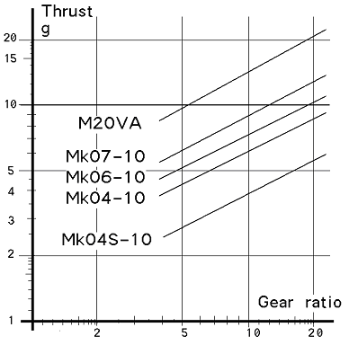
  Mk04-08 | 5g | 200 mA
  Mk04-10 | 4g | 150 mA
  Mk04S-10 | 3g | 150 mA
  Mk04S-30 | 1g | 60 mA
  Mk04-30 | 1.2g | 60 mA

jdn070828

