CH-1092 Belmont, Switzerland  Tel +41 21 728-6156, Fax 728-6157  Email info@didel.com, www.didel.com | 
File www.didel.com/slow/propellers/PropSet.doc

Propulsion sets
1,36 grams for 3-5 gr thrust, 100 to 140 mAh at 3.6V

These products are not available any more

Didel offer two assembled and tested gearboxes (test report included) using the MCF5030L propeller, the Mk04-13 motor and two different gearboxes:
The 4P10 provides 4 to 5 grams of thrust at 3.6V, 135 to 145 mA
The 4P15 provides 3 to 4 grams of thrust at 3.6V, 100 to 110 mA
The difference in thrust is due to the differences between the propellers.

The gearboxs are available separately (4R10, 4R15); they include a down/side thrust bushing and a propeller connector for both balsa props and MCF props (centering post).
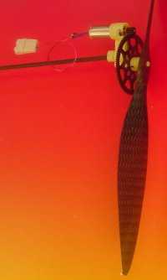 | 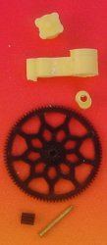 | 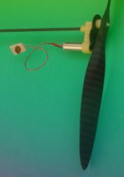 | 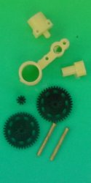
4P10 prop set | 4R10 gearbox | 4P15 prop set | 4R15 gearbox
The 4P10 and 4P15 motor (Mk04-10) have a blocked current of 240-260 mA. This means the 4P10 is at maximum propeller power, and the 4P15 at maximum efficiency. With a larger propeller, the 4P15 could get more thrust that the 4P10, but the interest of the 4P15 is to allow longer flights with the 20 mAh LiPo.

With 4mm Didel motors, one can expect the following current and thrust at 3.6 Volts:
Motor | Coil resistance | Motor weight | No load  current | Blocked current | Thrust at max power
 |  |  |  |  | Direct | 4R7 | 4R10 | 4R15 | 4R22 | 4R33
Mk04S-10 | ~11 Ohm | 0.47g | 30-50 | 300 | ~ 1g | ~ 3g | ~ 4g | ~ 4.2g | ~ 4.5g | ~ 5.5g
Mk04-10 | ~13 Ohm | 0.66g | 25-50 | 250 | ~ 1g | ~ 3.2g | ~ 4.5g | ~ 4.7g | ~ 4.9g | ~ 6g
Mk04L-10 | ~14 Ohm | 0.79g | 30-60 | 240 | ~ 1g | ~ 3.3g | ~ 4.6g | ~ 4.8g | ~ 5g | ~ 6g
Mk04S-24 | ~24 Ohm | 0.47 | 15-25 | 130 | ~ 0.6g | ~ 1.8g | ~ 1.7g | ~ 2g | ~ 2.3g | ~ 2.7g
Mk04-40 | ~40 Ohm | 0.66 | 12-25 | 90 | ~ 0.5g | ~ 1.6g | ~ 2.2g | ~ 2.3g | ~ 2.5g | ~ 2.8g
Mk04L-40 | ~40 Ohm | 0.79 | 15-30 | 90 | ~ 0.5g | ~ 1.6g | ~ 2.2g | ~ 2.4g | ~ 2.6g | ~ 3g

If the motor current is below 60% of it stall torque, the thrust is about equal to the current in 100mA units multiplied by the square root of the gearbox ratio.
To be at max power (current is half of the blocked current), one must select a propeller of the correct diameter. The choice for lightweight carbon propellers is limited. The 100 mm MCF props are good for the 4R7 only. One misses 120-160 mm lights props with high pitch for the 4R15, 4R22 and 4R33. Balsa props are still a good solution to get a light correct size. (see www.didel.com/slow/propellers/BalsaProp.doc).
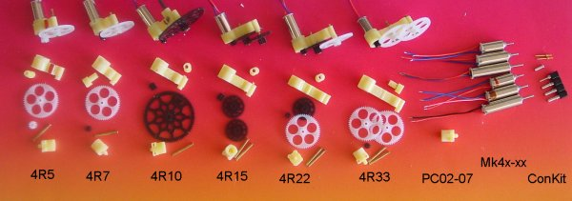

jdn050112/ us170104

