CH-1092 Belmont, Switzerland  Tel +41 21 728-6156, Fax 728-6157  Email info@didel.com, www.didel.com | 
File www.didel.com/slow/propellers/BalsaProp.doc

Balsa propellers for ULS

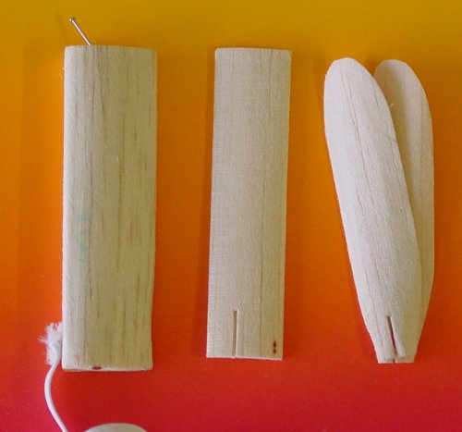 | Very slow flyers need large and ultralight propellers that spin slowly. The larger the propeller the more eficiant it will be and less power needed: doubling the diameter of the propeller divides by two the power required for the same thrust. Commercial propellers are very heavy.  Balsa propellers are low cost, easy to do and they do not break so frequently when the plane flyes at 1m/s.  We propose to do the blades out of a thin sheet of balsa, formed on a balsa block. The blades are assembled with a propeller connector and press fit on the last gear of DIDEL gearboxes. The propeller can be easily changed and removed for transportation.

Connector choice

DIDEL propeller connectors have been developed to facilatate the easy construction of balsa blades and pitch adjustment.  There is a choice of 4 prop connectors.  PC07-02 matches the new M0.2 gears. It is compatible with 0.7mm carbon rods.  PC03-10 is for M0.3 gears and 1mm CR  The problem is that carbon rod (CR) diameter is not precise. If the rod is too large, a reamer is used to enlarge the bore, so it is a light pressfit .Sanding the CR is not recommended, because usually the external hard CR coating hold the fibers together.  If the rod is too small, a coating with cyanolit, and adequate sanding or scraping when dry, will usually solve the problem. | 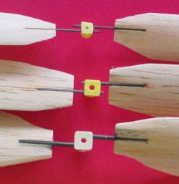

Blade gabarit  The important piece is a bloc of balsa, shaped at the form of the propeller. A rather concave profile with about 20% of curvature seems to be the best.  From the required pitch, profile and the angle of attack, it is easy to make a precise drawing of the block. Despite not having a wind tunnel or complex simulations the pitch, the profile and the angle of attack are easy to shape in to the block.  A precise CNC mill is not necessary. Several marks on the balsa block and adequate sanding will get a good result. Since a block is carved in minutes, testing different shapes is easy. | 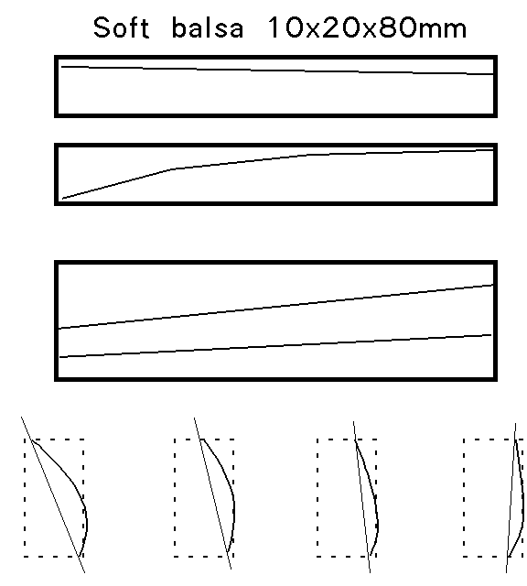

Preparing the blade

The propellers are simply made from 0.8mm first grade balsa, low density if the weight is of primary concern. Hard balsa means a larger possible thrust, but more weight and possibly more brittle. 1.5mm soft balsa will be lighter than 0.8mm hard balsa, and will be stiffer.

Put the blades in boiling water for several minutes, and apply the two well superposed blades on the block of balsa. Use flat elastic used for clothing (about 5mm by 0.5 mm) to press the blade on the balsa. Wait until completely dry.At least one day at normal temperature, faster in winter close to your heating system, or inside the kitchen oven adjusted at 50 degrees. | 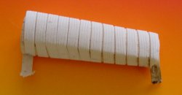

When you remove the bands after drying, keep the blades together; they will stick slightly. Cut the slot with a specially made tool, and possibly a gabarit. (see photo). A saw with the good bade width and adjusted guide is easyer.  The tool is formed of two knifes blades, glued together with a separator that give a distance of 0.9mm to the tip of the blade (to be compatible with the 1mm CR used later). The separator can be aluminium or hard balsa trimmed to the good thickness (0.2 to 0.5mm).  The slot length is up to you. We do it about 10-12 mm long, but more will reinforce the blade. | 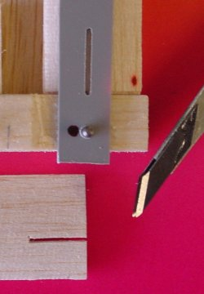

Cut the outside shape and sand with the blade to give it a nice profile. You can check the curvature with a razor blade (the shadow has amplified the curvature on the picture).  We do not put any paint on the blade, because we do not believe the prop will keep its shape, and paint will add weight. We have natural balsa blades that have kept their shape for years. | 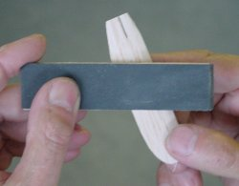 | 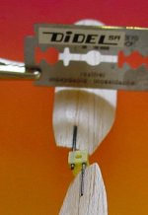

Prepare two carbon rods, 20 mm long or more, 1 mm in diameter to fit the PC03-10 prop connector. Insert in the balsa slots; it should fit with no play and no strain. A drop of thin CA along the cabon rod will glue quite well.

Adjusting the propeller

It is best is to have a carbon rod that will fit with a slight presure in the connector, making pitch adjustments easy, but holding well enough for flight tests.  If the insertion force is too high you risk to break the light glue joint where the carbon rod is attached to the balsa. If the force is too low, and it is not ready for definitive gluing, put a thin layer of glue on the rod, and scrape it if it is too thick.  If you do not have a commercial pich adjustment gabarit, it is easy to build it.  We set the angle of the propeller to 25 to 30 degrees at 40 mm from the center. | 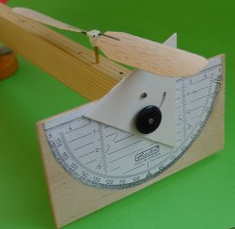

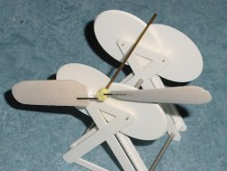 | Balancing the propeller is done as usually. A perfect mechanical and aerodynamic balance is not easy, but it is not so critical, since the propeller will spin at a quite low speed.  Perfomance of several balsa props have been measured in  www.didel.com/slow/propellers/PropStudy.doc

Copy of commercial props

You can make a mold from a commercial prop using araldit or plaster, and use it to shape your balsa blades. We did it for the WES 160/120 carbon propeller. The result had 15% less thrust, but propellers made with a balsa gabarit as decribed before, performed slightly better than the carbon prop, the thrust, but not for the power (a thin and smooth blade is better for the drag).
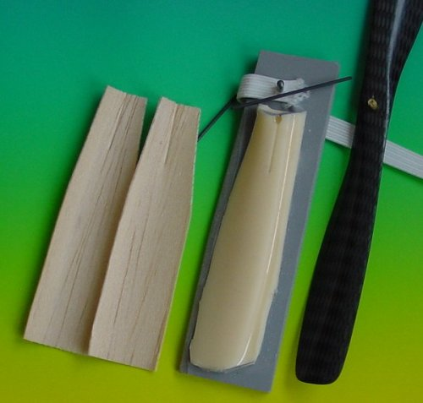

06.06.03/jdn Us/11.6.03

