PIC 16F877 - CALM instructions

Code 14 bits | Microchip | CALM |  | Flags | Operation
110000 kkkkkkkk | movlw val | Move | #Val,W | [none]
000000 1fffffff | movwf reg | Move | W,Reg | [none]
001000 0fffffff | movf reg,0 | Move | Reg,W | [Z]
001000 1fffffff | movf reg,1 | Test | Reg | [Z]
000000 01100010 | option | Move | W,Option | [none]
000000 01100101 | tris porta | Move | W,TrisA ¹ | [none]
000000 01100110 | tris portb | Move | W,TrisB ¹ | [none]
000000 01100111 | tris portc | Move | W,TrisC ¹ | [none]
111110 kkkkkkkk | addlw val | Add | #Val,W | [C,D,Z] | #Val+W -> W
000111 0fffffff | addwf reg,0 | Add | Reg,W | [C,D,Z] | Reg+W -> W
000111 1fffffff | addwf reg,1 | Add | W,Reg | [C,D,Z]
111100 kkkkkkkk | sublw val | Sub | W,#Val,W | [C²,D,Z] | #Val+(-W) -> W
000010 0fffffff | subwf reg,0 | Sub | W,Reg,W | [C²,D,Z] | Reg+(-W) -> W
000010 1fffffff | subwf reg,1 | Sub | W,Reg | [C²,D,Z] | Reg+(-W) -> Reg
111001 kkkkkkkk | andlw val | And | #Val,W | [Z]
000101 0fffffff | andwf reg,0 | And | Reg,W | [Z]
000101 1fffffff | andwf reg,1 | And | W,Reg | [Z]
111000 kkkkkkkk | iorlw val | Or | #Val,W | [Z]
000100 0fffffff | iorwf reg,0 | Or | Reg,W | [Z]
000100 1fffffff | iorwf reg,1 | Or | W,Reg | [Z]
111010 kkkkkkkk | xorlw val | Xor | #Val,W | [Z]
000110 0fffffff | xorwf reg,0 | Xor | Reg,W | [Z]
000110 1fffffff | xorwf reg,1 | Xor | W,Reg | [Z]
001110 0fffffff | swapf reg,0 | Swap | Reg,W | [none] | Reg → swapped Reg
001110 1fffffff | swapf reg,1 | Swap | Reg | [none] | Reg → Reg sw. Reg → W
000001 1fffffff | clrf reg | Clr | Reg | [Z=1]
000001 00000000 | clrw | Clr | W | [none]
000000 01100100 | clrwdt | ClrWDT |  | [none]
000000 01100011 | sleep | Sleep |  | [none]
001001 1fffffff | comf reg,1 | Not | Reg | [Z] | Reg → .not.Reg
001001 0fffffff | comf reg,0 | Not | Reg,W | [Z] | Reg → Reg .not.Reg → W
001010 1fffffff | incf reg,1 | Inc | Reg | [Z] | Reg+1 → Reg
001010 0fffffff | incf reg,0 | Inc | Reg,W | [Z] | Reg → Reg Reg+1→ W
000011 1fffffff | decf reg,1 | Dec | Reg | [Z] | Reg-1 → Reg
000011 0fffffff | decf reg,0 | Dec | Reg,W | [Z] | Reg → Reg Reg-1→ W
001101 1fffffff | rlf reg,1 | RLC | Reg | [C] | Reg → .rlc.Reg
001101 0fffffff | rlf reg,0 | RLC | Reg,W | [C] | Reg → Reg .rlc.Reg → W
001100 1fffffff | rrf reg,1 | RRC | Reg | [C] | Reg → .rrc.Reg
001100 0fffffff | rrf reg,0 | RRC | Reg,W | [C] | Reg → Reg .rrc.Reg → W
0100bb bfffffff | bcf reg,b | Clr | Reg:#b | [none]
0101bb bfffffff | bsf reg,b | Set | Reg:#b | [none]
001111 1fffffff | incfsz reg,1 | IncSkip,EQ | Reg | [none] | Reg+1 → Reg
001111 0fffffff | incfsz reg,0 | IncSkip,EQ | Reg,W | [none] | Reg → Reg Reg+1→ W
001011 1fffffff | decfsz reg,1 | DecSkip,EQ | Reg | [none] | Reg-1 → Reg
001011 0fffffff | decfsz reg,0 | DecSkip,EQ | Reg,W | [none] | Reg → Reg Reg-1→ W
0110bb bfffffff | btfsc reg,b | TestSkip,BC | Reg:#b | [none]
0111bb bfffffff | btfss reg,d | TestSkip,BS | Reg:#b | [none]
101kkk kkkkkkkk | goto addr | Jump | Addr | [none]
100kkk kkkkkkkk | call addr | Call | Addr | [none]
110100 kkkkkkkk | retlw val | RetMove | #Val,W | [none]
000000 00001000 | return | Ret |  | [none]
000000 00001001 | retfie | RetI |  | [int]
000000 00000000 | nop | Nop |  | [none]

 | 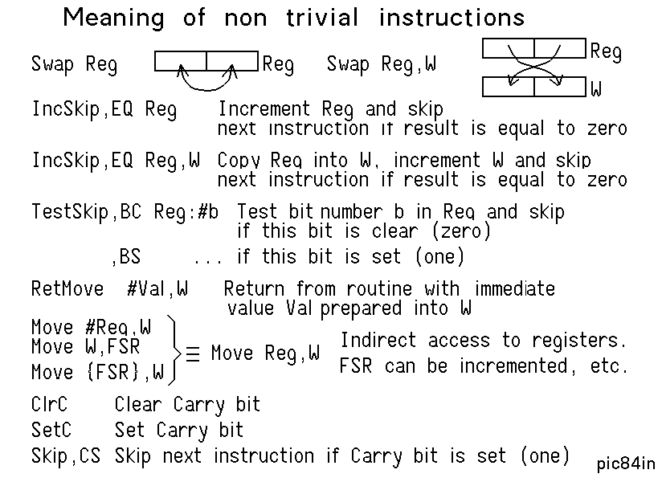
  bcf status,0 | CLRC | Clr F:#0
  bsf status,0 | SETC | Set F:#0
  btfss status,0 | Skip,CS | TestSkip,BS F:#0
  btfsc status,0 | Skip,CC | TestSkip,BC F:#0
  btfss status,2 | Skip,EQ Skip,ZS | TestSkip,BS F:#2
  btfsc status,2 | Skip,NE Skip,ZC | btfsc status,2
Note 1: Move W,TrisD, Move W,TrisE does not exist. Select in Bank1
Note 2: Processor add the 2-s complement; Carry value is inverted compared to most other μP
All instructions execute in 4 clock cycles (1 μS at 4 MHz) except the Skip, Jump, Call and Ret that takes the double
Compare for equality: Xor W,Reg or Xor Reg,W Compare for Inequality: Sub instruction, but be careful
Except I/O, 16F87x, and other 14-bit instruction PICs have the same instruction set. jdn060828

